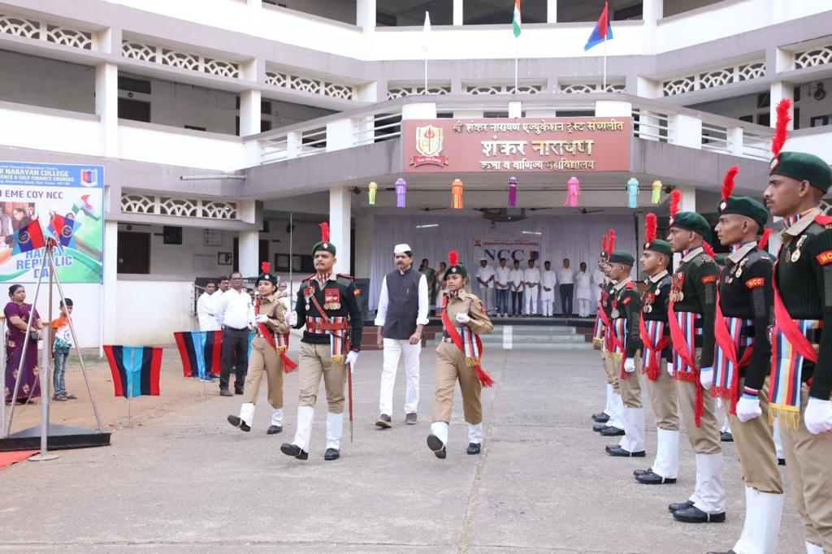
Celebrating Republic Day NCC Cadets and Hon. Secretary Shri. Maheshji Mhatre
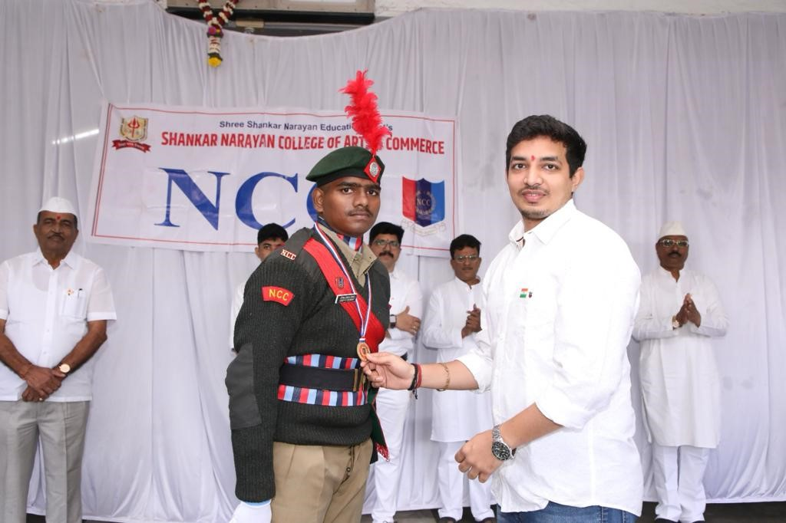
Felicitation of NCC Cadet by Guest Shri. Vinay Patil
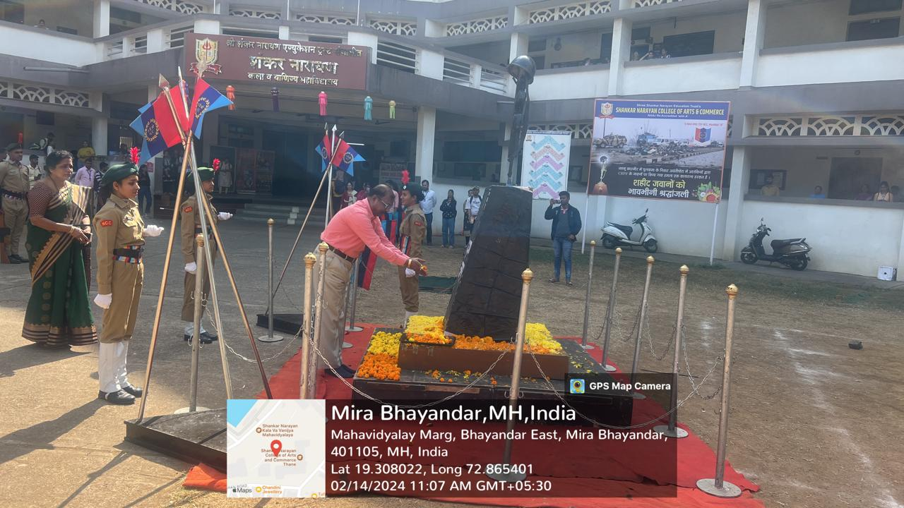
Heartfelt tribute by performing shockshastra to CRPF Martyr in 2019 Pulwama Terror Attack

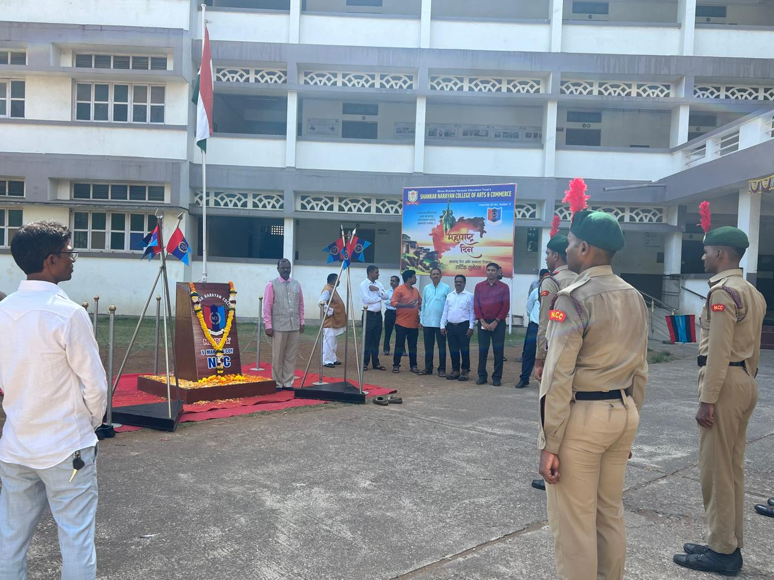
Celebration of Maharashtra Day in the College Campus

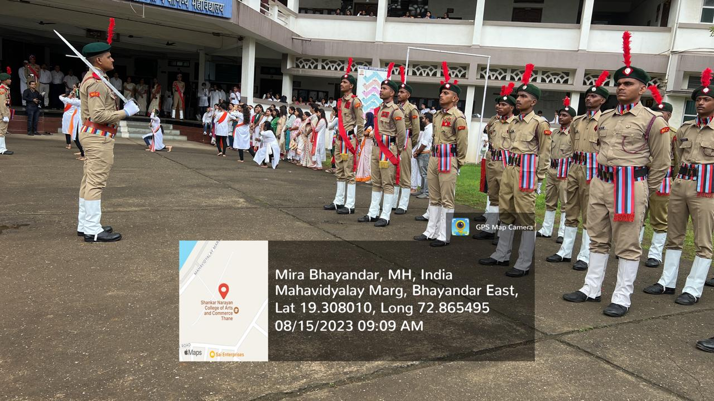
Celebration of 78th Independence Day

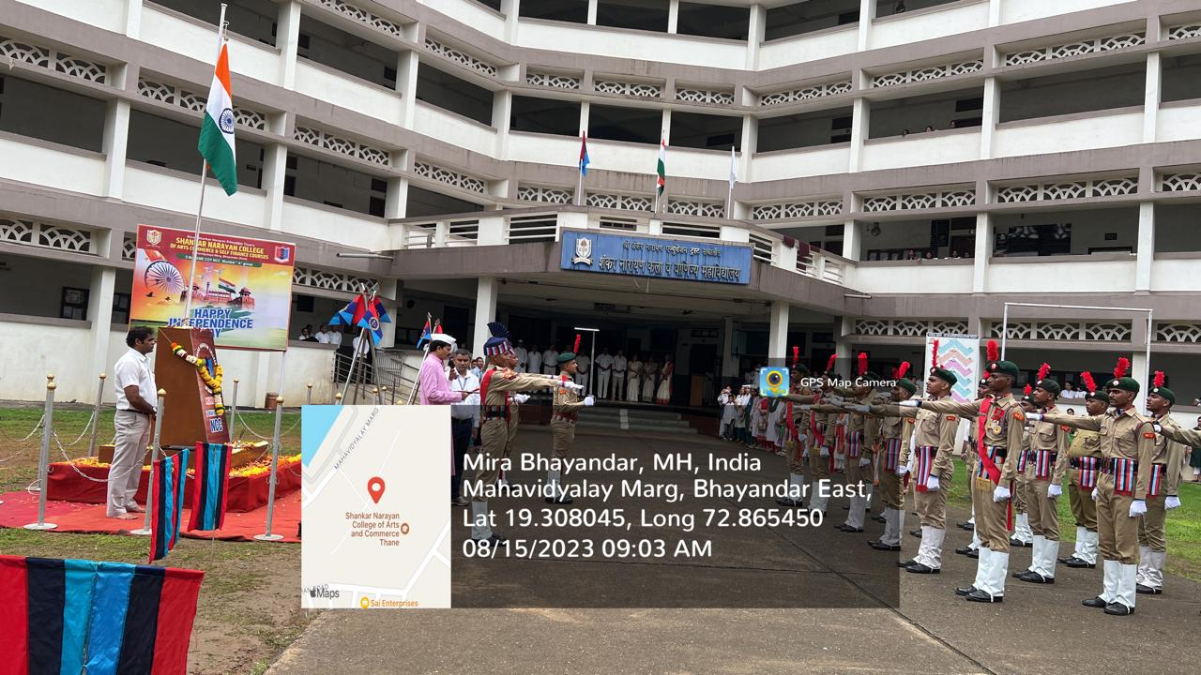
NCC Oath taken during celebration of Independence Day

