Report of Research and Development Cell ( 2023-24 )

The Research and Development (R&D) Cell has been actively working to foster a strong research culture among students and faculty at our institution. Today, one of the indices for the measurement of the potential of any educational institution is its research activity. Recognizing the importance of research in academic growth and professional development, R & D Cell has implemented various initiatives to enhance research skills, promote scholarly activities, and support collaborative research efforts. This report outlines the key actions taken by the R&D Cell to encourage and support research activities within our academic community.
Objectives of Research and Development Cell:
- To create academically sound youth by developing knowledge, skills, and attitudes of the research.
- To encourage the students to participate in research activities at inter-collegiate, district, University, State, Zonal, National, and International levels.
- To encourage and guide faculty to undertake Minor/ Major Research Projects of UGC and other funding agencies.
- To provide guidance and support to Undergraduate students to undertake research work for whom funding is available through UGC, ICSSR, and other Government bodies.
- To promote research in various departments of the Institution.
- To provide a Creative atmosphere where higher studies and research thrive amongst the Faculty and Students.
To develop a research culture among the students, every year Research and Development Cell organizes an Intra College Research Paper Presentation Competition for undergraduate and postgraduate students at the College level to provide opportunities for academically sound youth by developing knowledge, skills, and attitudes of research. Selected students and research projects are further encouraged to participate in the Inter Collegiate Aavishkar Research Convention of the University of Mumbai.
- Research and Development Cell Committee- 2023-24
Sr.No | Name of The Faculty | Designation | Department
1  2  3  4  5  6  7  8  9 | Dr.Anupama Gawde  Mr.Ajit Jadhav  Mr.Mohan Malhanor  Mrs. Laxmi Vishwakarma  Dr.Manisha Shinde  Mr. Sandeep Vishwakarma  Mr.Ganesh Kumar Narayan  Mr. Sandesh Dongre  Mr.Kiran Padvale | Co-ordinator  Member  Member  Member  Member  Member  Member  Member  Member | Accountancy  Mcom  Accountancy  BAF  BFM  Bsc.IT  MSC-IT  Librarian  Library Assistant

1. Intra College Research Paper Presentation Competition- Avishkar Research Convention for undergraduate and postgraduate students
In alignment with the University of Mumbai’s Avishkar Research Convention, the R&D Cell organized a Research Paper Presentation Competition to identify and encourage research talent among the students on 12th September, 2023. The Orientation program on” Recent Trends in Research” was organized on 10th August,2024 for commerce and self-finance course students. Dr. Anupama Gawde, Co-ordinator of Research and Development Cell conducted a session on Research methodology and explained in detail about the Research process, Data Collection, and Hypothesis. The competition provided a platform for students to present their original research work, hone their presentation skills, and receive feedback from faculty mentors and peers. Students can select topics from the category given below:
- Category 1- Commerce, Management and Law
- Category 2- Humanities, Language and Fine Arts
- Category 3- Engineering and Technology
- Category 4- Agriculture and Animal Husbandry
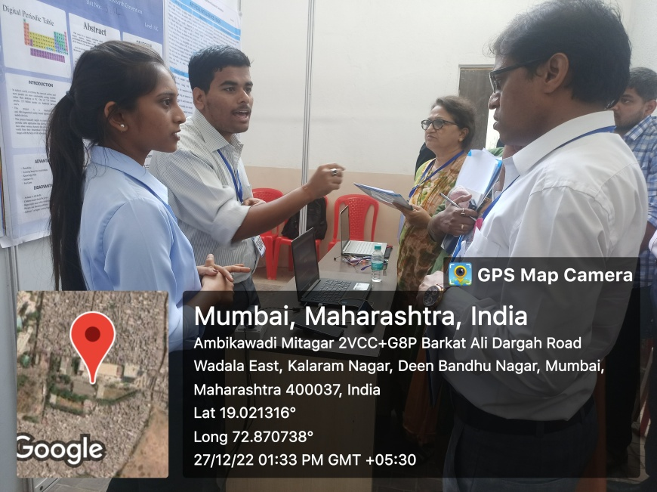
- Category 5- Pure Science
Objectives of Research Paper Presentation Competition:
- To identify the hidden innovative talents and capacities of the students.
- To provide opportunities for inculcating research attitudes in the students.
- To develop personality, presentation skills, and communication skills in the students.
- To promote the interaction among the students for the exchange of various innovative ideas for research problems.
- To encourage the students to participate in the Aavishkar Research Convention- Intercollegiate Research competition of University of Mumbai.
- To inspire students to pursue high-quality research in their academic fields.
The second round was conducted on 28th September 2023 and 10 projects were selected to represent our institution in the Avishkar Research Convention of the University of Mumbai promoting our students’ work at a larger scale and providing them with exposure to intercollegiate competition and networking opportunities.
The frontiers of education are changing every day and the world is moving from a knowledge-based society to a society of innovation. Thus, research becomes one of the most important components of higher education. It is essential to unveil the unknown and unexplored areas of knowledge in all fields of academic inquiry.. Students of Post Graduate and Undergraduate category presented research projects on topics like:
- Creating Awareness about "PCOD & PCOS" and breast cancer among young generations
- Study of Depression among College students in Thane Region
- Sign Language detection (Using Python)
- E-Census: revolutionizing Data Collection and Analysis
- Gallantry- The Police Private app
Students participated from B.Com/BSC-IT, MSC-IT, and Self-Financed Courses at Undergraduate and postgraduate levels. Students were selected to represent in 18th Intercollegiate Aavishkar Research Convention of the University of Mumbai for the Thane district zone. To promote interaction among students and the exchange of various aspects of research, the Research and Development Cell organizes such activities every year.
Outcome of Intra College Research Paper Presentation Competition:
- It has helped to identify the students' hidden innovative talents and capabilities.
- It has provided opportunities for inculcating a research attitude in the students.
- It has developed personality and communication skills in the students.
- It has facilitated interaction among the students to exchange various innovative ideas for research problems.
- The selected students were encouraged to participate in Avishkar Research Convention- Inter collegiate Research competition.
- Achievements of Research and Development Cell

- Representation of students in 18th Intercollegiate Avishkar Research Convention 2023-24 of University of Mumbai– First Round (Thane District Zone)
Nine projects were selected for the 18th Inter-Collegiate Avishkar Research Convention at the University of Mumbai. 27 students represented in the First round at the Undergraduate and Postgraduate level in the Avishkar Research Convention of the University of Mumbai at B. N. Bandodkar College of Science, Thane on 5th December,2023 in which 2 research projects were selected for final round for Poster and Model Presentation at Post Graduate level.
- 18th Intercollegiate Avishkar Research Convention 2023-24 of University of Mumbai– Final Round (Thane District Zone)
Students of MSC-IT represented in the 18th Aavishkar Inter Collegiate Research Convention in the Final Round of the University of Mumbai. at Shaha and Anchor Kutchhi College, Chembar, Mumbai 19th December, 2023. It was a proud moment and a great achievement for the College.
- Category Engineering and Technology (Level :PG)
- Student Name - Prathamesh Gujjeti
Title of the Reserch Project - Gallantry The Police Private app.
- Student Name: Sana Ansan
Title of the Research Project: Smart child Safety Device with Real TimLocation Tracking and Emagery Call feature

Student Achievement –Research and Development Cell- 2023-24
- First Rank in the Research Paper Presentation Competition at the International Multidisciplinary Conference
Today unprecedented changes have been taking place in the business world which led to the emergence of new areas for research. To face these changes and challenges there is a dire need to reorient teachers and students in research techniques and methodology to shape their sensibility towards identifying problems and researching for solutions.
- Secured First Rank in "in one day International multidisciplinary conference on “Global Paradigm Shift: Initiatives of India in Science, Education, Technology, Business & Climate at Veer Wajekar Arts, Science anal Commerce College Mahalan Vibhag Phunde, on 10th January 2024
Student of SYBSCIT Mr.Vishal Gupta participated and presented a Research Paper on "Creating awareness on PCOD, PCOS and breast cancer among young girls in Higher Education Institutions (HEI) and Best practices of WDC and ICC” and won the first rank. This Research Paper stood out for its originality, depth of research and relevance to the contemporary academic landscape. The presentation was appreciated by the esteemed panel of judges for its clarity, innovative approach, and impactful findings. The research paper was also selected for publication in International Journal.

- Student of MSCIT Part II Mr. Prathmesh Gujjeti participated and presented Research Paper titled “Gallantry The Police Private App”in one day International multidisciplinary conference on “Global Paradigm Shift: Initiatives of India in Science, Education Technology, Business & Climate at Veer Wajekar Arts, Science anal Commerce College Mahalan Vibhag Phunde, on 10th January 2024
- Student of SY BSC-IT Mr.Vishal Gupta awarded in Global Fiscal Dialogue event at SNDT Women’s University, on 23rd February 2024 for valuable Contribution in advocating diplomacy, representation as a Country and adding value to discussion at SNDT Women's University Churchgate.

- Secured 1st Position in "Mock stock" event at CONVEGNO 2024 at Rohidas Patil Institute of Management Studies held on 2nd February 2024.Student of SY BSC-IT Mr. Vishal Gupta Secured First position.
This achievement reflects the high standards of academic excellence fostered by the College, which provides a nurturing environment for students to pursue innovative research and showcase their talents on global platforms.
In this current scenario, the teachers can't deliver good quality instructions without being tuned to the current subject developments, for which they must constantly update their knowledge. A well-recognized way to deal with this paradigm is for the teachers to be active researchers in the areas in which they are interested. As researchers, they need to understand the past and recent developments in their subject areas. Many teachers have participated and presented research papers in State, National, and International Seminars and conferences.
Dr. Anupama Gawde won 1st prize for a research paper presented in One day International Multidisciplinary Research Conference at Veer Wajekar Arts, Science anal Commerce College Mahalan Vibhag Phunde, on 10th January 2024
Research and Development Cell motivates the students and teachers to undertake the Interdisciplinary projects and provide required financial support. The significant factors indicating potential growth in the research activities include the enhancement in the research publications in peer-reviewed journals, UGC care listed journals, collaborations, and Doctoral Programs. R& D Cell expresses our sincere thanks to Management, Principal, Teaching staff, students, and Non-teaching staff for their active co-operation and support.

Dr. Anupama Gawde,
Co-ordinator,
Research and Development Cell

