Industrial Visit 2024-25

1. Water Kingdom Water Filter Plant (04 December 2024)
- S.Y.I.T. (A , B & C) and S.Y.C.S.(A & B) total 176 students visited Water Kingdom Water Filter Plant where students learnt about the process of Water Filtration, chlorine, UV-light and ozone treatments and knowledge about the coagulation process.
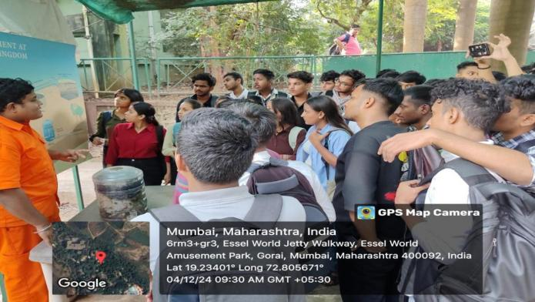
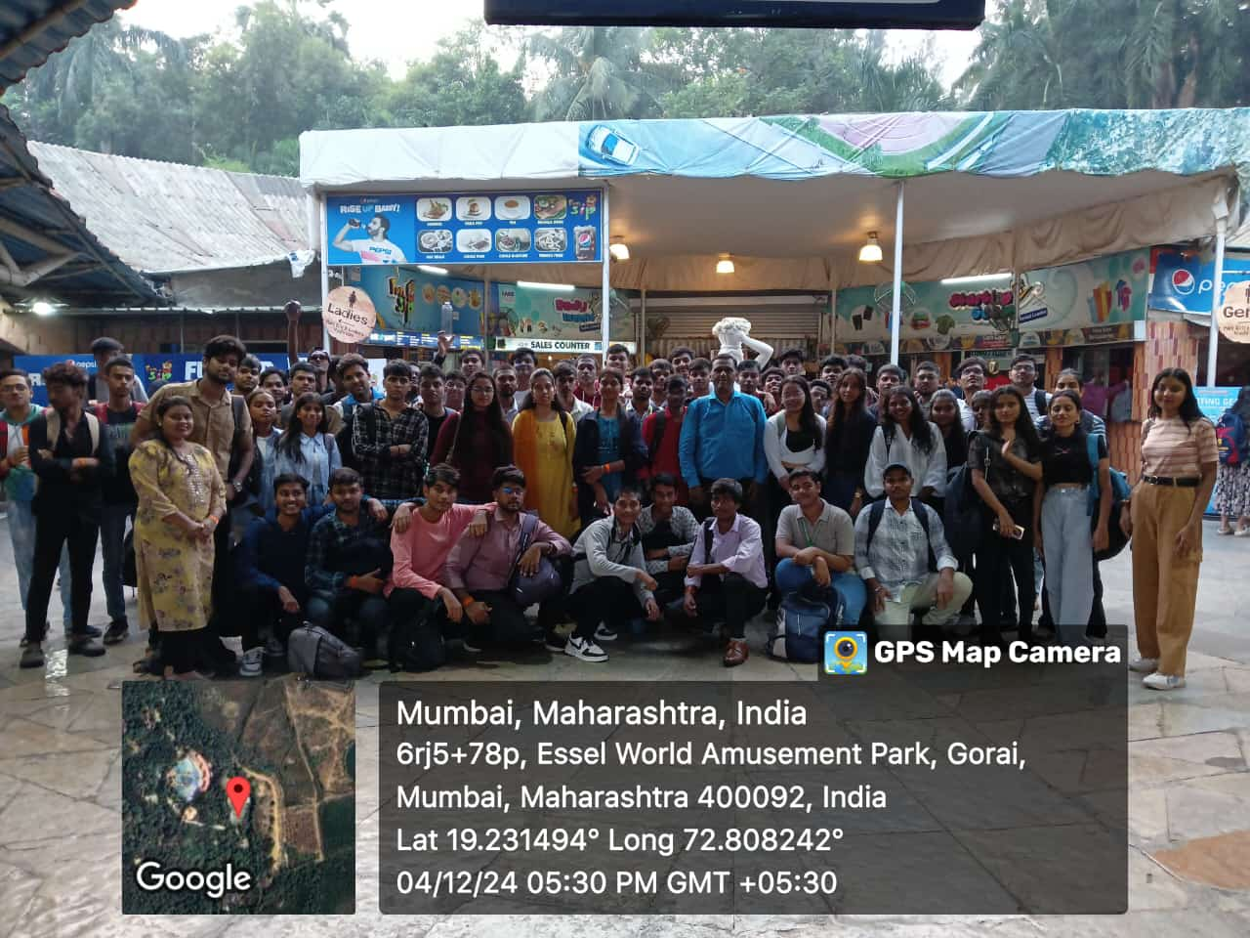
Students group picture at Water Filtration Plant Students Learning Water Filtration Process
2.Navneet Prakashan Pvt Ltd at Virar (06 December 2024)
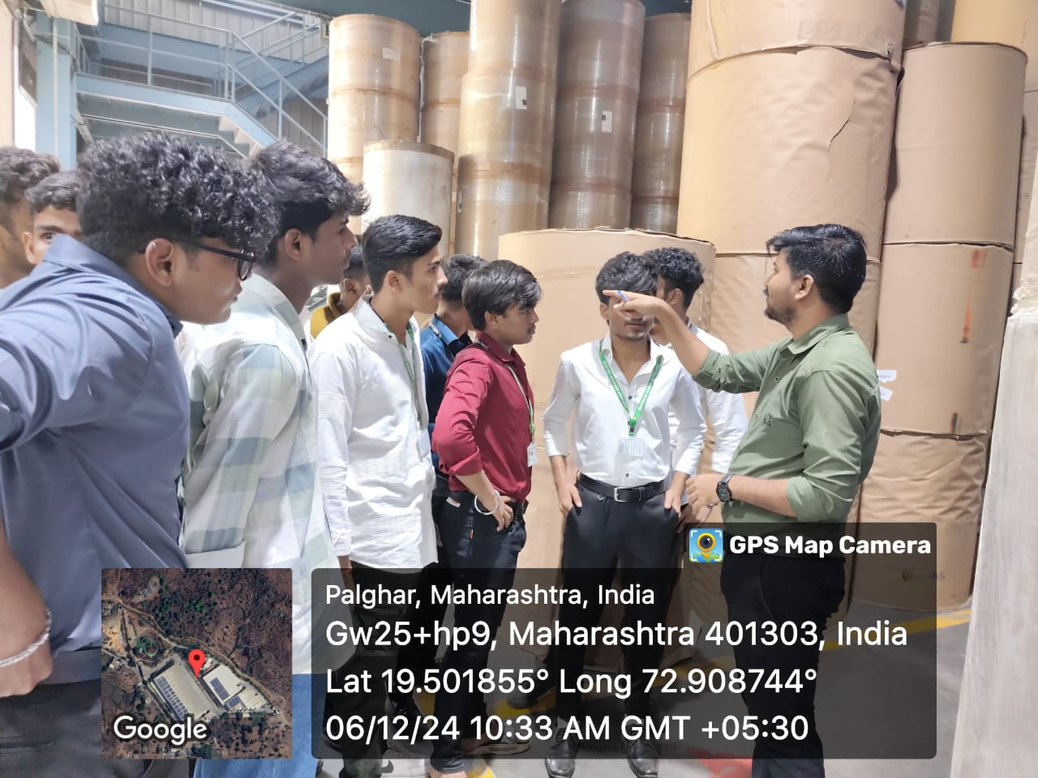
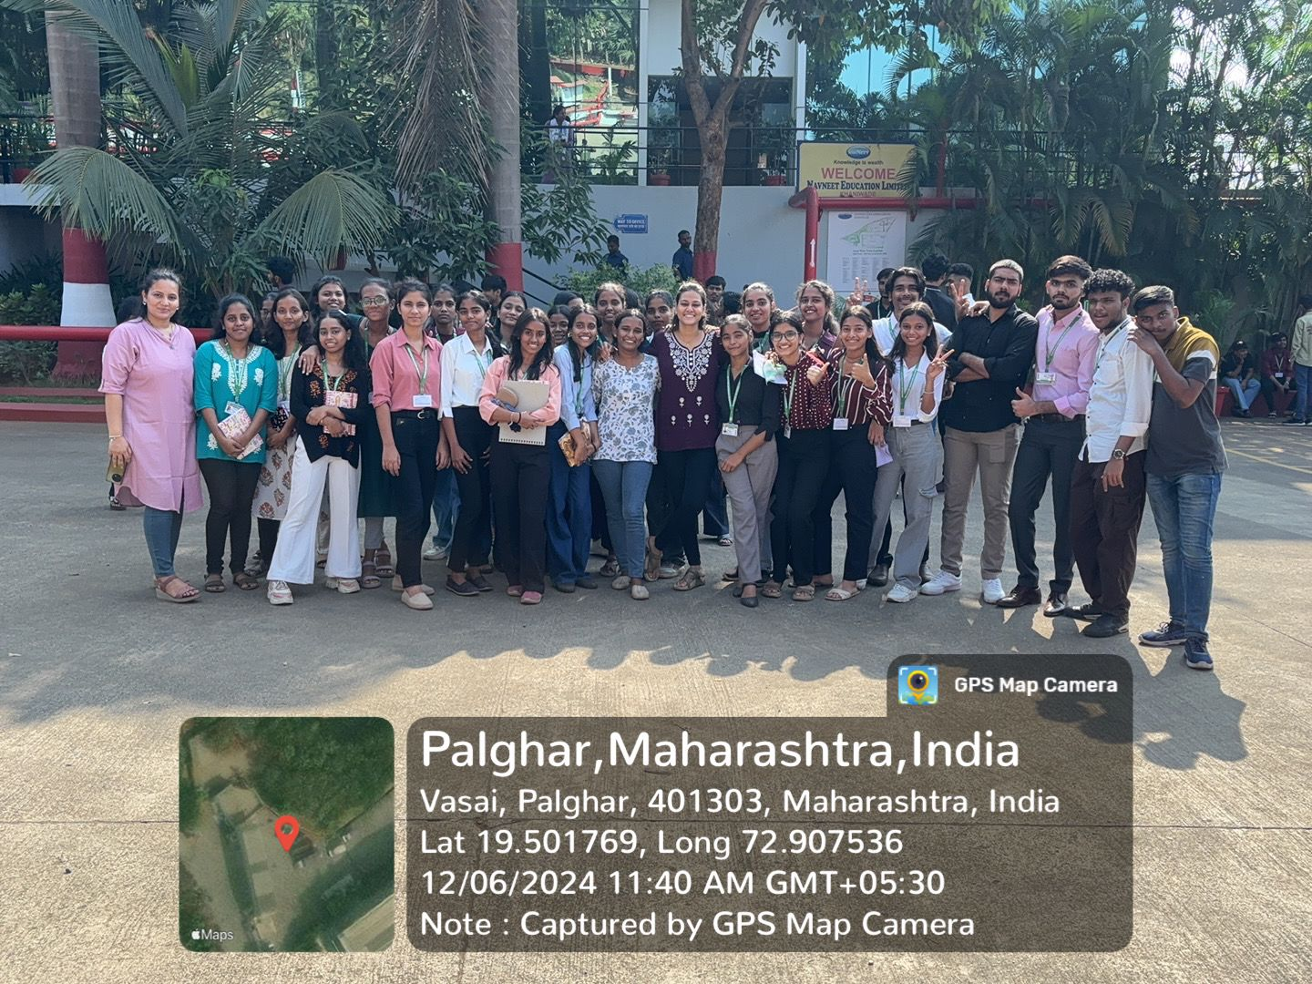
- F.Y.I.T. (A , B & C) total 92 students visited visited Navneet Prakashan Manufacturing Pvt Ltd. Navneet is a law abiding Corporate and has been doing business in the most ethical manner. It offers Educational Syllabus– based content in print and digital media, Scholastic Paper , Non paper Stationary products , General books and children’s book. .Total 154 students of first years visited Navneet. Overall visit helped students in understanding the technology and the equipment used as well as manufacturing Process of books.

Students group picture at Navneet Publication Students Learning Embedding Process

3.Navneet Prakashan Pvt Ltd at Virar (13 December 2024)
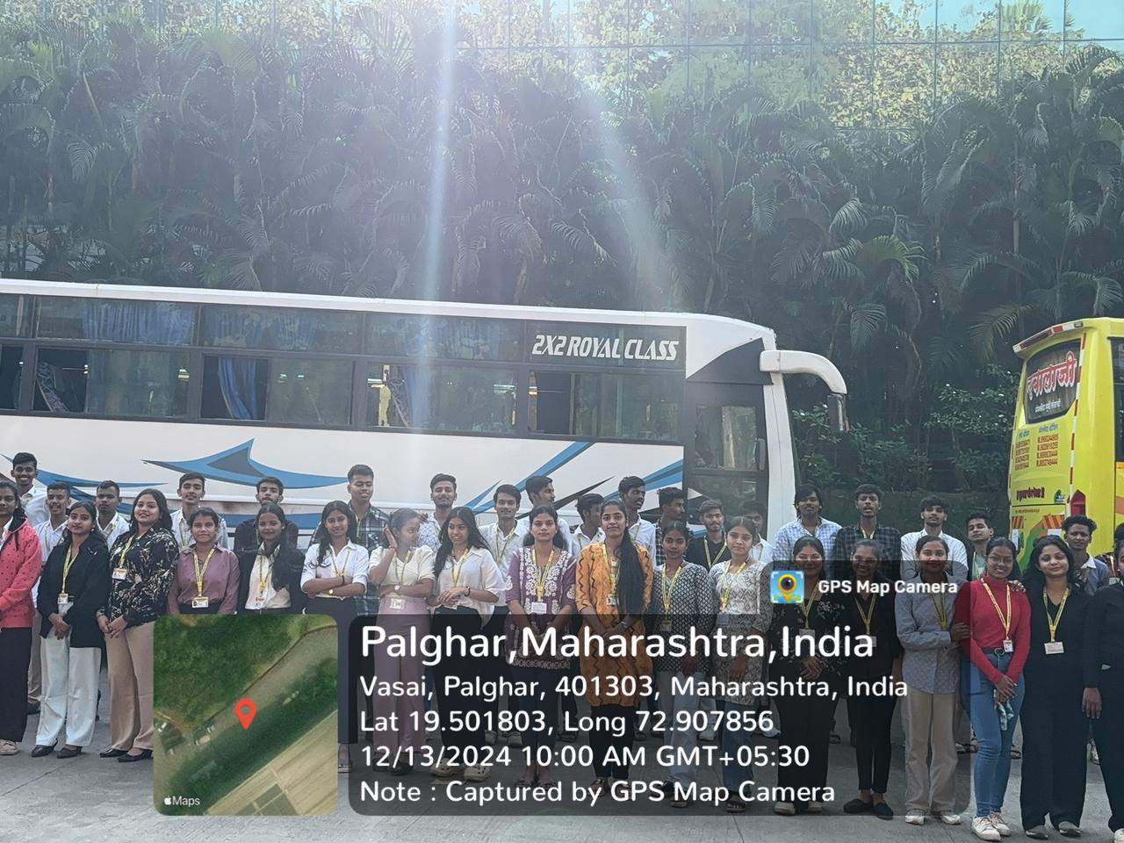
- F.Y.C.S. (A , B ) & F.Y.I.T.(B) total 89 students visited visited Navneet Prakashan Manufacturing Pvt Ltd. Navneet is a law abiding Corporate and has been doing business in the most ethical manner. It offers Educational Syllabus– based content in print and digital media, Scholastic Paper , Non paper Stationary products , General books and children’s book. .Total 154 students of first years visited Navneet. Overall visit helped students in understanding the technology and the equipment used as well as manufacturing Process of books.
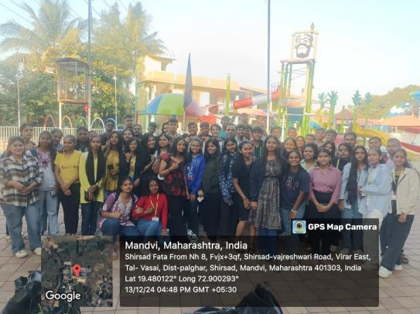

Students With Teachers group picture Students group picture at Navneet Publication

4. ShangrilaWater Filter Plant (11 January2025)
- T.Y.I.T. (A , B & C) and T.Y.C.S.(A & B) total 161 students visited Shangrila Water Filter Plant where students learnt about the process of Water Filtration, chlorine, UV-light and ozone treatments and knowledge about the coagulation process.
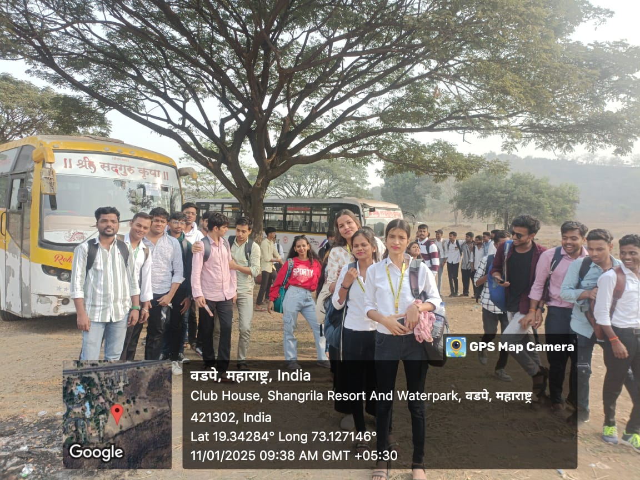
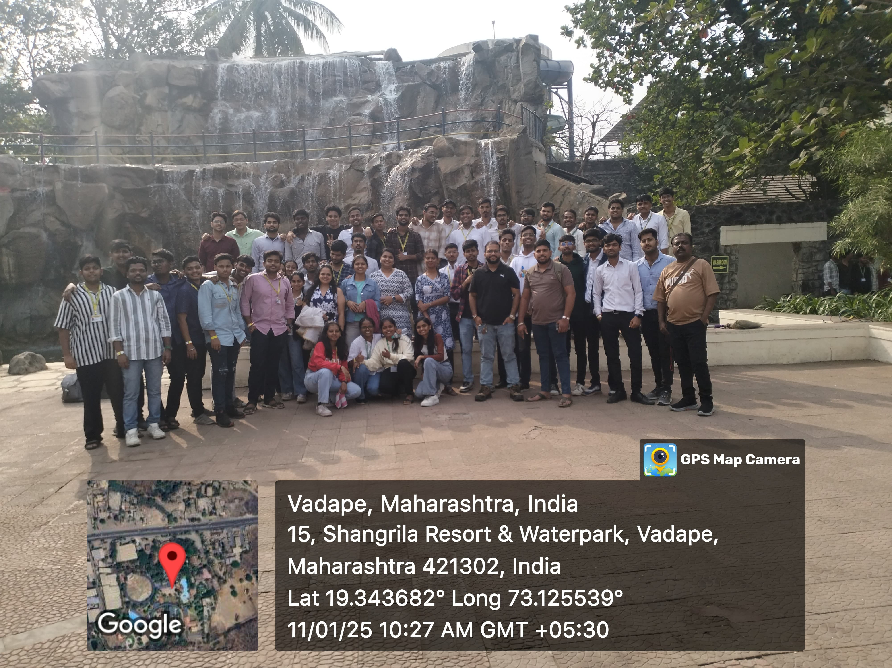
S

T Sudents with teacher Group Picture Students at Shangrila Water Filter Plant

