Water Kingdom, Water Filtration Plant, Gorai (4th December, 2024)
- S.Y.BSc.C.S. (A / B) Students visited Water Kingdom, Water Filtration Plant, Gorai where students learn’t about how 1000 liter of water is filter in water kingdom.
- Water Filters remove unwanted impurities from water such as sediment, taste and odour, hardness and bacteria to result in better quality water. From producing better-tasting drinking water to more specialist applications such as brewing coffee and making crystal clear ice, we offer a huge range of filters and cartridges to solve any number of water-related issues.
- Water is one of the most important substances on the planet, it covers 71% of the Earth’s surface and the human body can contain as much as 75% of the stuff. Water is vital to a huge number of applications including agriculture, science, medical, transportation, heating, recreation and food processing as well as washing and perhaps most important of all: drinking.
- 'Water Kingdom', is one of the largest Theme Water Parks in Asia, are located on 64 acres of land.
- They follow floating solar plant, fire fighting, filtration plant, vermiculture plant and STP plant.
- Total number of students participated in Industrial Visit were 71.

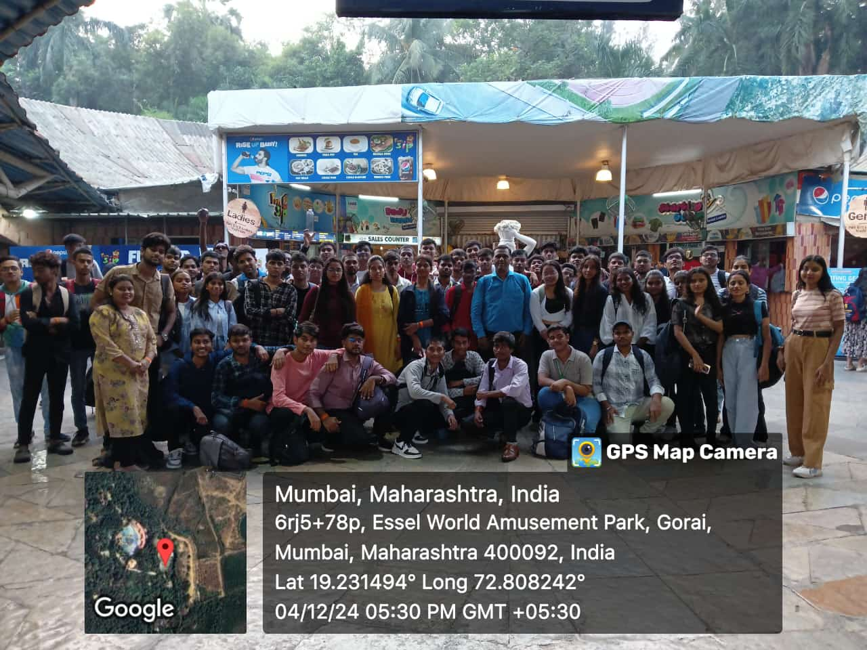
Students Group Picture at Water Kingdom, Water Filtration Plant, Gorai

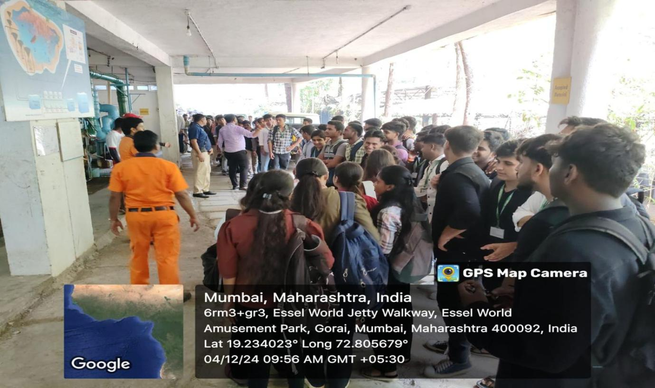

Students gaining knowledge regarding, Water Filtration Plant, Gorai

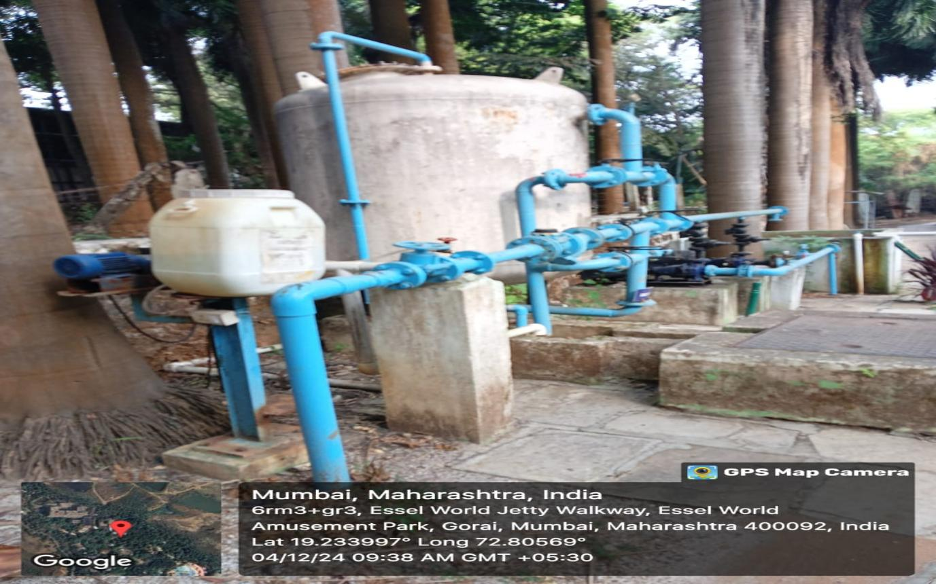

Water Kingdom, Water Filtration Plant, Gorai

