Navneet Prakashan Pvt Ltd at Virar on (13th December, 2024)
- F.Y.B.Sc.C.S. (A / B) Students visited Navneet Prakashan Manufacturing Pvt Ltd. where students learnt about the manufacturing process of books in general.
- Navneet Education Limited is a purpose-driven organization, doing what it takes to move the needle and promulgate knowledge. The Gala Group established the brand in 1959 and since then they have been the major force in the dissemination of knowledge to the little learners of India. It has been India’s most loved educational content provider.
- Navneet is a law abiding Corporate and has been doing business in the most ethical manner. It offers Educational Syllabus– based content in print and digital media, Scholastic Paper and Non paper Stationary products and general books and children’s book.
- Navneet also manufactures stationery, general books and children’s books in multiple Indian and foreign languages making it a dominant player in the field of publishing. Navneet will focus on serving the regional teaching and learning needs with supplemental digital solutions.
- Vikas, Gala, Grafalco, YOUVA, TOPClass and TOPScorer are prominent brands owned by Navneet that are much loved by students and teachers alike.
- Total number of students participated in Industrial Visit were 80.

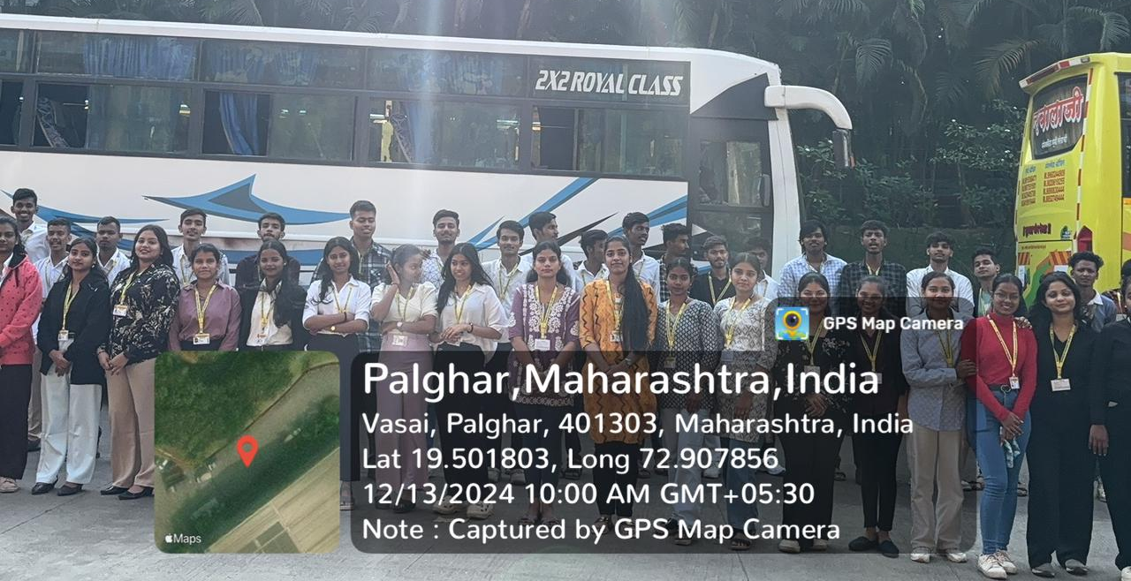
Students Group Picture at Navneet Prakashan Pvt Ltd at Virar

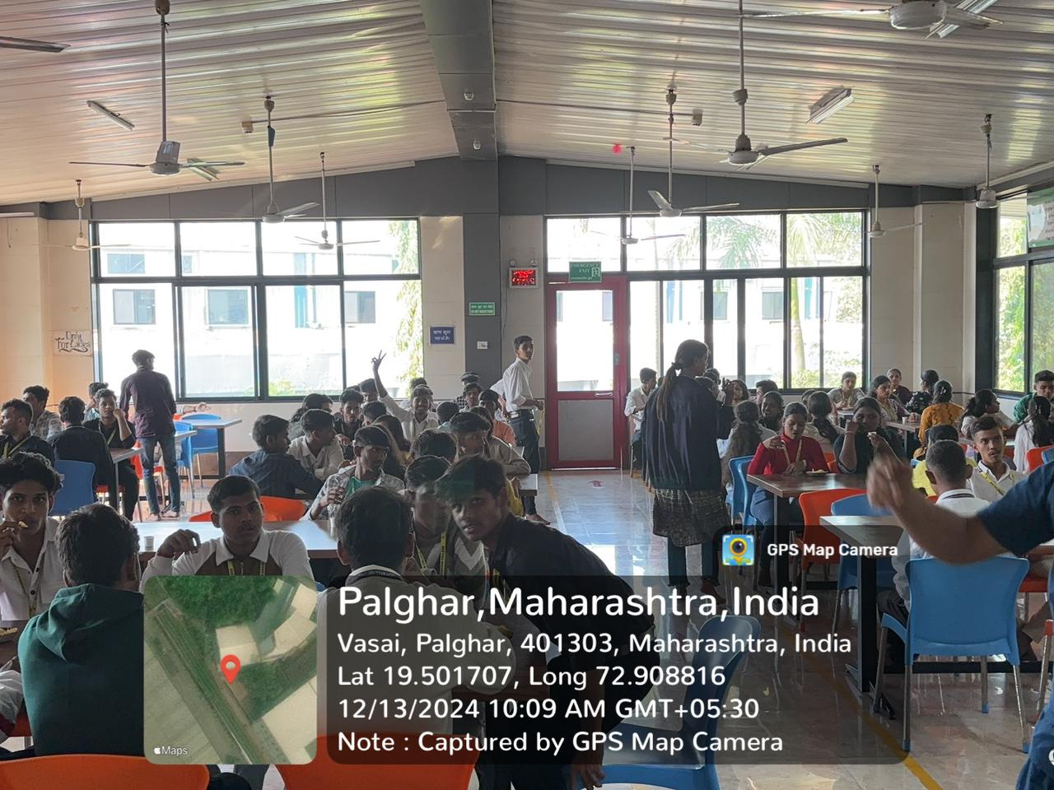
Students having snacks at Navneet Prakashan Pvt Ltd

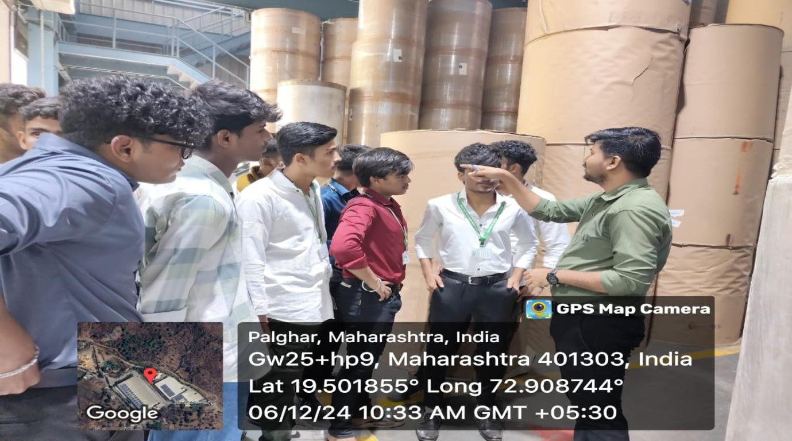
Students Gaining Knowledge regarding Publication house from Expert

