Shangrila Water Filtration Plant (11th January,2025)

- T.Y.BSc.I.T (A, B & C) Students visited the Shangrila Water Filtration Plant, where students learned about how 1000 liters of water is filtered efficiently at the facility.
- Water Filters remove unwanted impurities from water such as sediment, taste and odor, hardness, and bacteria to produce better-quality water. From producing better-tasting drinking water to more specialized applications like brewing coffee and making crystal-clear ice, the plant offers a wide range of solutions for numerous water-related needs.
- Water is one of the most important substances on the planet, covering 71% of the Earth's surface, with the human body containing as much as 75% of it. Water is vital for various applications, including agriculture, science, medical use, transportation, heating, recreation, food processing, washing, and, most importantly, drinking.
- Shangrila Water Filtration Plant is a key facility that demonstrates the importance of advanced water filtration technology to meet the growing demand for clean and safe water across diverse applications.
- The plant integrates sustainability practices, including the use of floating solar plants, firefighting systems, filtration technologies, vermiculture processes, and STP (Sewage Treatment Plant) facilities.
- Total number of students who participated in the Industrial Visit: 84.

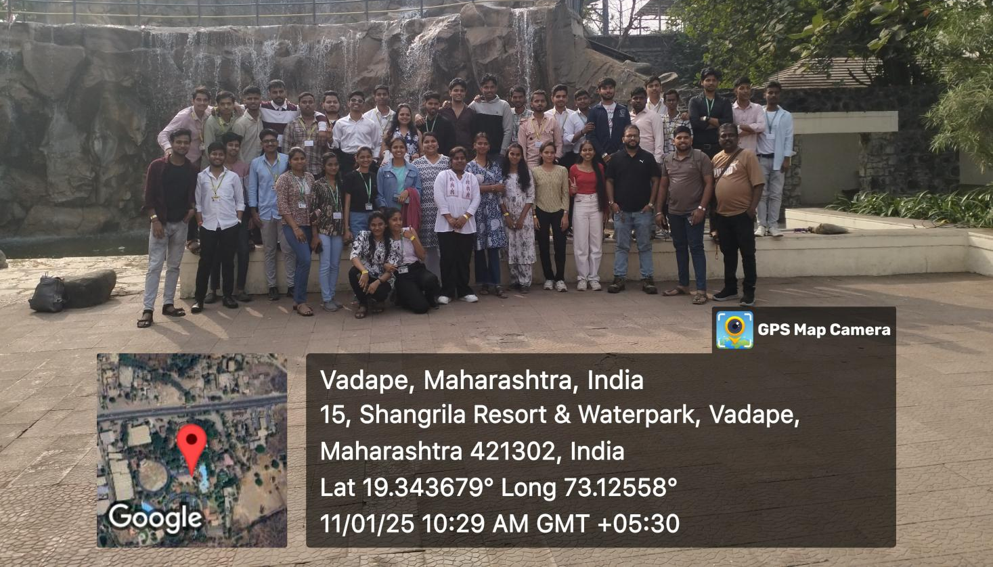

Shangrila Water Filtration Plant

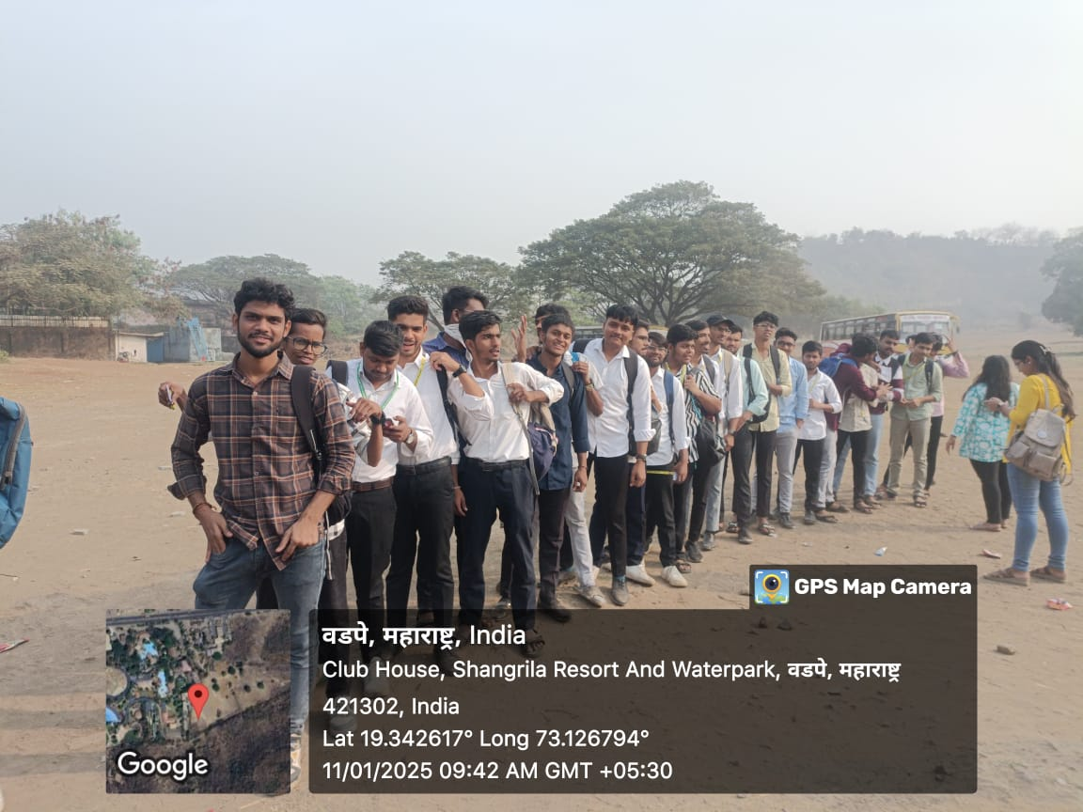

Shangrila Water Filtration Plant

