Report on Orientation Program
For Placement Opportunities(CS)

5th August 2024

An orientation program had been organized by the placement cell of Shankar Narayan College in collaboration with Anudip Foundation on 5th August 2024, Monday. The session lasted for an hour and half, starting from 11:00 am. The purpose of the session was to provide awareness about career opportunities.

Keynote speaker for the event was Ms. Rupali Pawar who is currently working with Anudip Foundation for the last 3 years as a Senior Soft skills and IT trainer. She has an overall experience of 20+ years in IT training industry, personality development and grooming.She had done certification in Microsoft and Red Hat Linux.

Total 81students of T.Y.B.Sc.CS attended the seminar and benefited from the information provided by the resource person. Agenda covered were number of students placed previous year by the foundation ,the courses offered by the foundation and benefits of these were informed to the present students. Previous student placement and their success stories were shared. Lastly once all placement opportunities were discussed, the forum was opened for question and answers.

Overall the session was interactive and students came across various opportunities.Department of Information Technology and Computer Science worked and cooperated wholeheartedly.

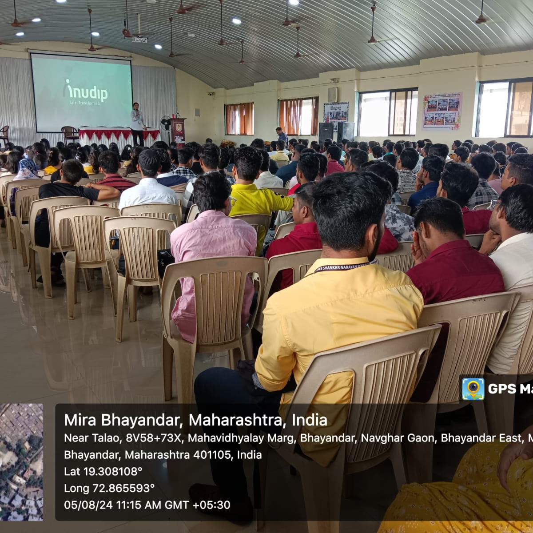

Speakers interaction with student

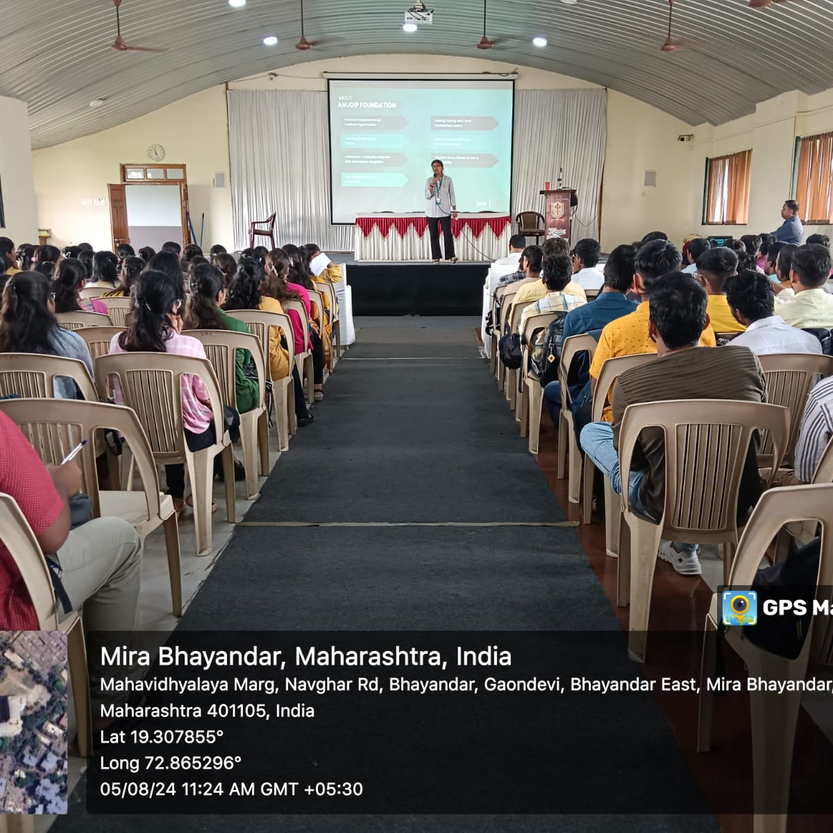
Ms. Rupali Pawar conducting the session.

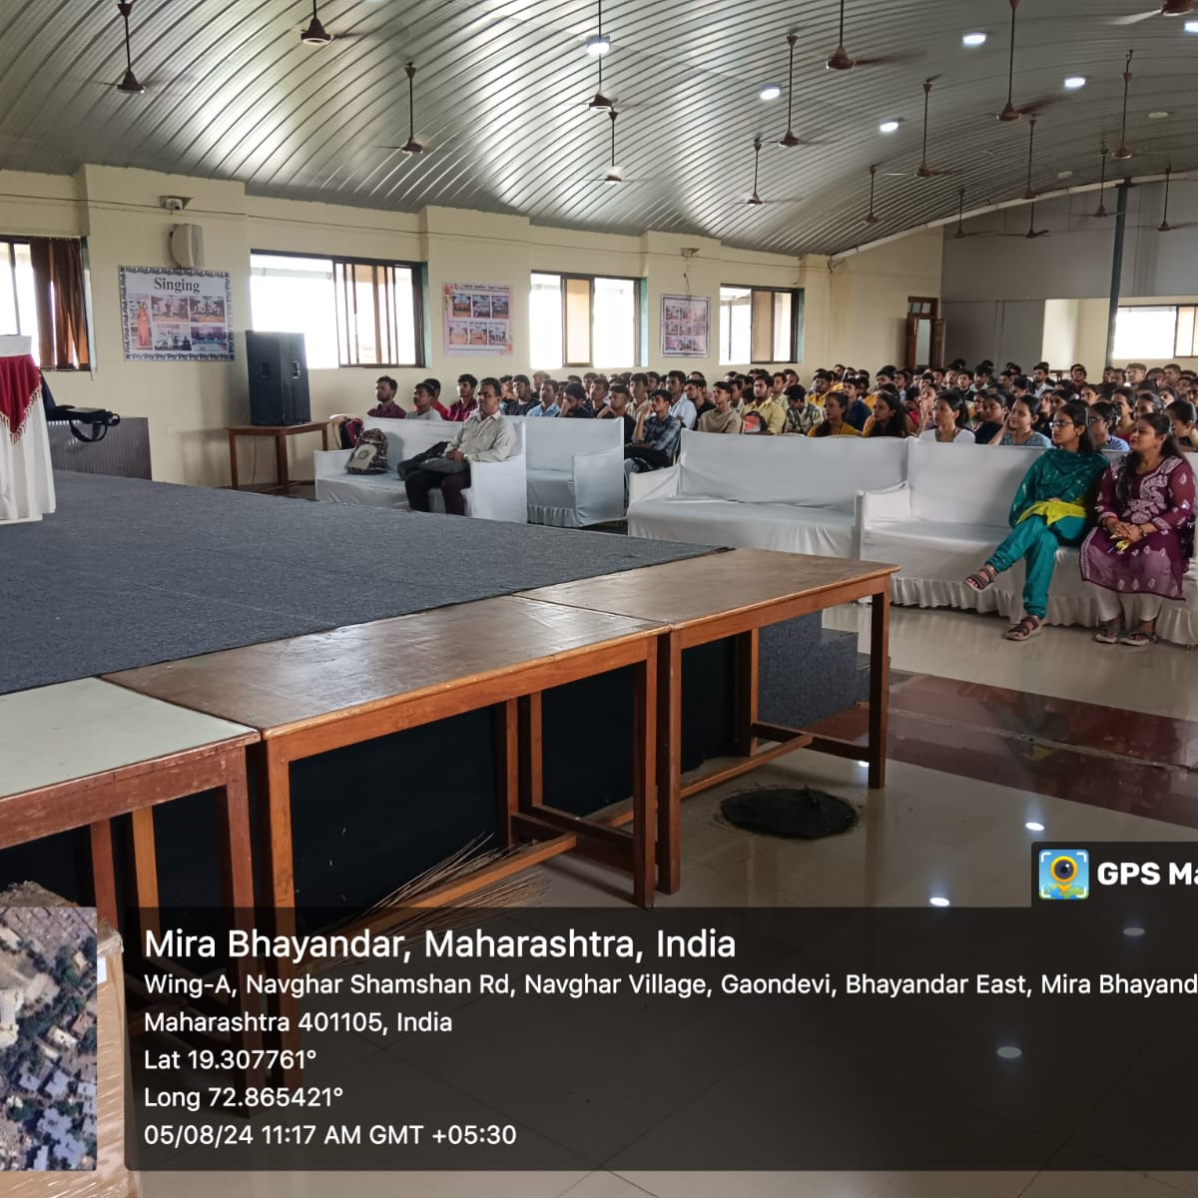

Students attending the session .

