Department of B.Sc.IT/CS organized an Industrial Visit to Water Kingdom (Water Filtration Plant) on Wednesday , 26th November 2025 for S.Y.B.Sc.I.T. and S.Y.B.Sc.C.S. students.

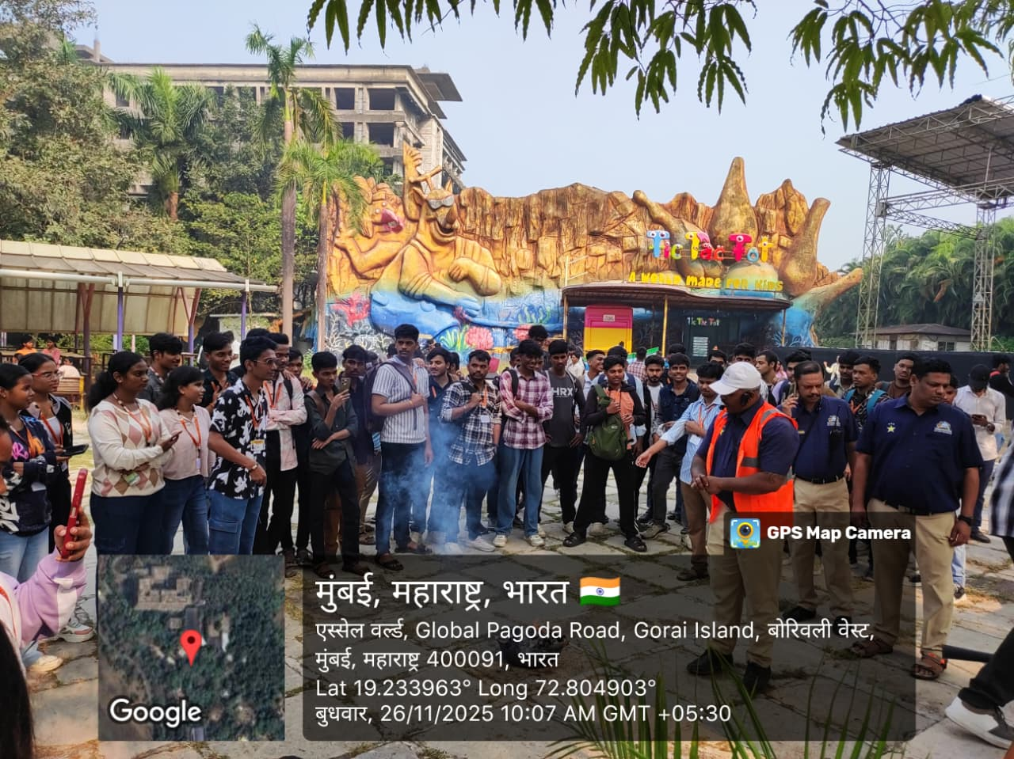
Water Kingdom S.Y.B.Sc.I.T./S.Y.B.Sc.C.S.

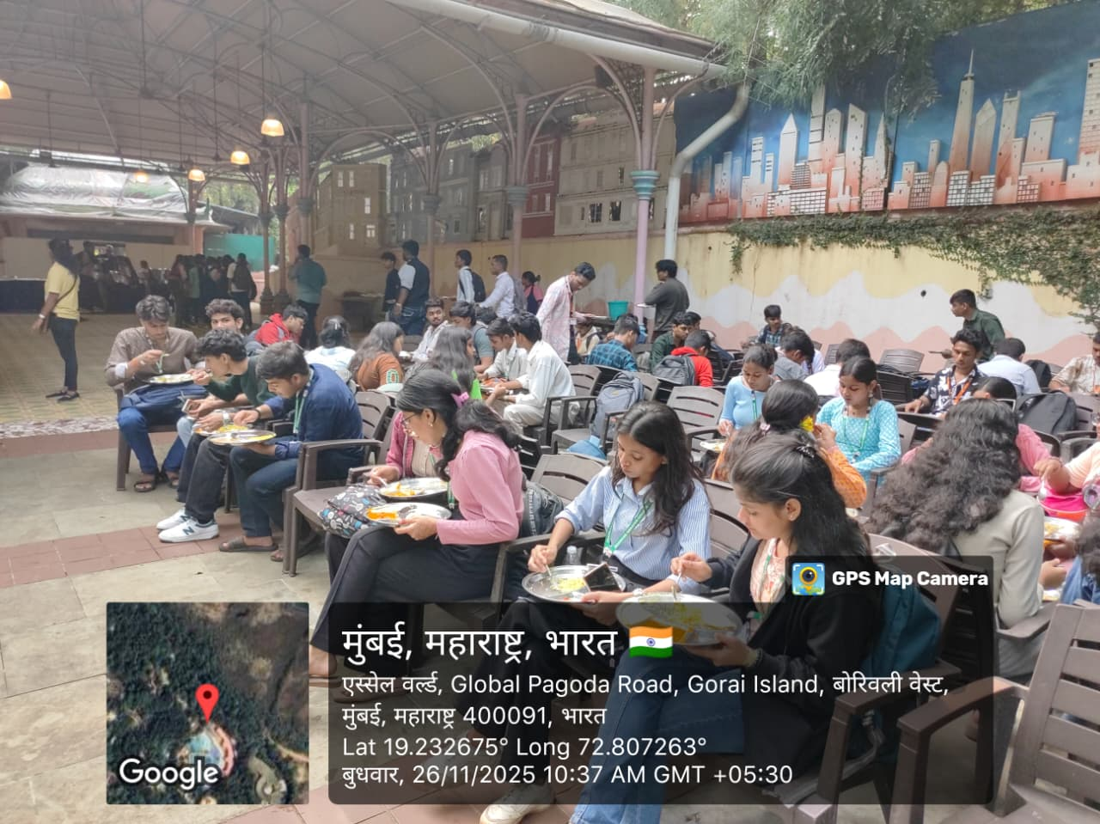
Water Kingdom S.Y.B.Sc.I.T./S.Y.B.Sc.C.S.
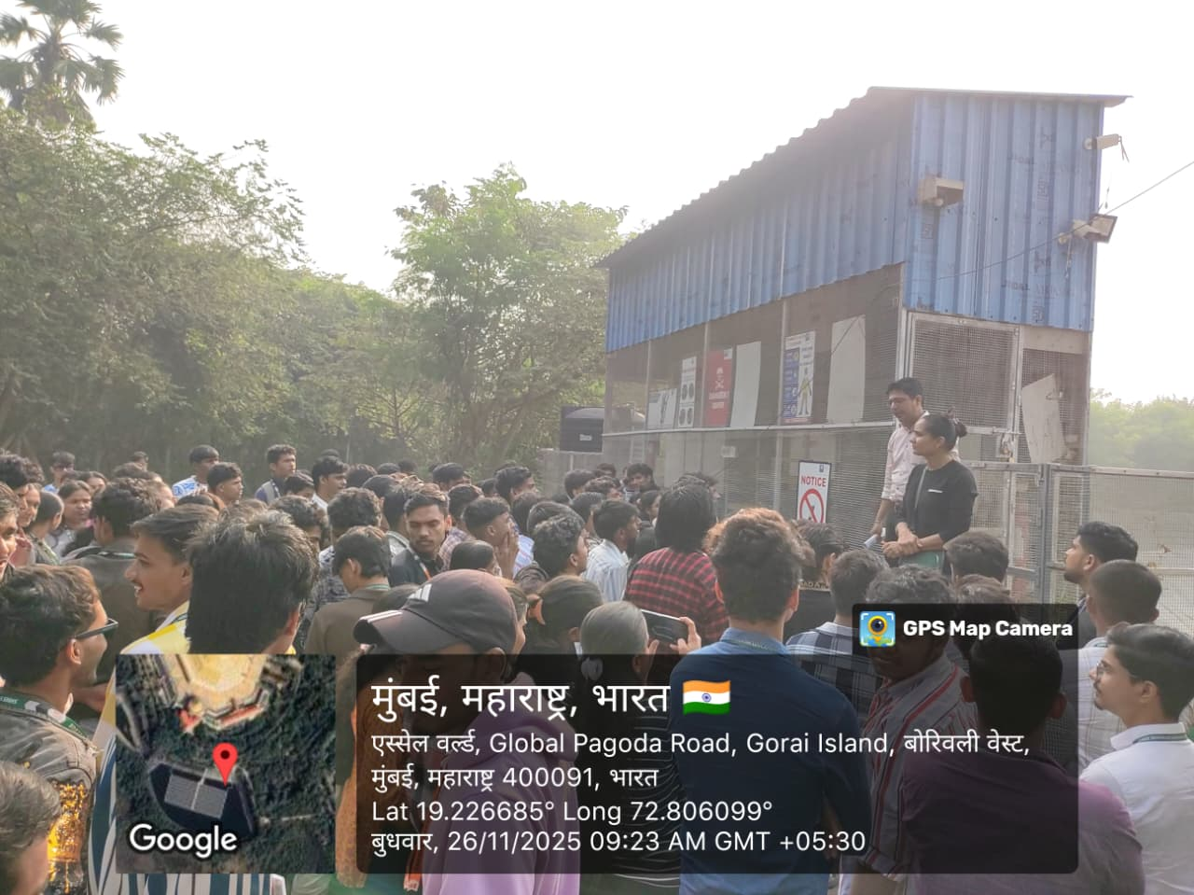
Water Kingdom S.Y.B.Sc.I.T./S.Y.B.Sc.C.S.

