Department of B.Sc.IT/CS organized an Industrial Visit to Shangri-La(Water Filtration Plant) on Friday, 21st November 2025 for T.Y.B.Sc.I.T. and T.Y.B.Sc.C.S. students.
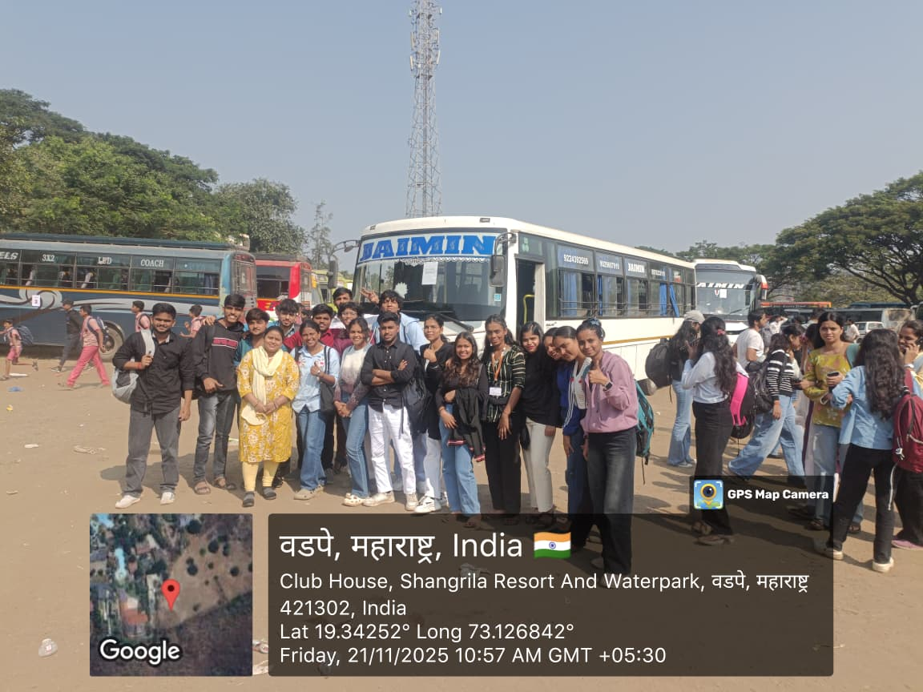
Shangrila Water Filter Plant T.Y.B.Sc.I.T. & T.Y.B.Sc. C.S.
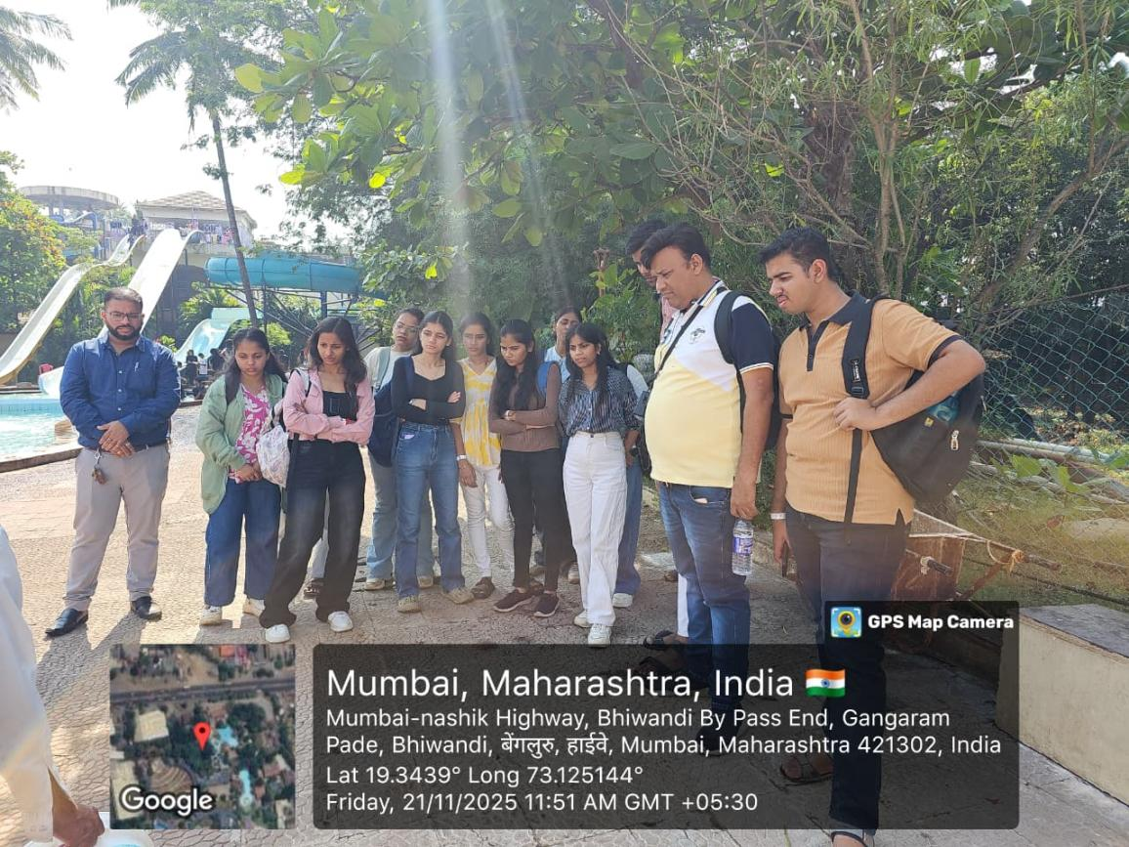
Shangrila Water Filter Plant T.Y.B.Sc.I.T. & T.Y.B.Sc. C.S.

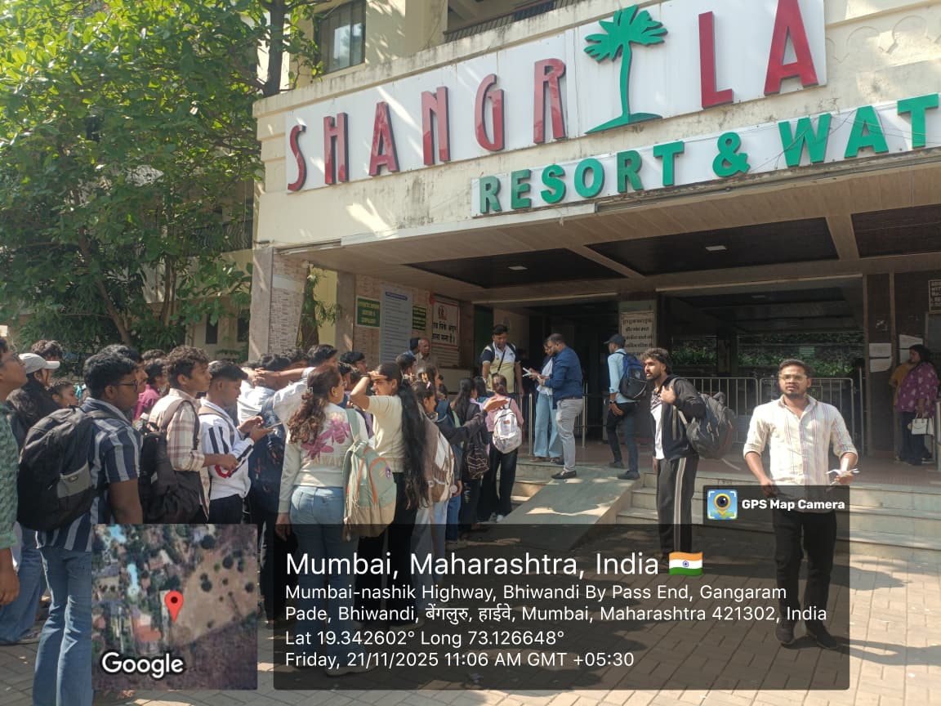
Shangrila Water Filter Plant T.Y.B.Sc.I.T. & T.Y.B.Sc. C.S.

