Department of B.Sc.IT/CS organized an orientation on "TNS Training and Placement Orientation Program" on Saturday, 26th July 2025 for T.Y.B.Sc.I.T. and T.Y.B.Sc.C.S. students.

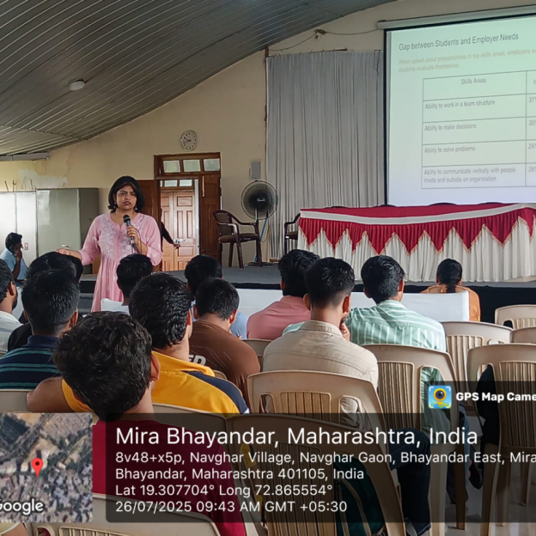

Speaker’s interaction with T.Y.B.Sc.I.T. and T.Y.B.Sc.C.S. student

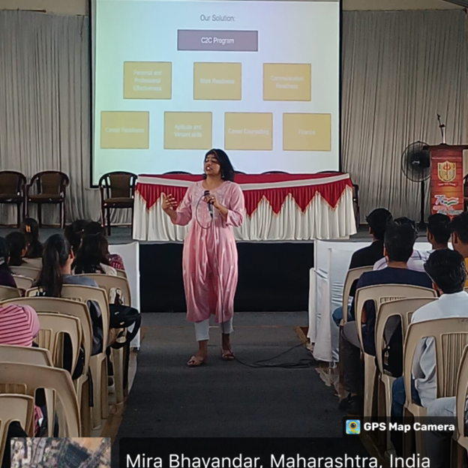
Ms. Sowmya Nair conducting the session.

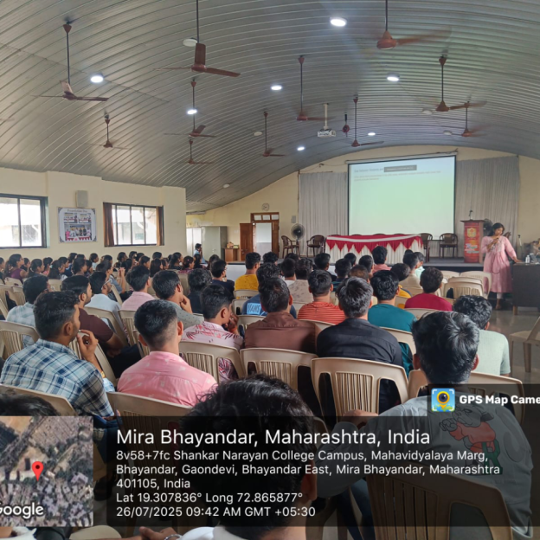

T.Y.B.Sc.I.T. and T.Y.B.Sc.C.S. Students attending the session.

