Department of B.Sc.IT/CS organized an Quastech orientation on "Innovative Programming Skills for Digital Tansformation Seminar" on Monday, 24th November 2025 for F.Y.B.Sc.I.T. and F.Y.B.Sc.C.S. students.

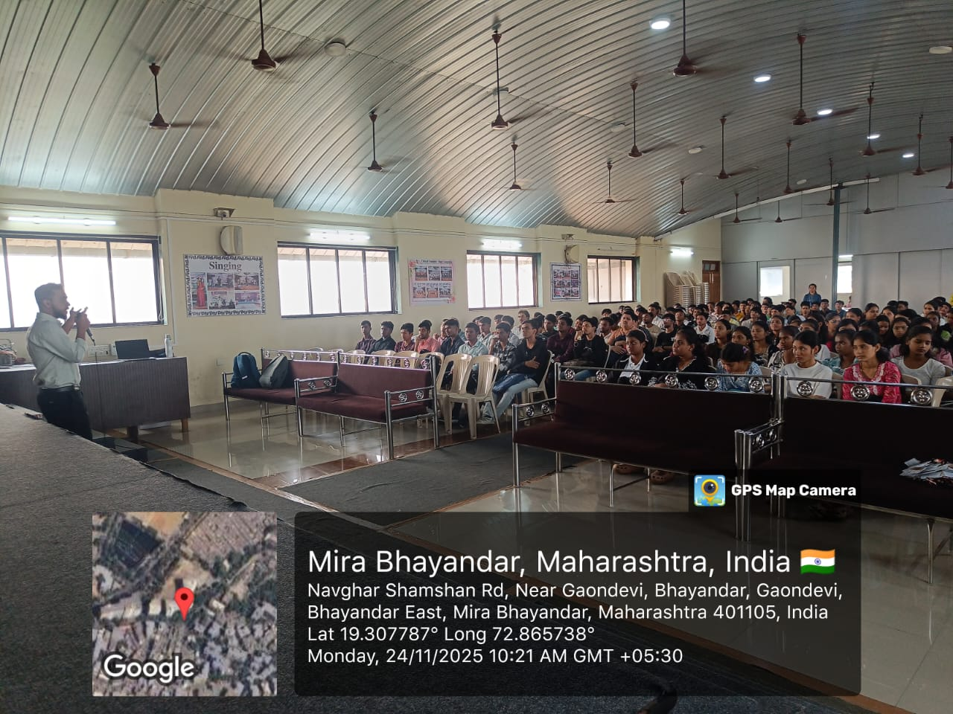

Speaker’s interaction with F.Y.B.Sc.I.T. and F.Y.B.Sc.C.S. students

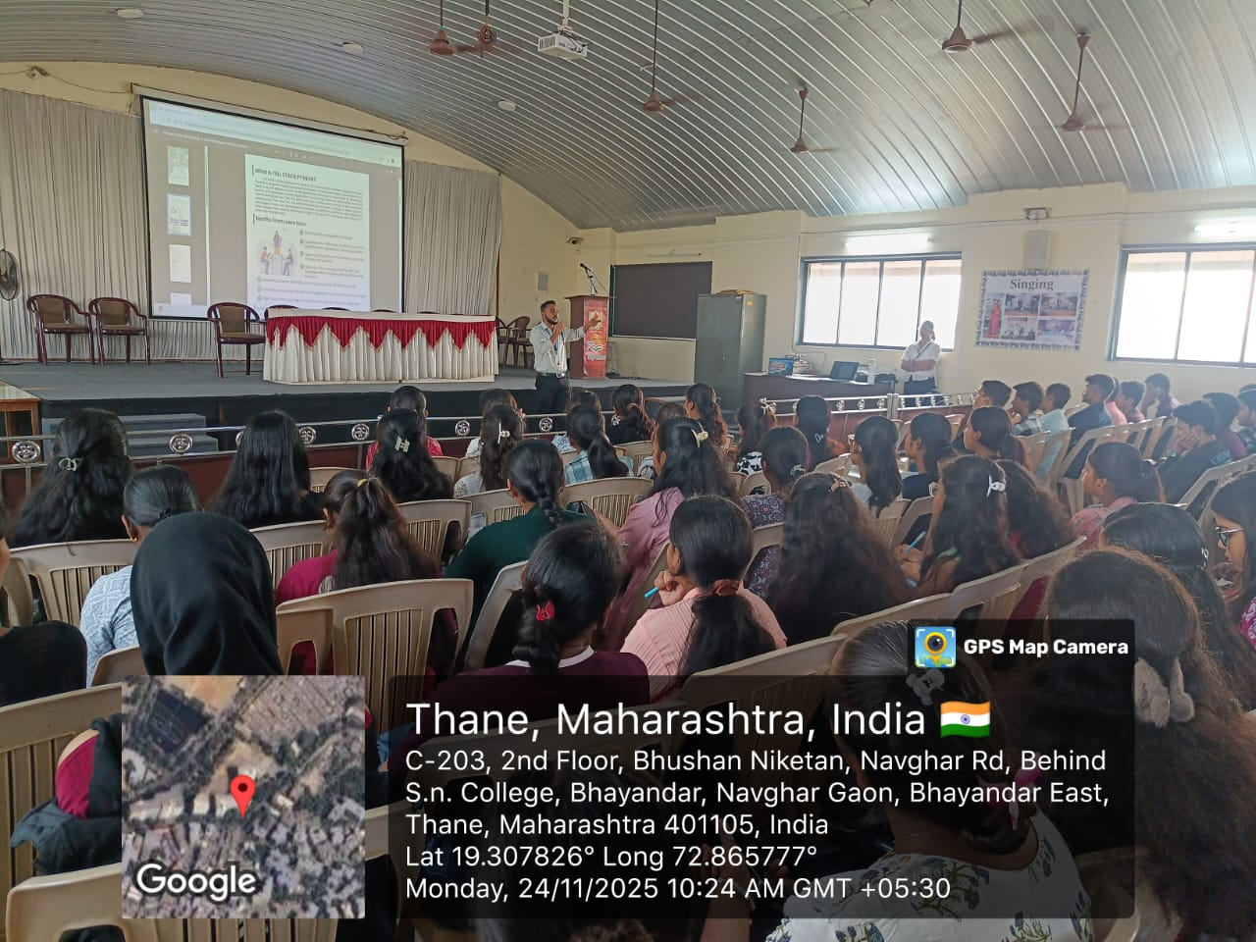

Mr. Vivek Sharma conducting the session.

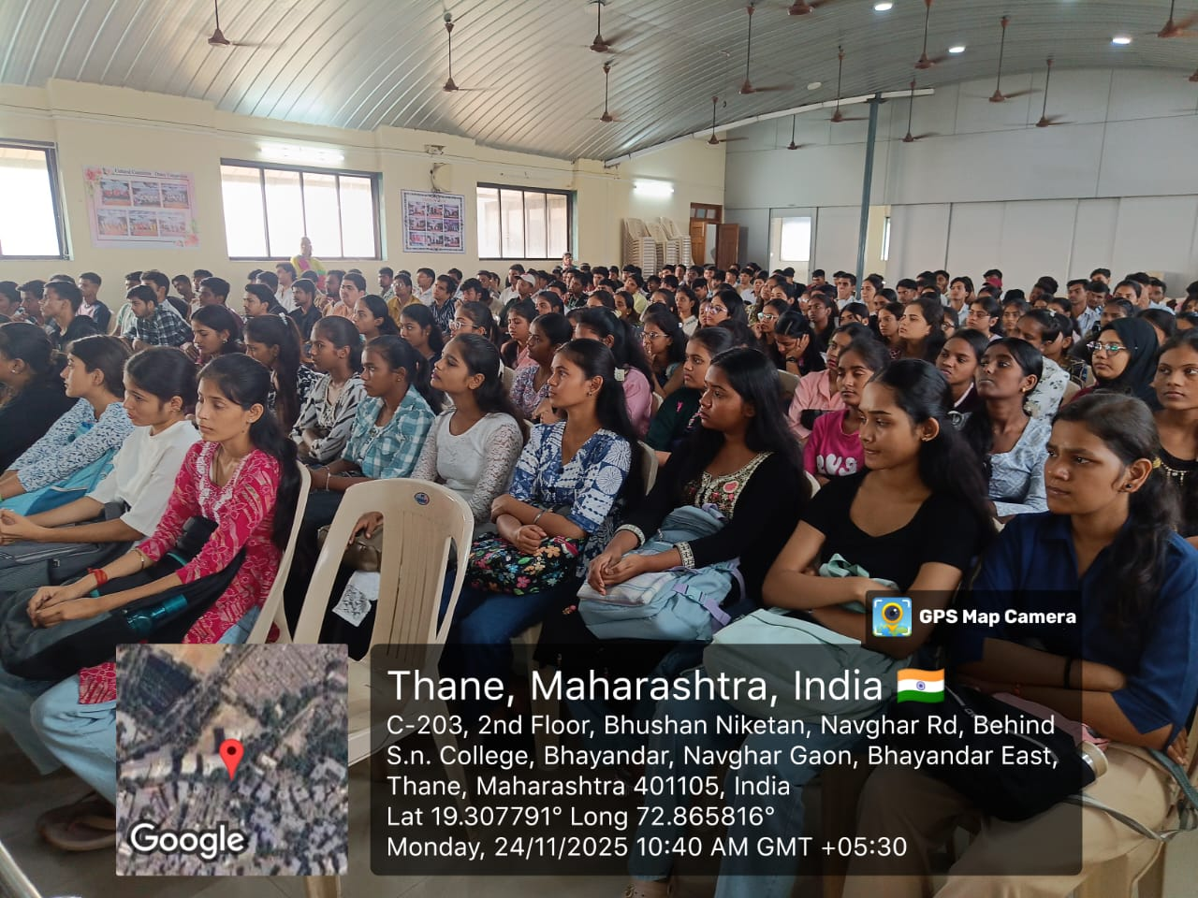

F.Y.B.Sc.I.T. and F.Y.B.Sc.C.S. Students attending the session.

