7.2 Best Practice I
- Title of the Practice:
Establishment of Language Laboratory in the College (Certificate Course in English Pronunciation)

- Objective of the practice:
Allow students to learn English Pronunciation effectively

- The Context :
Shankar Narayan College of Arts and Commerce has optimum students from lower middle class and migrants which do not have formal exposure to English Language and Pronunciation. Hence the Laboratory and Certificate Course.

- The Process:
The Department of English under the banner of English Language Laboratory started a Certificate Course in English Pronunciation that teaches the basics of English Phonetics. A relevant software from the IT Company for the same was purchased and installed. The syllabus for the said course was developed by the Department of English. Batches of students were made accordingly and the content of the course was taught in the span of 90 days.

- Evidence of Success:
28 students completed the course successfully

- Problems encountered and resources required
The college charges minimal fees of a thousand rupees which also is financially unbearable for many students.

Best Practice II
- Title of the Practice:
Social Extension Activities Outside the Campus

- Objective of the practice:
Assisting students to learn their social responsibilities and commitments through a range of activities designed by the various committees of the college

- The Context
he regular curriculum penetrates academic insights among the students especially the students from Commerce pushing back the the sense of social responsibilities. The parralel exposure to academic excellence and social commitment has been sensed by the college. Hence a battery of events were organized by various committes like NSS, NCC, Inner Will Club, WDC and the like.

- The Process
NSS, NCC, Inner Will Club, WDC, Gandhian Studies Centre and the like committees organized many events and rallies outside the campus like Swachhata Rally, Traffic Control during Ganpati Immersion and a week long Pulse Polio Drive by NSS Unit of the College, Visits to Old Age Homes and Orphanages, Swachha Bharat Abhiyan Week in October. These activities made students participate for the social cause.

- Evidence of Success:
Hundreds and Hundreds of students participated enthusiastically in the said out of campus events
- Problems encountered and resources required
The college wishes to convert this number of hundreds to thousands as far as the participation of the students is concerned

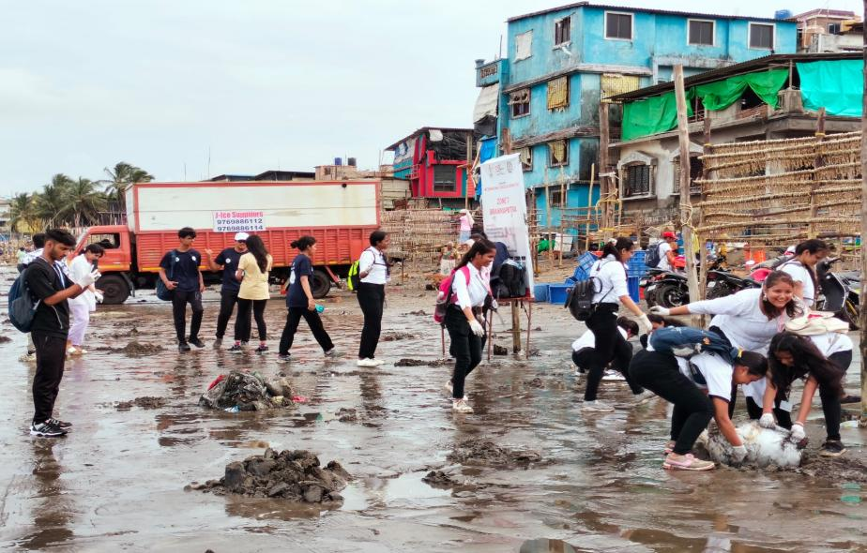
7.2. Social Extension Activities Outside the Campus
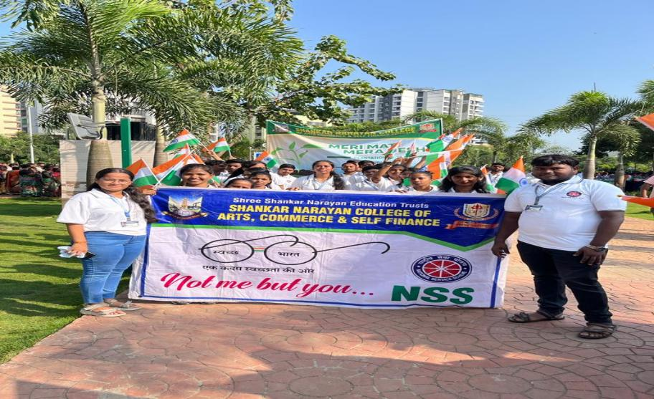
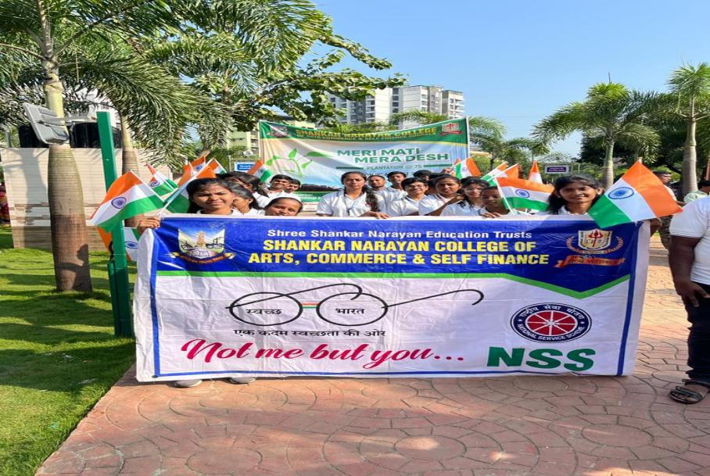
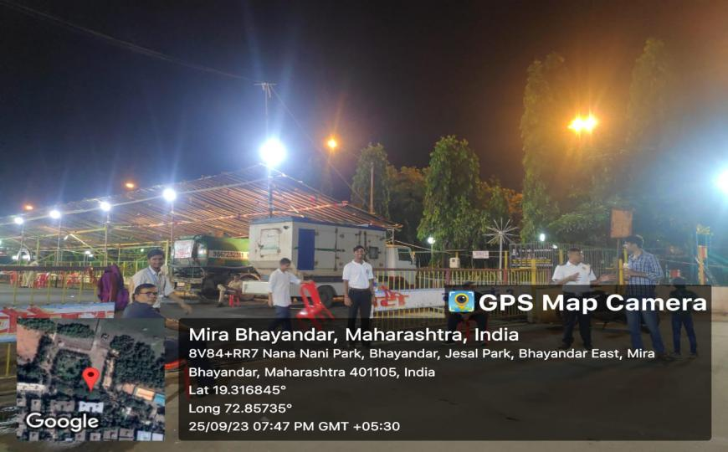
Swachhata Rally at Kaustubh Rane Smarak Ramdev Park Bhayander (East)
Beach Cleaning Campaign at Uttan beach Bhayander (West)
Swachhata Rally at Kaustubh Rane Smarak Ramdev Park Bhayander (East)

Ganpati Visarjan Event Jaisal Park Chaupati

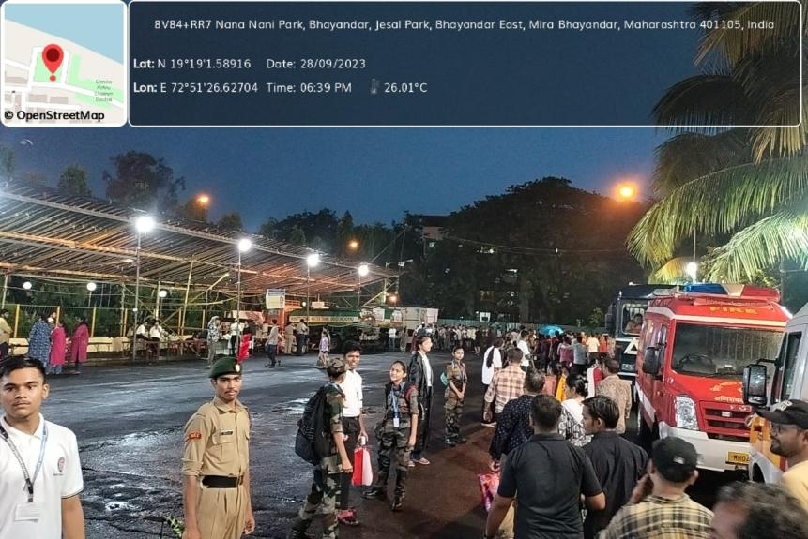
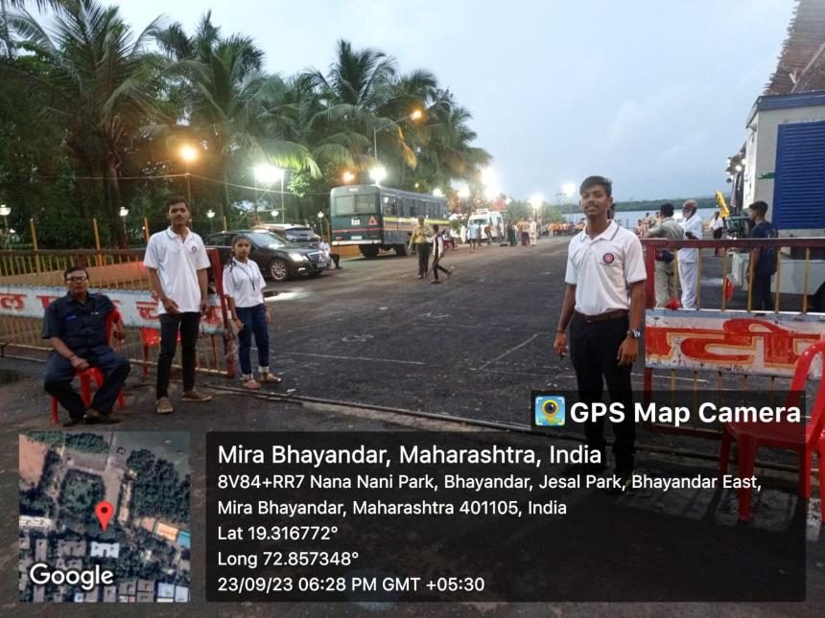
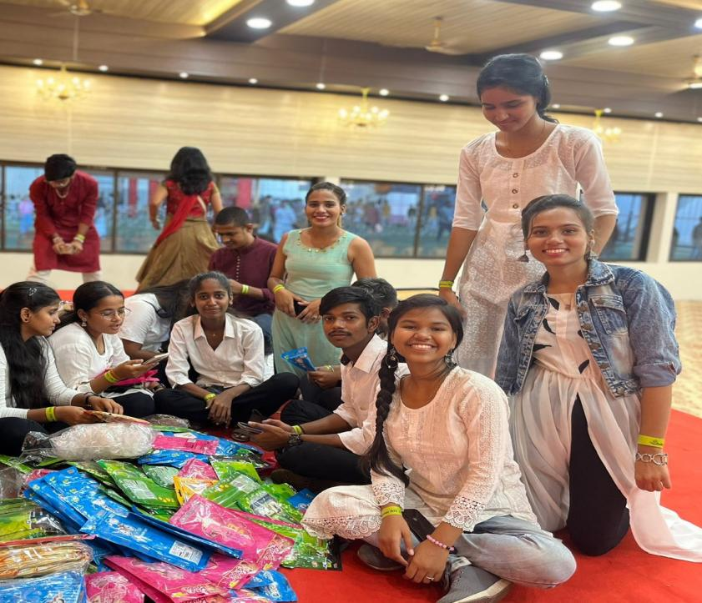
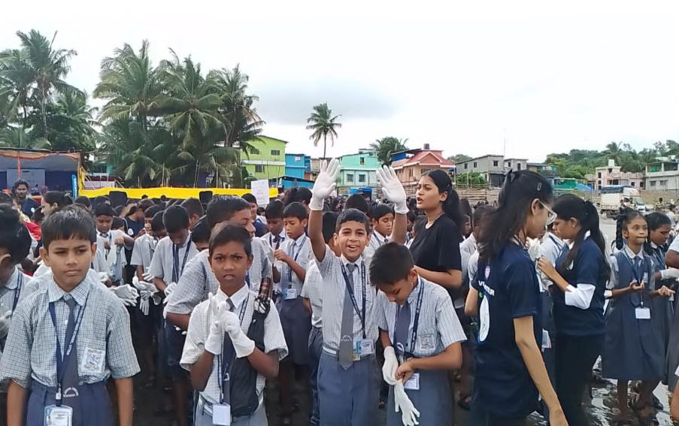
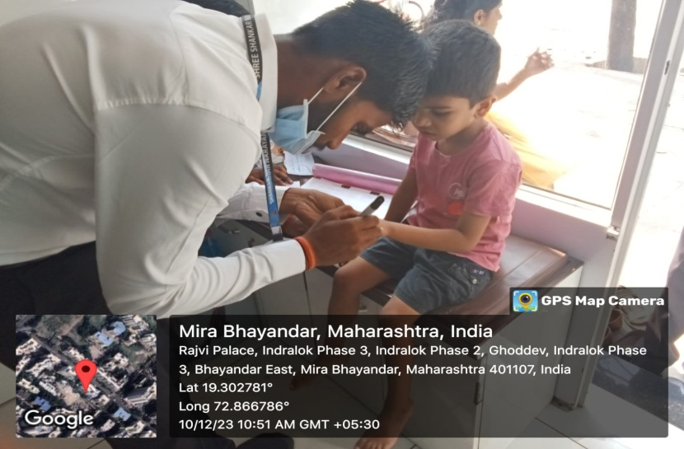
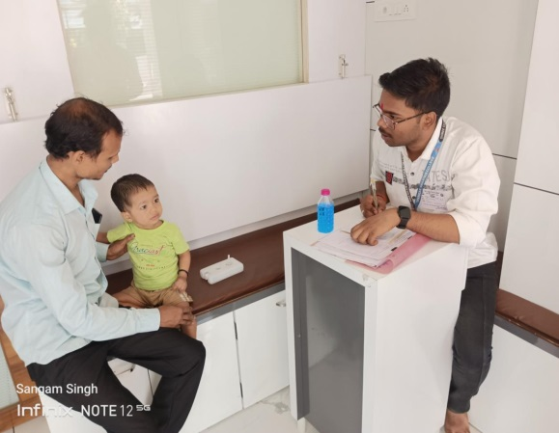
Subhmahasav Event for Special Children Beach Clean up event at Uttan Bhayander (West)

Ganpati Visarjan Duty for traffic control at jaisal Park Bhayander (East)
Ganpati Visarjan Duty for traffic control at jaisal Park Bhayander (East)

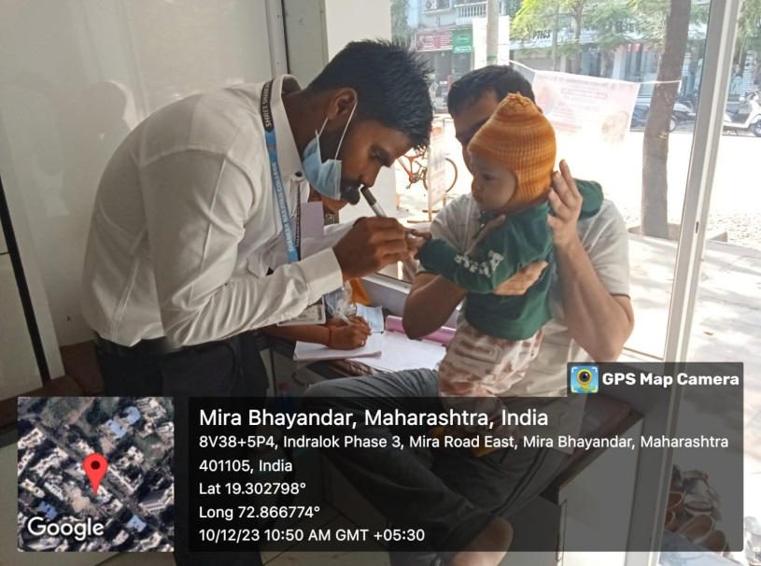
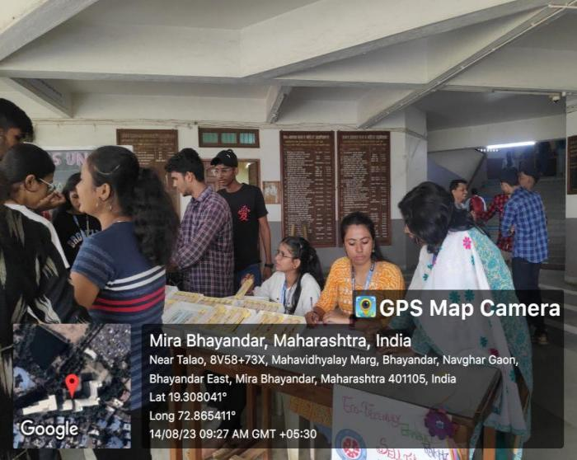
Rakhi selling for tribal women
Pulse polio drive with MBMC
Pulse Polio Drive with MBMC

Pulse Polio Drive with MBMC

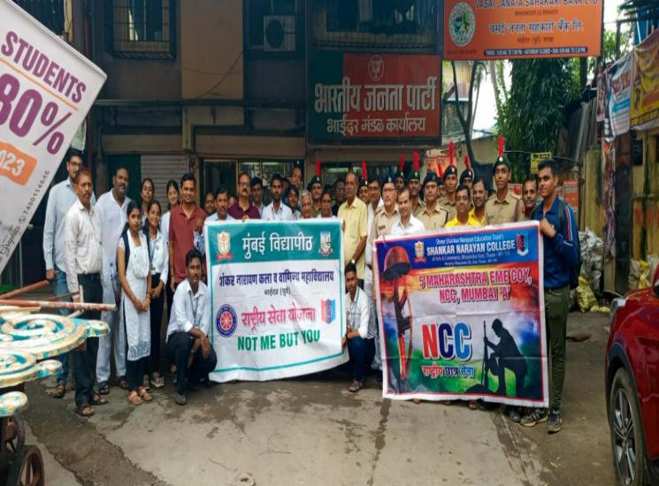
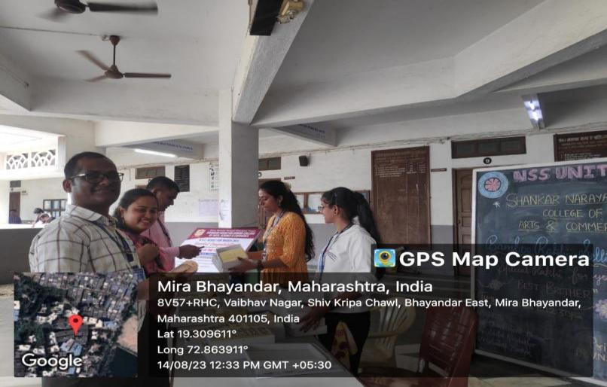
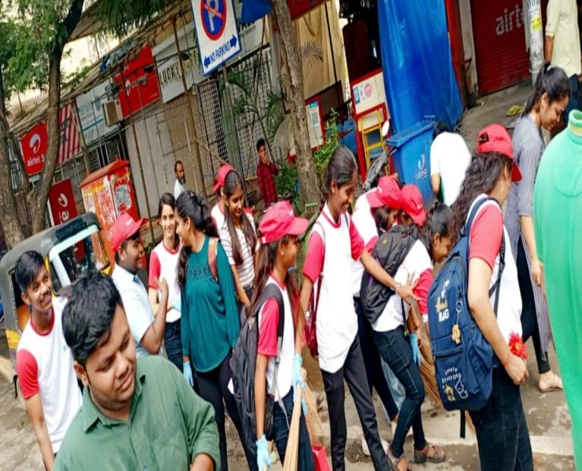
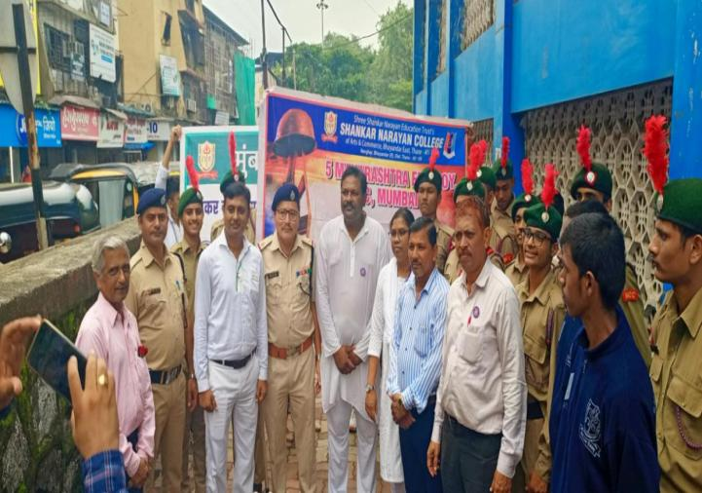
Bamboo Rakhi Selling for tribal women in the campus NSS Rally
Swacchata Rally at Bhyandar Railway Station
Swacchata rally at Bhayandar Railway Station

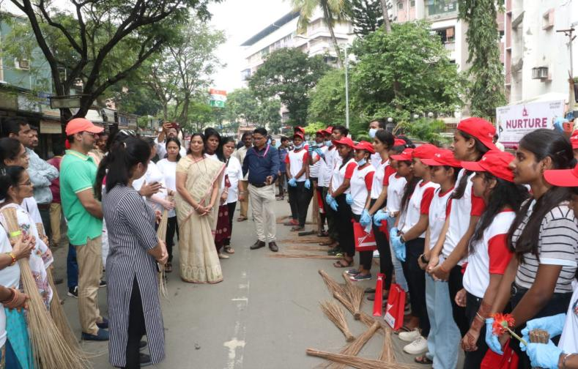

Swacchata drive by Wockhardt Hospital Mira Road

English Language Laboratory
Certificate Course in English Pronunciation
(Basic of English Phonetics)
List of Enrolled Students

Sr. No. | Name of the Student
1. | Mishra Roopali Shailendra
2. | Kumhar Sonam Ramavtar
3. | Aakanksha Ramesh Yadav
4. | Bipin Ganesh Kamat
5. | Kashish Parasnath Singh
6. | Yadav Rinku Dalsingar
7. | Rupali Anand Bagul
8. | Pratiksha Shashikant Maurya
9. | Snehal Pradeep Vishwakarma
10. | Saksham Vijay Pandey
11. | Sakshi Sanjay Singh
12. | Chandani Thakur
13. | Anshika Rajnarayan Tripathi
14. | Jagruti Santosh Salgaonkar
15. | Mishra Ritika Rambhavan
16. | Anjori Rajesh Ambasht
17. | Tiwari Abhinav Rameshwar
18. | Aarti Barnawal
19. | Bhavik Bhushan Patil
20. | Ashlesha Palekar
21. | Parmar Arti Shankarram
22. | Mali Mamta Nemaram
23. | Swami Jhamka Pratap
24. | Mishra Shivani Sukhendra
25. | Jhanvi Jayantilal Bhati
26. | Siddhi Amol Advade
27. | Chaurasiya Ganes Dilip
28. | Khan Sadiq Md. Zayed

Glimpses of Laboratory, Certificates and Distribution of Certificates
