7.1.1 Gender Equity
Annual Gender Sensitisation Plan
Being a Co-Educational institution, the college believes in gender equity addressing the academic needs of both genders through a range of activities. Women Development Cell C organized various activities based on the theme of Women Empowerment and Sensitisation every year with the intention of celebrating gender equity.
Safety and Security of Women
Programmes are organised to create awareness for the safety and security of girl students in the campus. The campus has hundreds of Close Circuit Television Cameras with almost zero blind spots and the real time monitoring of the CCTVs is also there.
Common Rooms
The college has boys and girls common rooms on the alternative floors. Even the washrooms for girls are spacious and well aeriated. Washrooms have sanitary napkin dispensers also.
The college has conducted seminars, programs, workshops, guidance lectures and the like on health, cyber security, women empowerment, Nutrition, Women safety, Government Scheme for women and the like. The programs like Hemoglobin Check-up Camp, Workshop on the various government schemes, Lectures on Gender Sensitization, lectures health and hygiene awareness of women, film screenings, sessions on stress management, AIDS awareness programs and encouragement programs for female students to participate in Sports events through sports week have individual and a professional too in the years to come.

The meeting of the WDC Cell members had been called on 11th July 2023 at 11.30 am , to discuss how to achieve the purpose of the Cell .All the members were given suggestions for organizing the different activities for fulfilling the purpose of the Cell. Accordingly plan has chalk out to conduct different activities.
1 .Awareness Campaign: On 21st and 22nd July 2023 Awareness about the functioning of Women Development Cell has conducted by sending the notices in all the classes as well as by directly approaching the students and explained them the aim and objective of the cell in our college for newly admitted students.
2. Workshop on Safety and Security: On 9th August 2023, the workshop was organized on safety and security under Mahila Jana Jagruti Abhiyaan, around 105 students were participated in it.
The objective of this workshop was achieved by giving them instructions about how to take care of health and hygiene of any women.
3. Seminar on personality development and menstrual hygiene:
On 9th Aug.2023 by Proctor and Gamble. Seminar was conducted on personality development and menstrual hygiene By considering Importance of Todays women’s Health issues. Around 460 girls participants were present. The participants were aware with how to Develop personality with the support of mind and physic. And a pack of sanitary napkins Were distributed.
4.Training Programme:
The college has signed MOU with Bharatiya Jain Sanghatana ( BJS) under the project of “Smart Girl” for the age group of 14 to 23. The training programme has conducted for college girls with the intensions to change their personality and make them competent to face the challenges in today’s world. it was conducted on 4th and 5th October 2023. Tranier was Mrs Urmi Jalawat,around 86 students participated in this programme and get benefited.
5.Parents Counseling Programme:
the women health awareness online workshop was organized specially for parents. On 21st October 2023 at 3 pm. Resource Person Was Dr Rajshree Bhasale.The parents get benefited as it was completely advisable to all common women’s participated in it.
6.Poster Exhibition:
On 9th March Poster Exhibition on the occasion of world women’s day with the theme gender equality was organized. the students used their creative mind to express their ideas on paper in a poster form. And it was displayed for viewers for Two days. it was appreciated by all the audience.

ICC & Women Development Cell

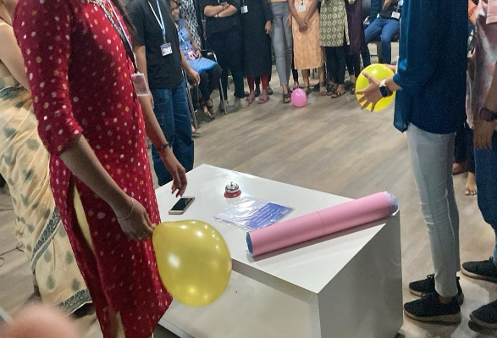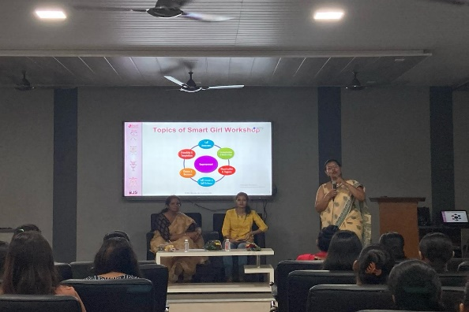

Skill Training Programme Practical Training

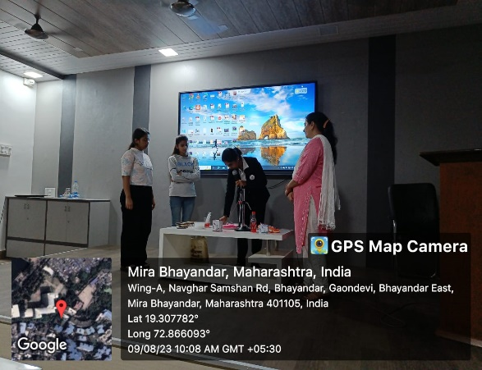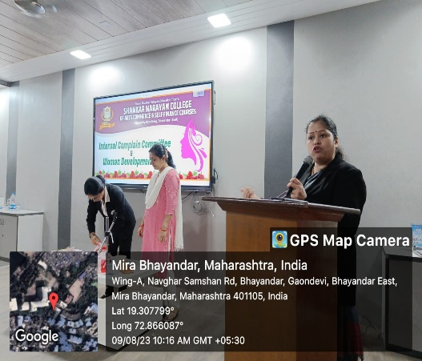

Workshop on safety and Security Workshop on Health and Hygiene

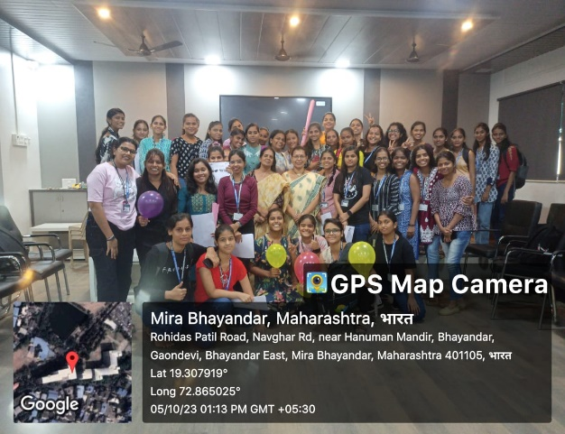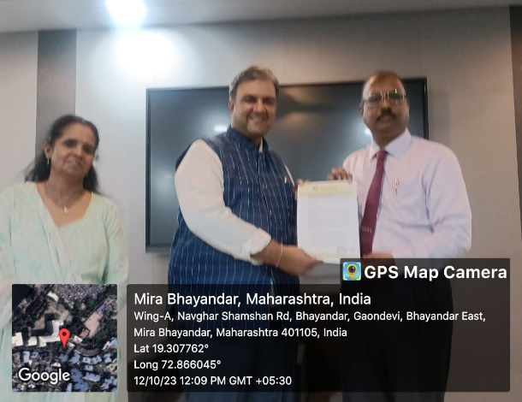

Participants of smart girl Training MOU sign with BJS’s

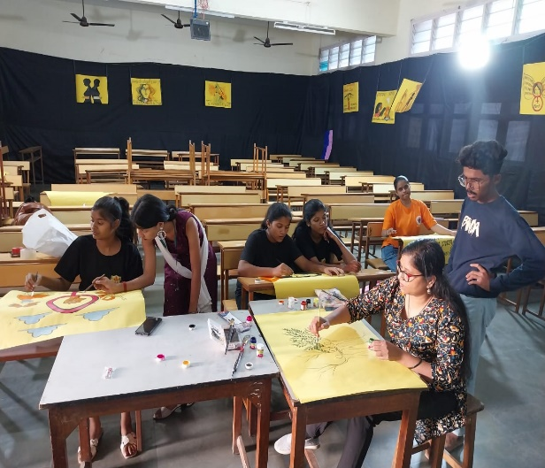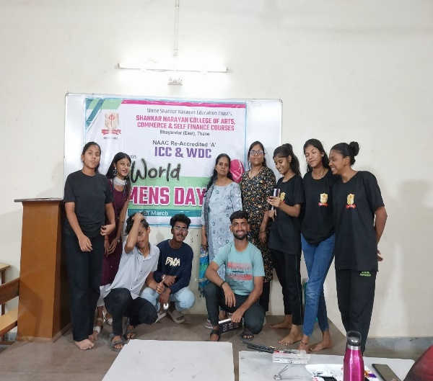

Poster Making and Exhibition on Gender Equality

