7.1.1 Counselling cell
Year of Establishment - 2012
Objectives:
1. To reduce stress among the students and thereby improve their performance.
2. To provide sustainable psycho-social support in order to gain control over all the circumstances.
3. To inculcate good life-style behaviour pattern among students.
2018-19
Major Activities-
1.Counselling of cell of college has organized one day counselling session -"Find yourself" on 22-01-2019. The guest speaker of the session Dr.Manisha Deverde
2. Counselling cell organised guest lecture on 02-03-2019 on the topic "Stress Management" conducted by Dr.Yasmin Siddique

Photos-
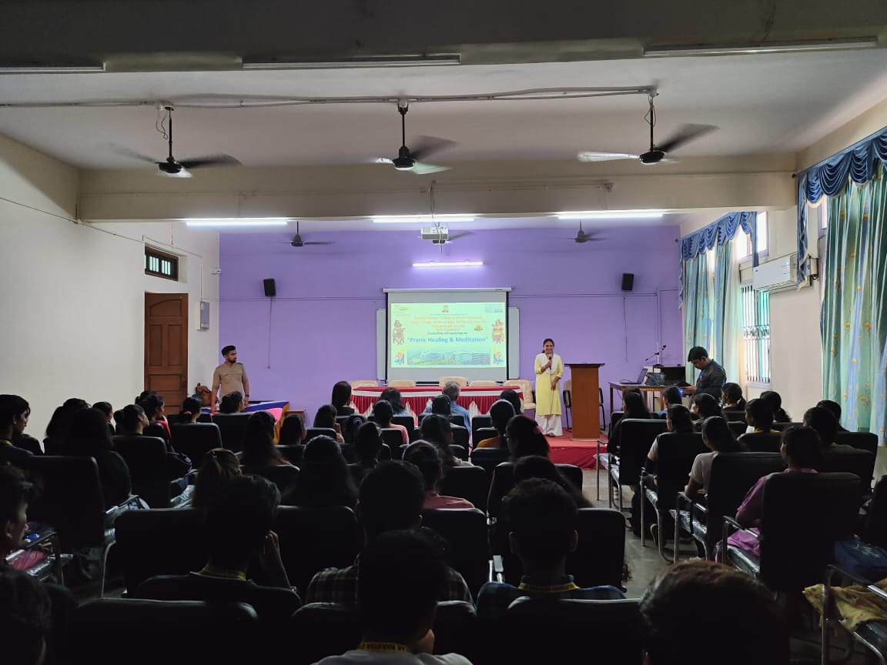
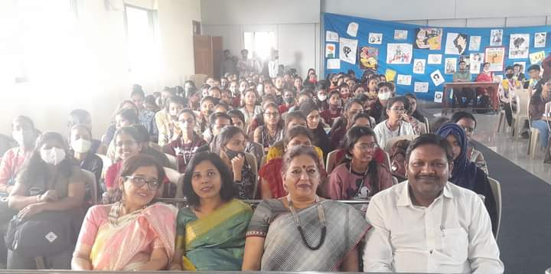
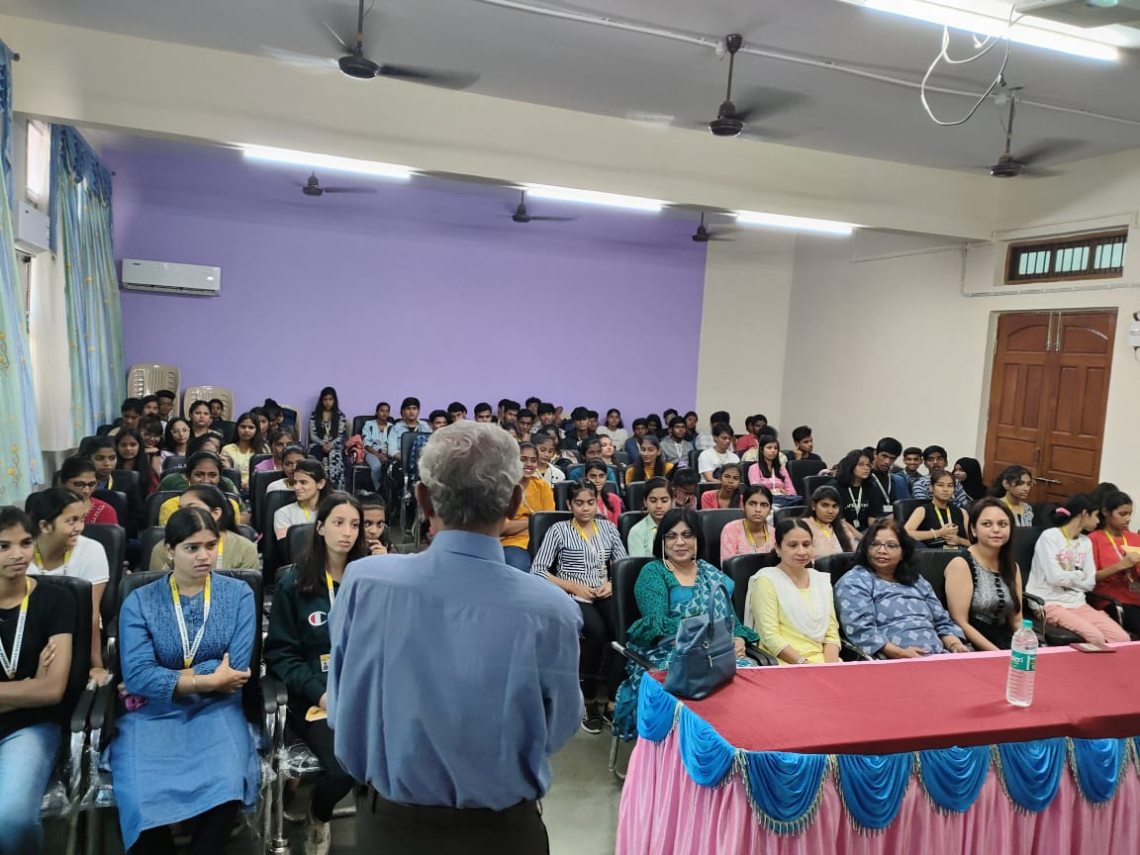
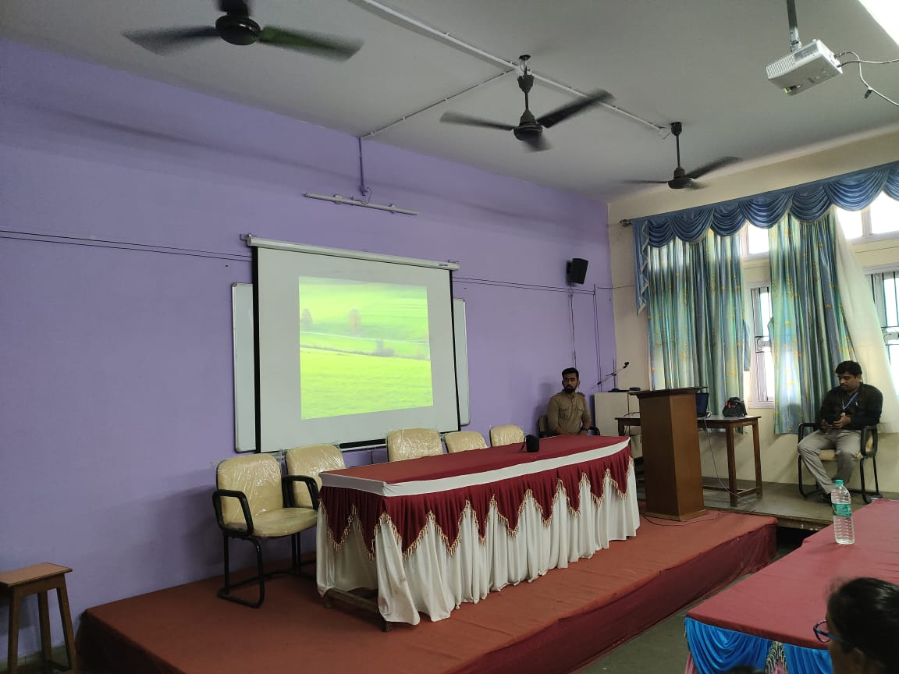

2019-20
Major Activities-
1.The Counselling cell organised one day seminar on 16-01-2020on the topic" Stress among youth" conducted by Dr.Imran Shaikh
3. The Counselling cell organised webinar on 29-04-2020on the topic" One to one counselling" conducted by Dr.Manisha Dewarde
Photos-
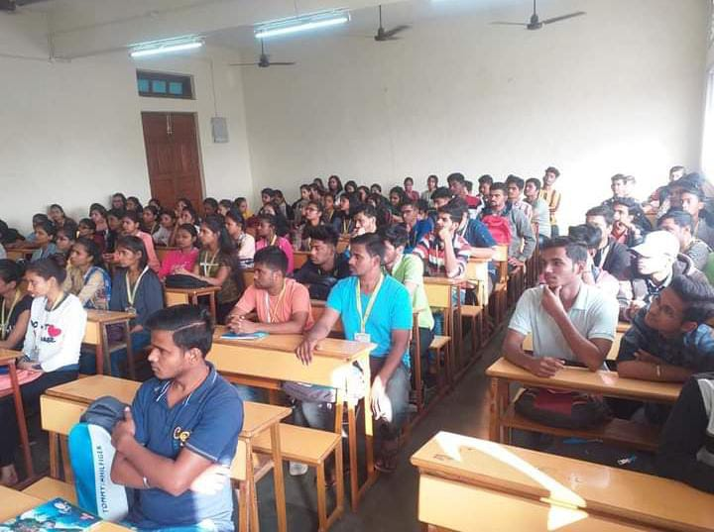
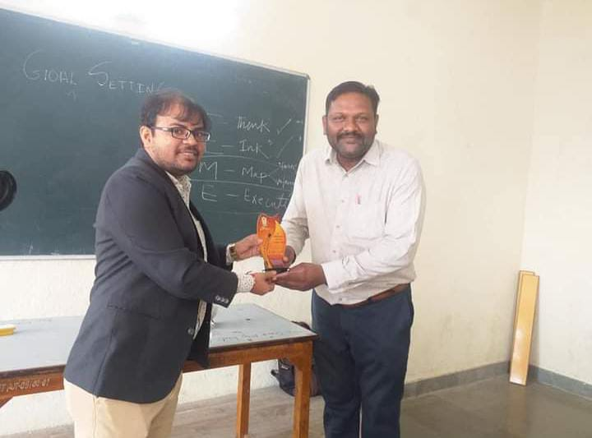

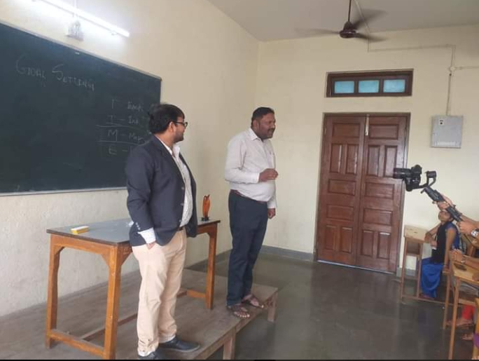

2020-21
Major Activities-
1 The Counselling cell organised webinar on30-03-2021on the topic "Stress reduction and ehancing mental health among youth conducted by Dr.Dhananjay Gambhire

3. The Counselling cell organised webinar on01-04-20210n the topic "Mental ill health and its coping machanisms conducted by Dr. .Dhananjay Gambhire
Photos

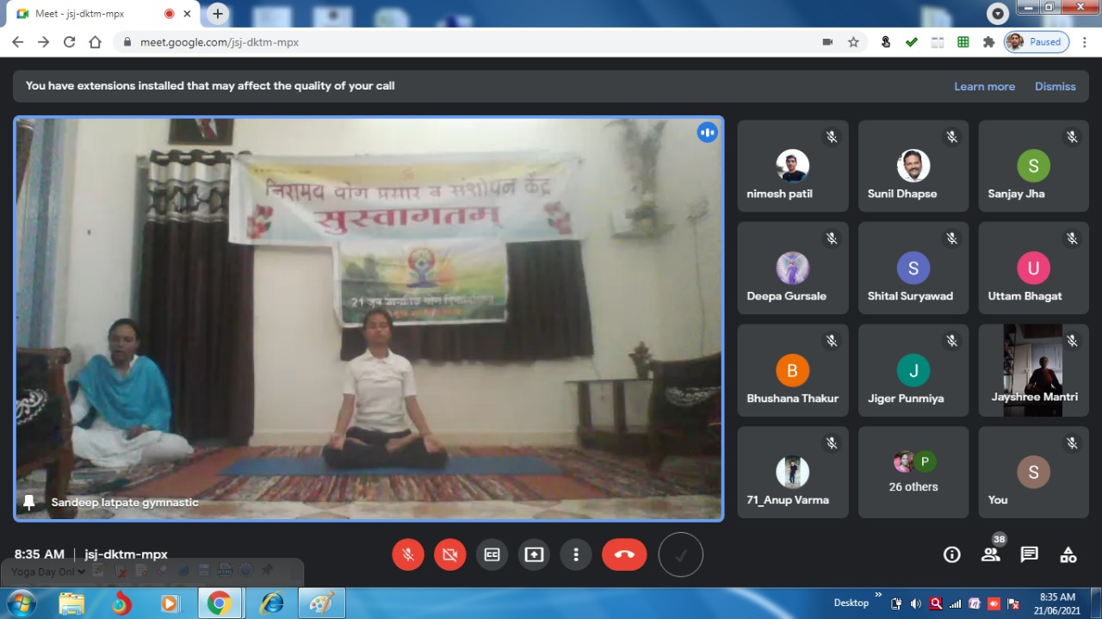
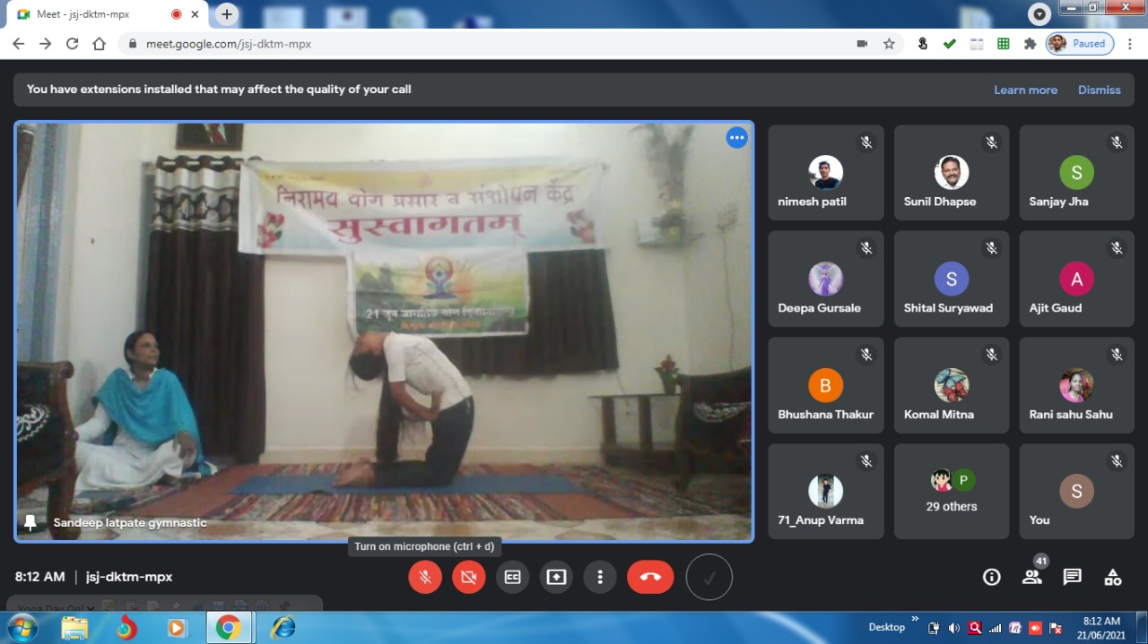

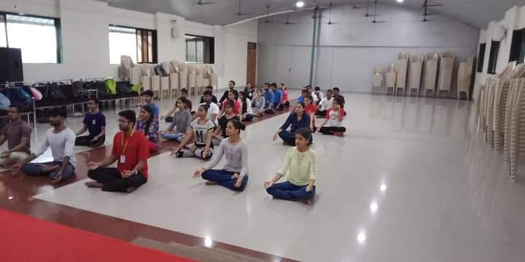
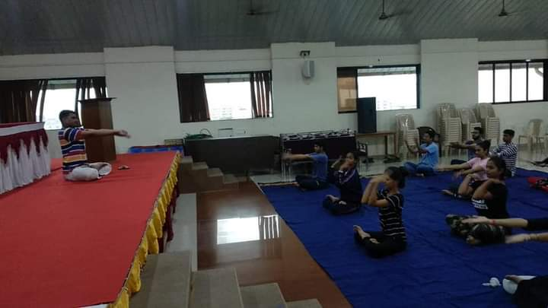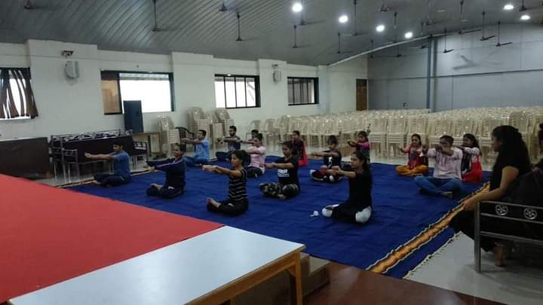

2021-22
Major Activities-
1. The Counselling cell organised Webinar on 14 -06-2021on the topic "Suitable Diet To Boost Up Immune conducted by Dr.Pritam Moon
2. The Counselling cell organised Webinar on 21-06-2021on the topic"Practicing Yoga With Pranayam "conducted by Mrs.Vidhya Anil Dhapse
3. The Counselling cell organised Webinar on 30-06-2021 on the topic "Stress and cardiac diseases" conducted by Dr. Chetan Bambure
4. The Counselling cell organised seminar on 22-02-20220n the topic ".Emergency Medical Services When And How to Access the services " conducted by Dr.Tashau Prasad
Photos-

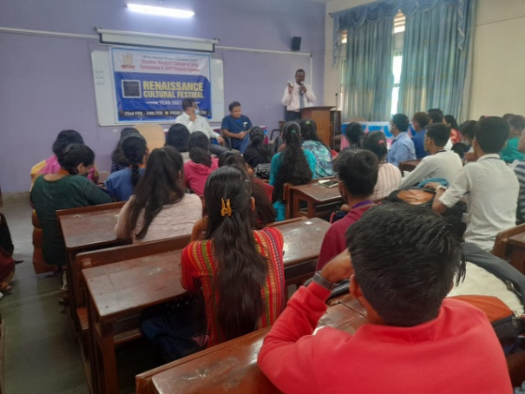
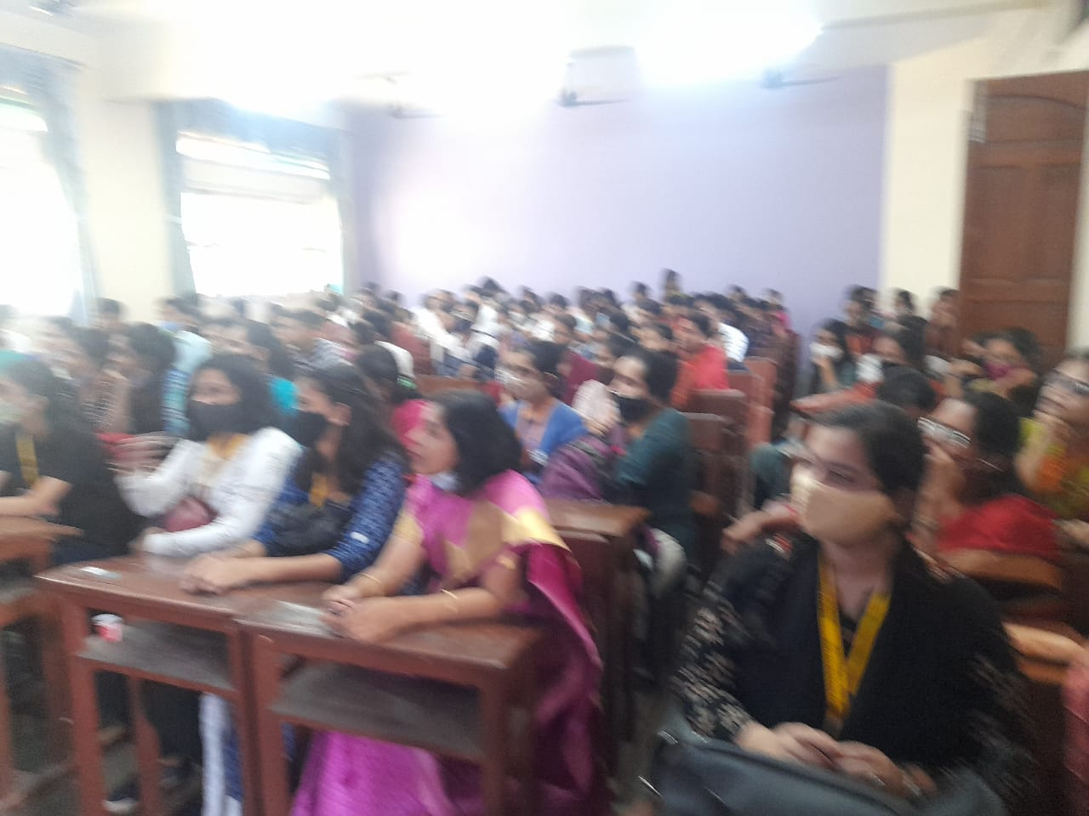

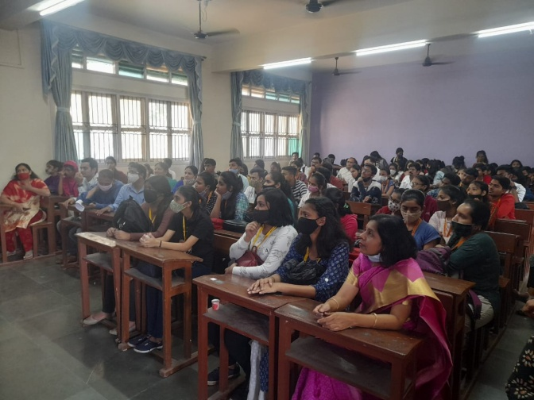
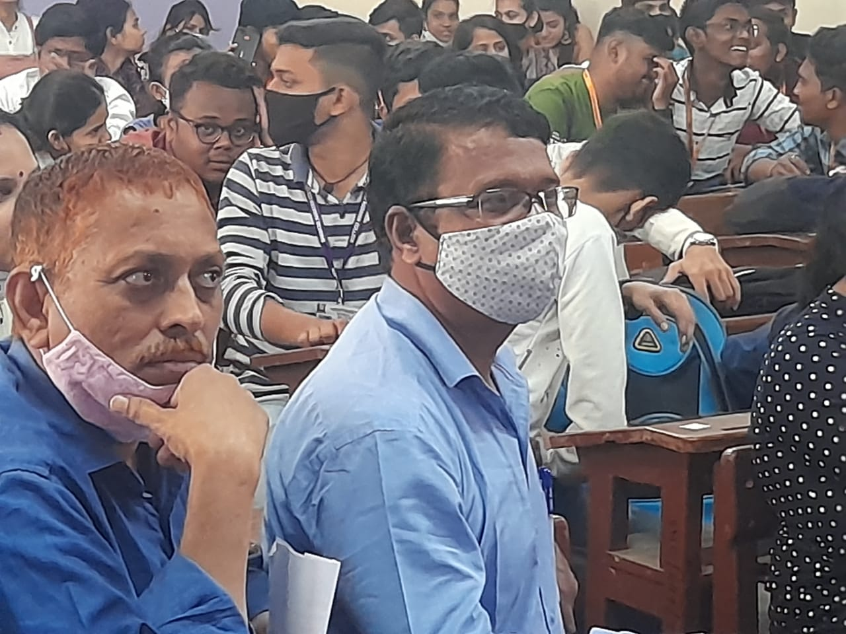

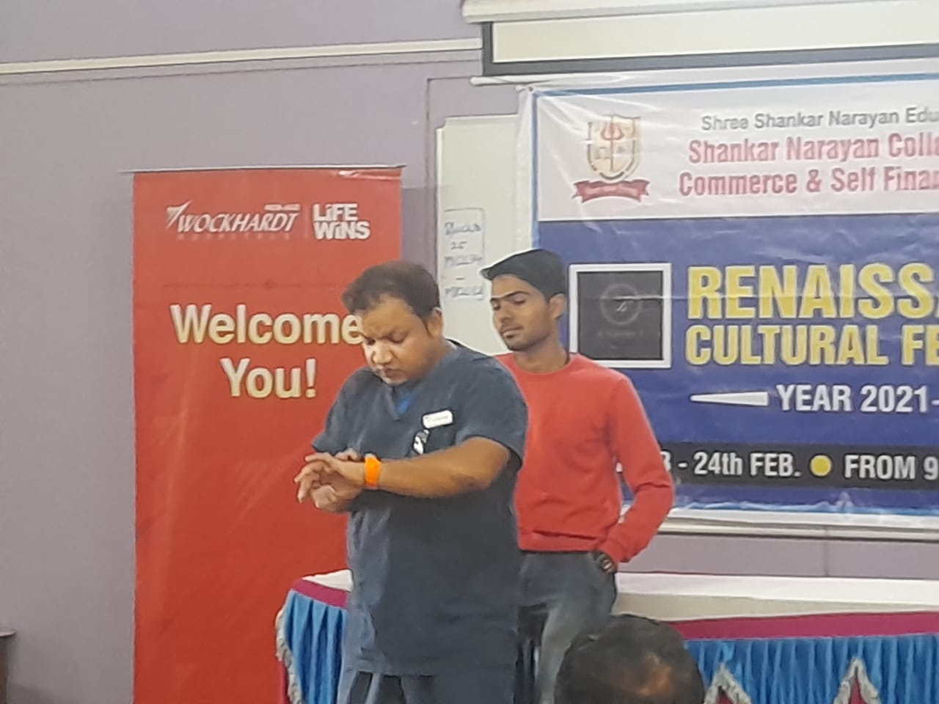

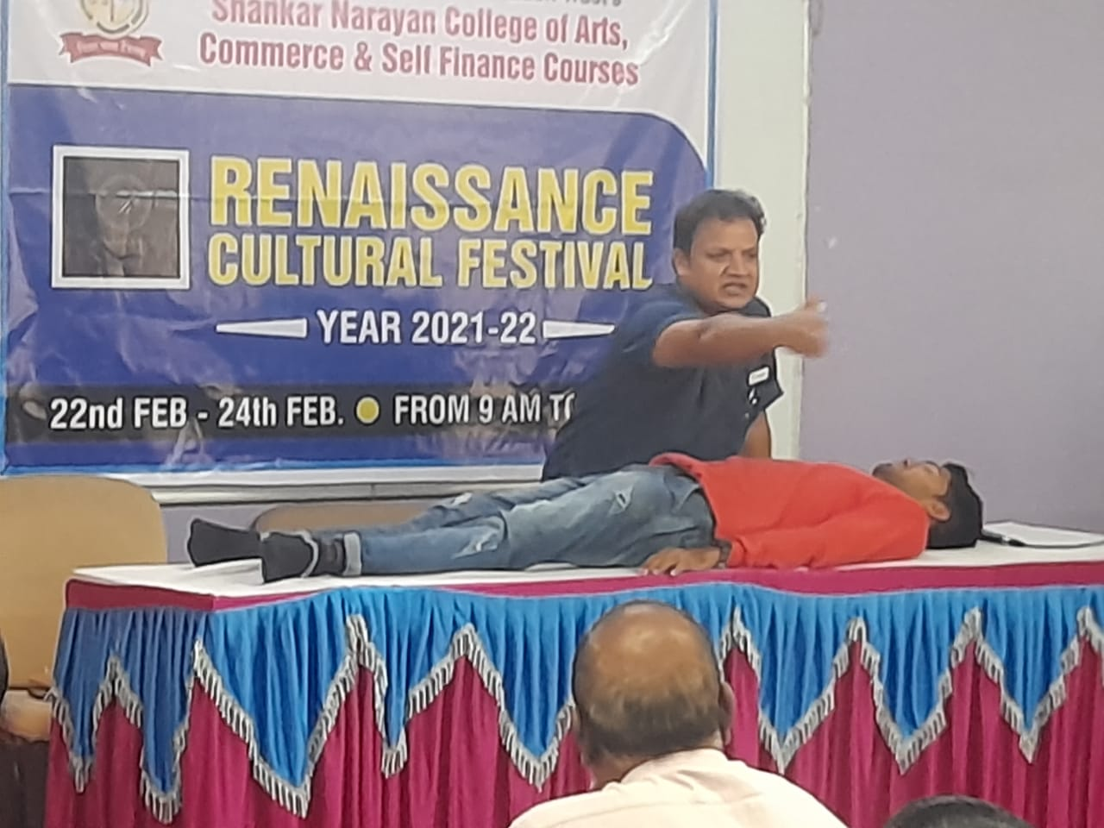
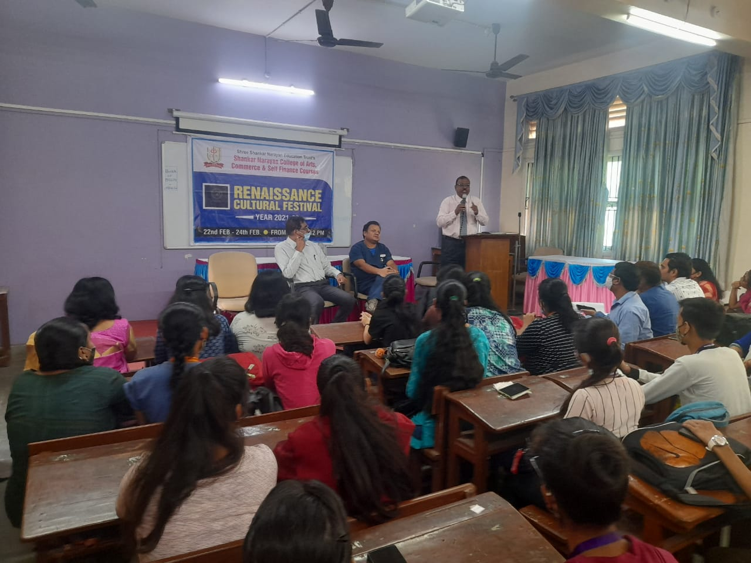
2022-2023
Sr. No. | Name of the Activity | Resource Person | Date | Number of Participants
 |  |  |  | Male | Female
01 | International Yoga Day Celebration | Mr. Nimesh Patil | 21/06/2022 | 18 | 23
02 | Public Speaking | Dr. Pradeep Tiwari | 9/07/2022 | 23 | 49
03 | Pranic Healing & Meditation | Mrs. Chhaya Kini, Mrs. Jayashree Rao | 20/12/2022 | 33 | 94
04 | Railway Safety and Protection | Mr. Madanlal Kastariya  Mr. Vikas Kediya | 16/01/2023 | 39 | 47

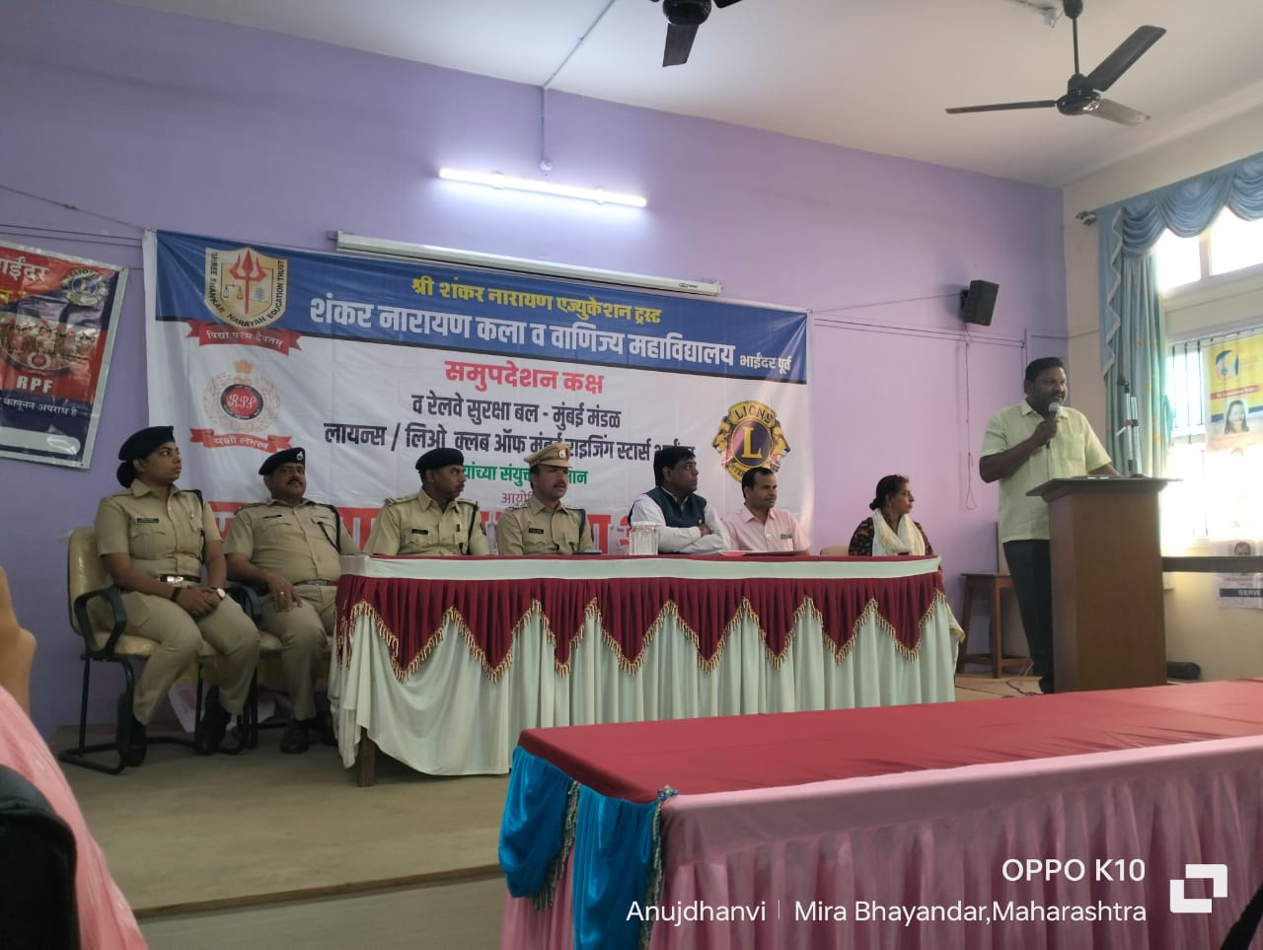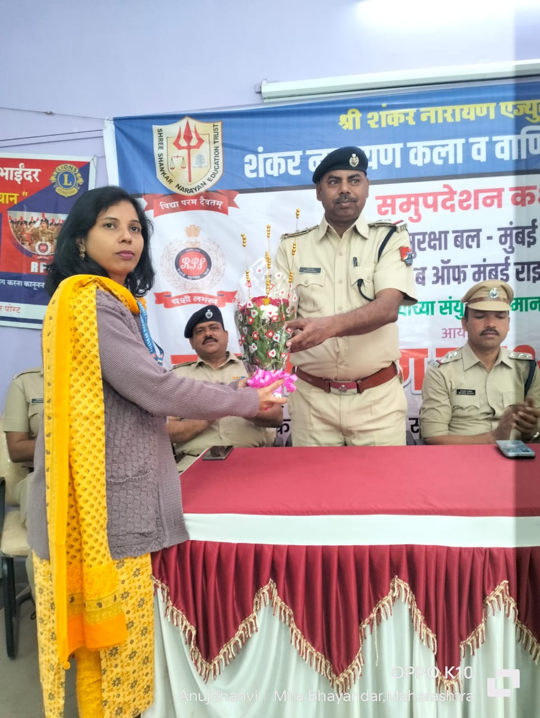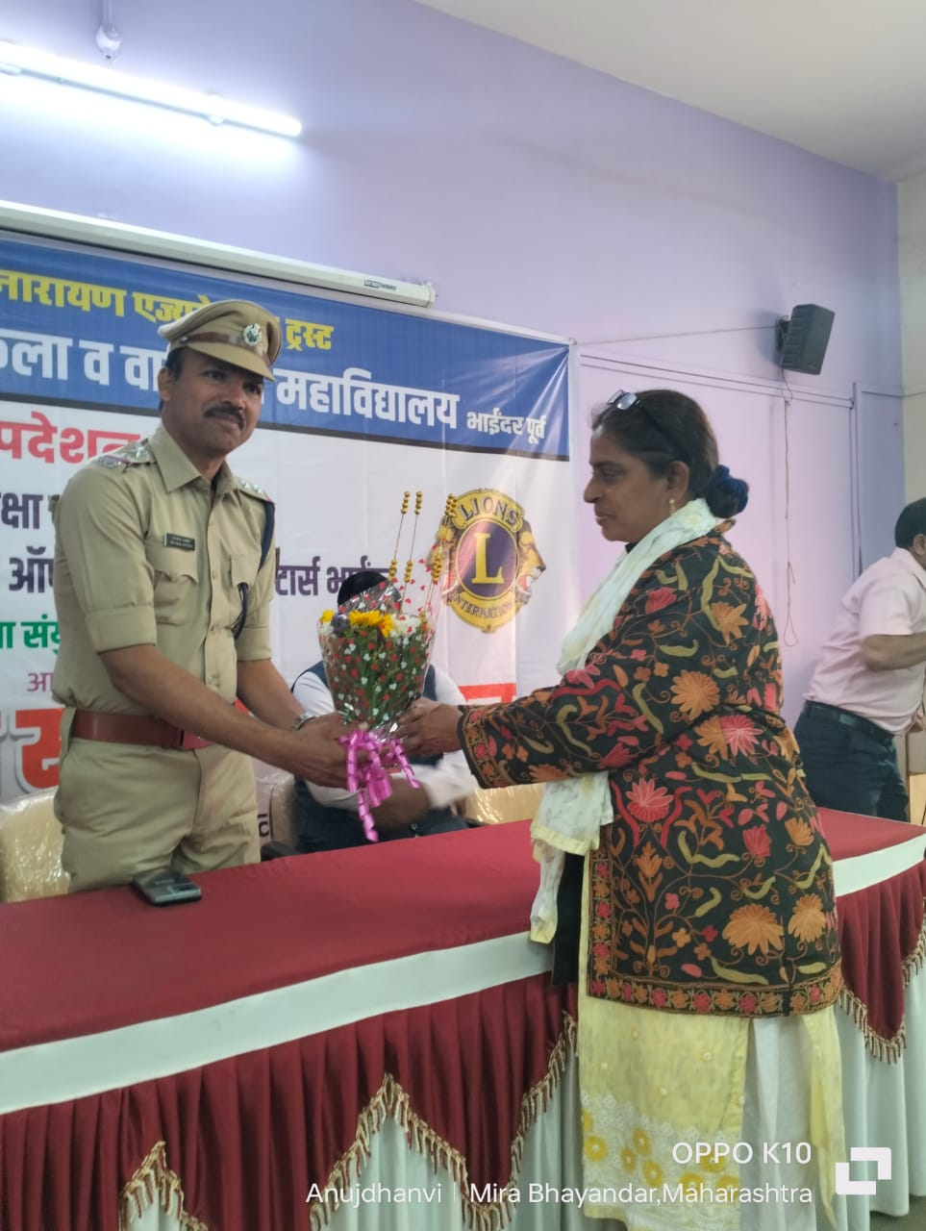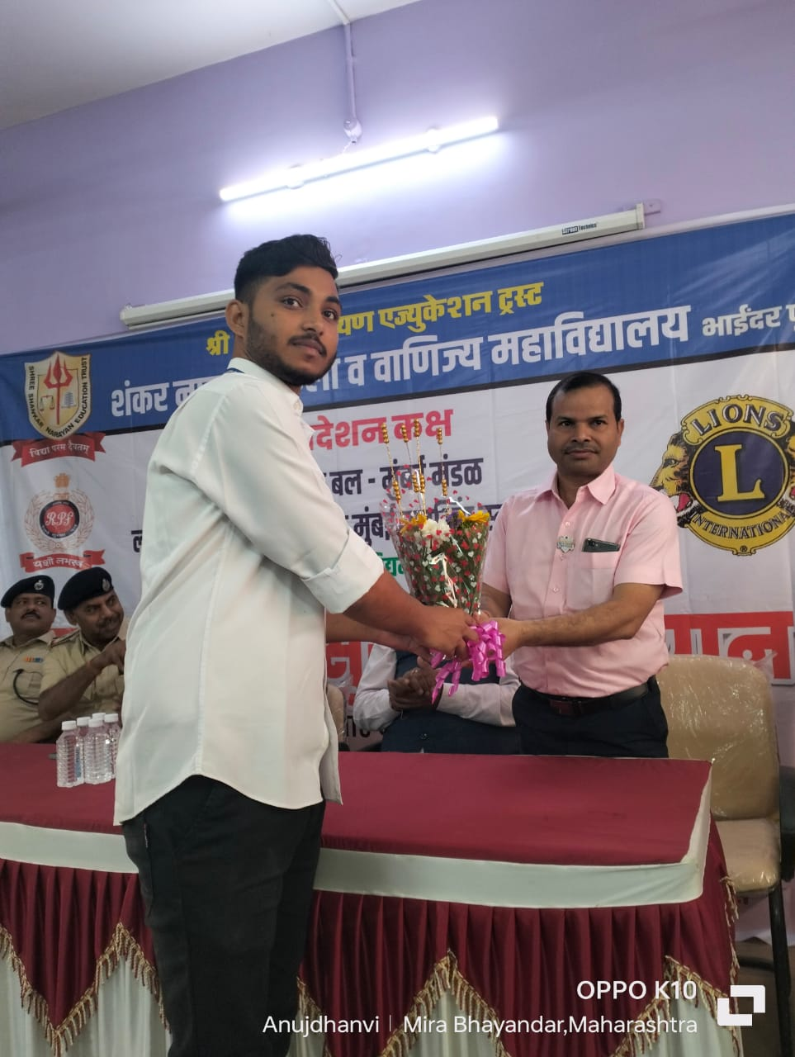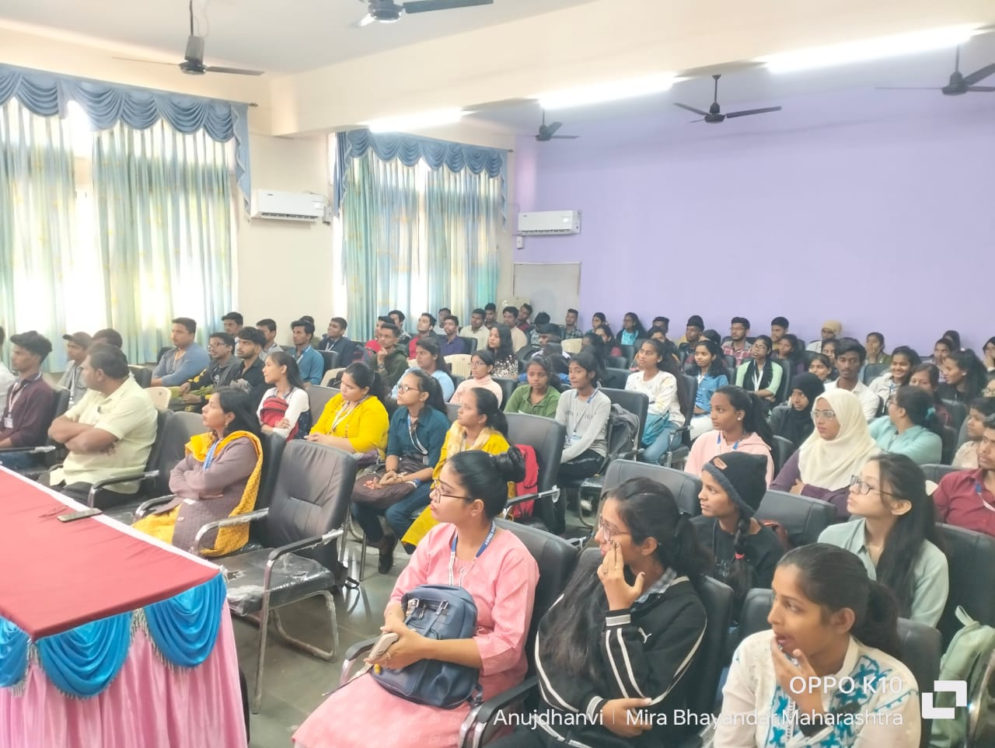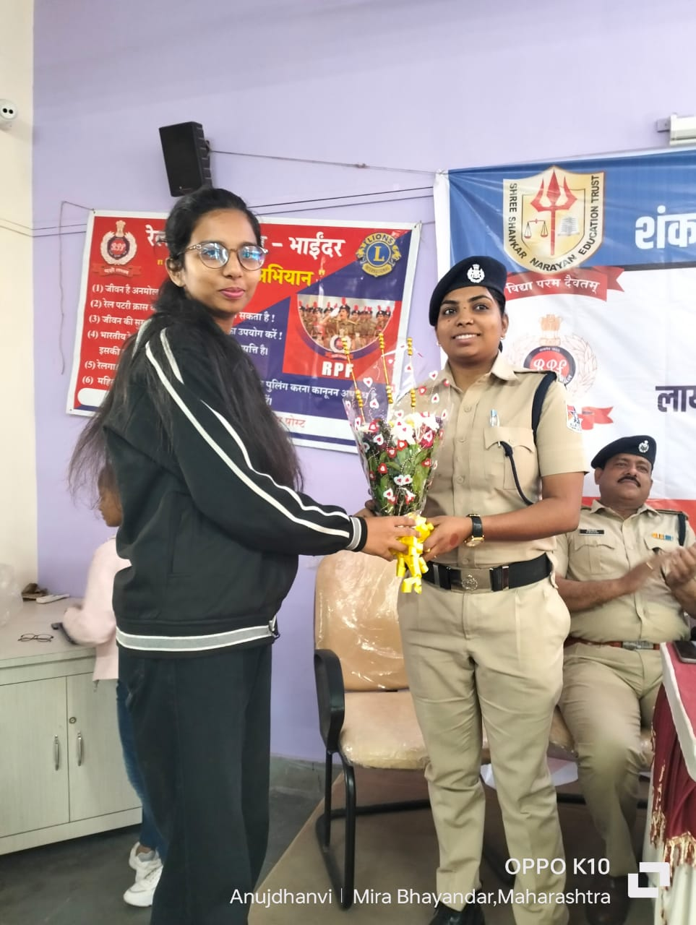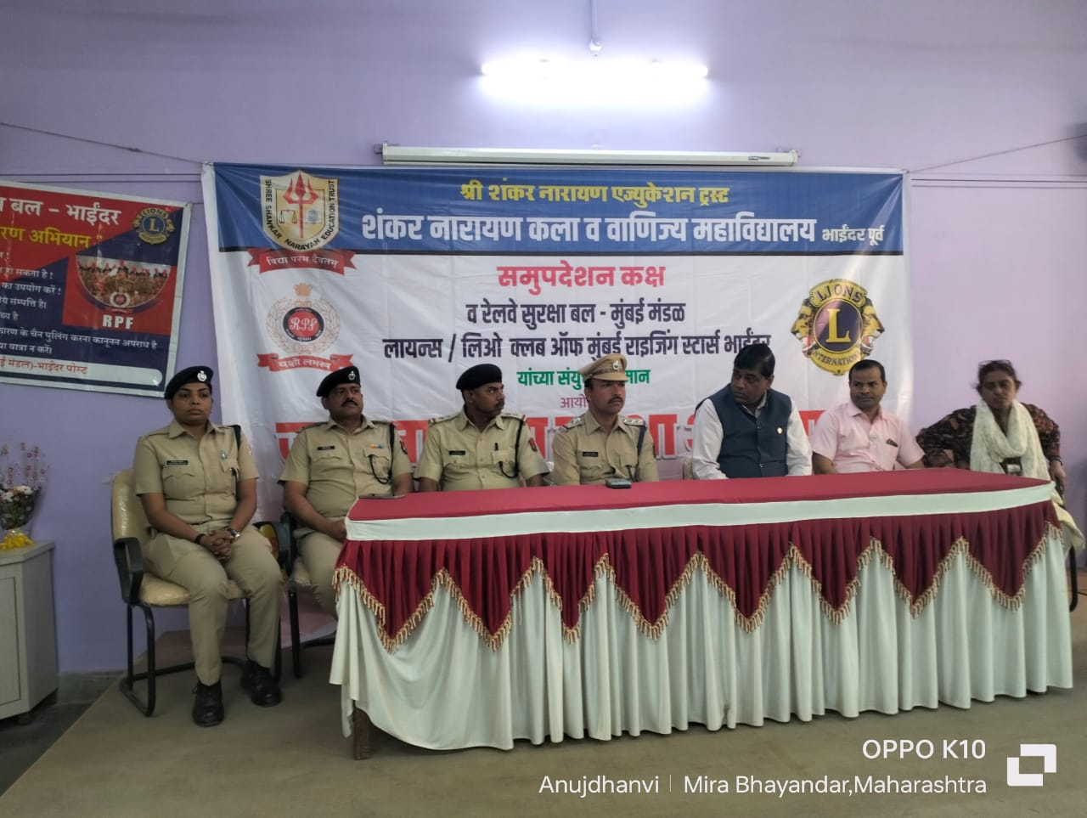

Counselling Cell’ s A Session on Railway Safety Protection as many students and teachers use Local Trains for commutation

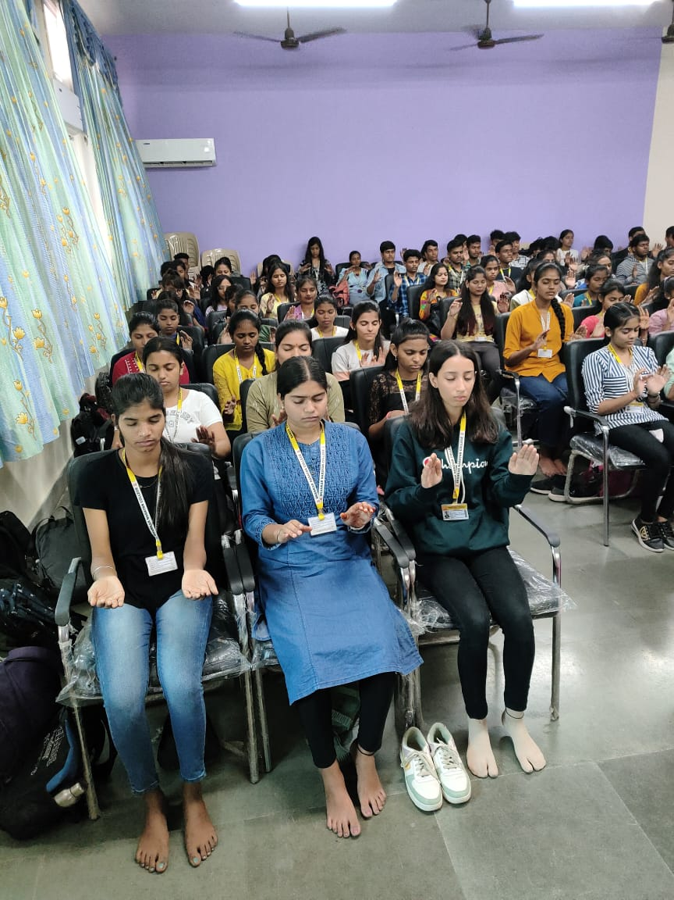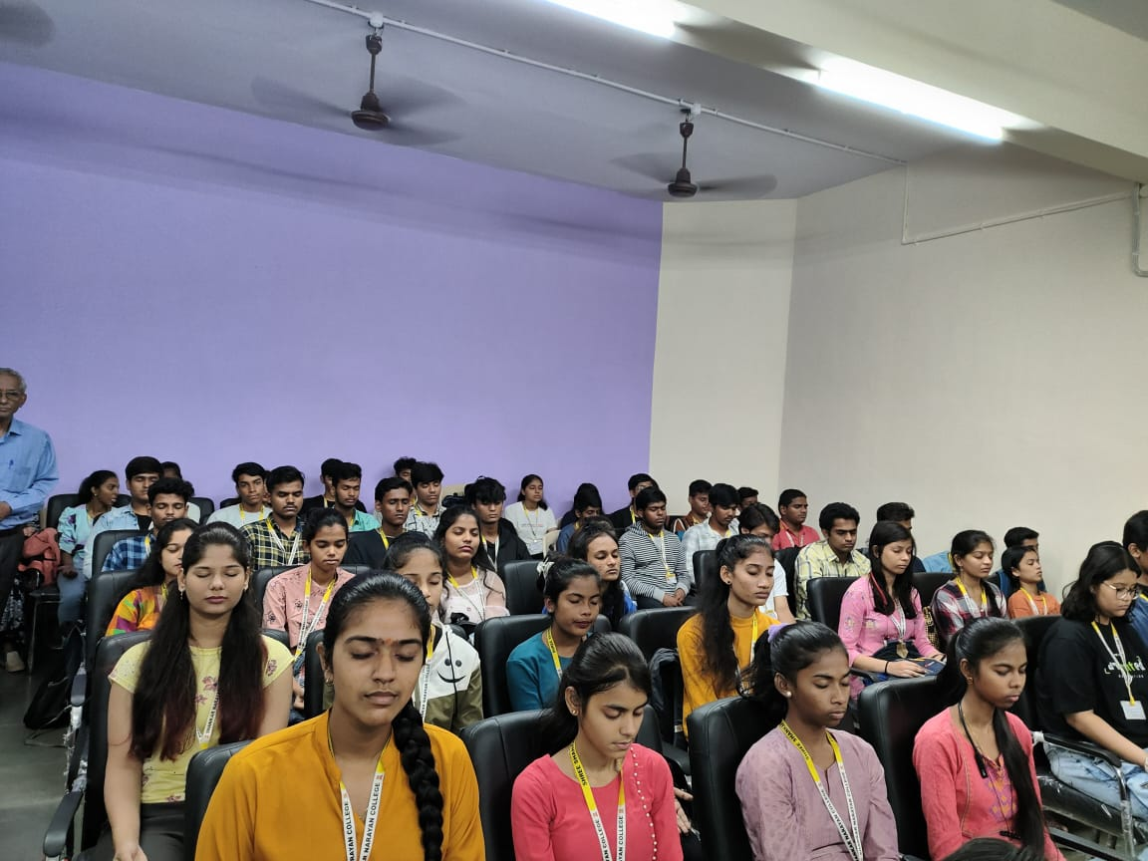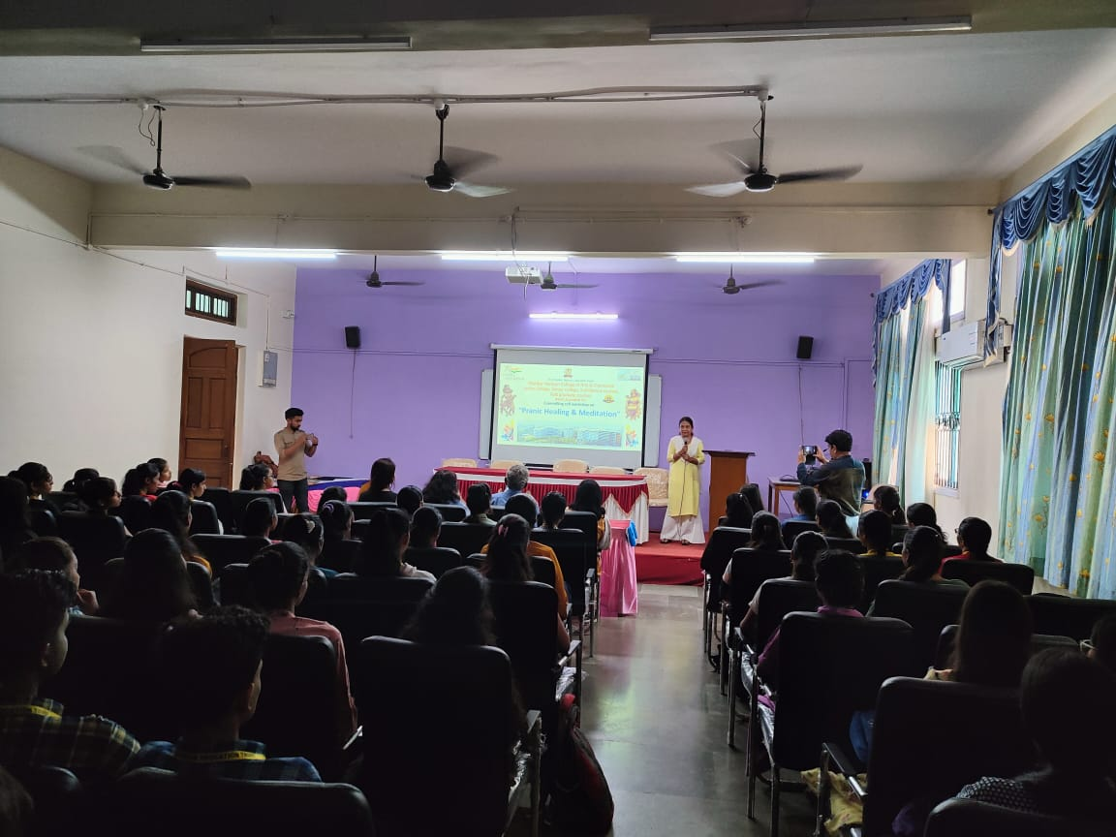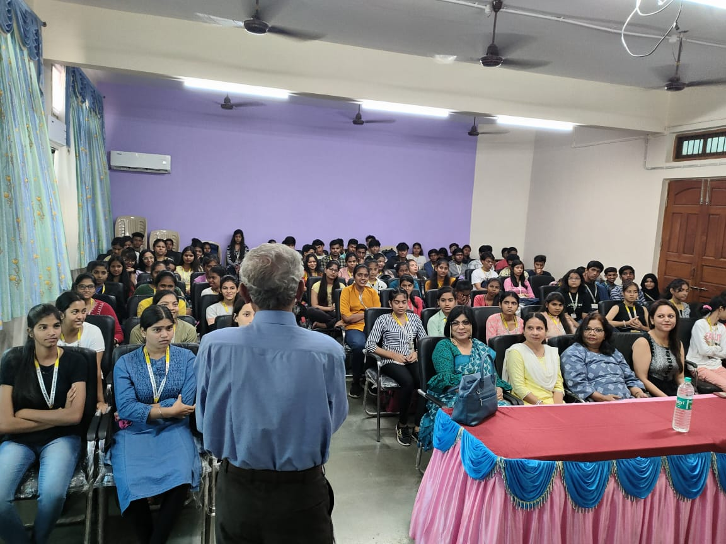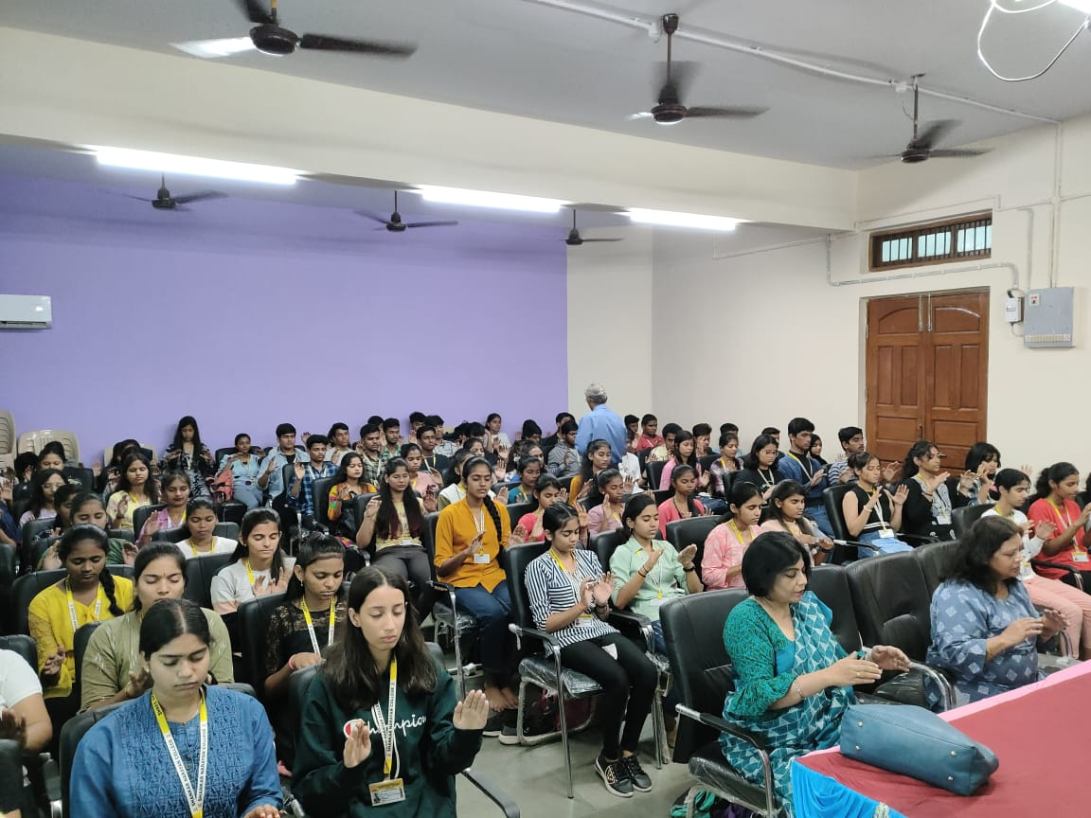

Healing Session for College Students

7.1.1 GANDHIAN STUDIES CENTRE

Best Practices
GSC conduct rallies in the community to promote Gandhiji 's thoughts.
Conduct seminar/webinar based on Gandhiji's experiential learning
for all stakeholders.
Paying tribute to Gandhiji on his birth and death anniversary to honour his contribution for country's independence.
Preparation of Code of Conduct to inculcate morale, ethics and values among all stakeholders
The Committee: Gandhian Studies Centre
Dr. V.N. Yadav. Principal
Dr. Ambuja Joshi, Coordinator, Dept. of Mathematics
Dr Dhiraj K. Chouhan, Dept. of English
Mr. Amol Bavaskar, Dept. of English

2018-2019
Date | Title of activities | Organising unit /agency/ collabrating agency | Name of the Teachers Coordinating | Number of students participated
 |  |  |  | Male | Female
2/10/2018 | Peace Rally | Institution Shankar Narayan College of Arts & commerce | Prof.Shital Khadakkar And Members of Gandhian Committe Centre | 100 | 150
30/01/2019 | Exhibition of "Gandhiji's Idealism" | Institution Shankar Narayan College of Arts & commerce | Prof.Shital Khadakkar And Members of Gandhian Committee Centre | 120 | 130

Annual Report 2018-2019
The Gandhian Studies Centre of our college had organised various events to celebrate 150th birth anniversary of 'Father of Nation' - Gandhiji. The programmes conducted were A tribute to Gandhiji on his birthday; Mega Peace Rally; Swatch Bharat activity; Seminar on 'Gandhiji's Experiential Learning -Need of the hour'; Homage to Gandhiji on his death anniversary; Exhibition of posters, portraits, sketches and slogans on Gandhian thoughts and students participation in the seminar on 'Gandhi and present day India 'conducted at neighbour college -Abhinav College of Arts and Commerce.
Activities on 150th birthday of Gandhiji
2nd October 2018:
1) The program was began with introductory speech of Commissioner,Mira-Bhayandar on youth and Gandhiji's principle.
2) A peace rally was conducted from our college to Bhayandar Railway Station in the morning hours between 8:00am to 9:30am. There were about 250 participants including Chairperson of the institute Shri Rohidasji Patil, other management supporting staff, students and teaching staff of the college. In the rally placards held by the students which conveyed messages on Gandhian thoughts and idealism. The Baggage police extended their support to conduct rally peacefully. The rally dispersed at Bhayandar station.
3) The Western Railway Staff of Bhayandar Station had organised 'swachh Bharat ' activity. This session was conducted by co-ordinated efforts of Gandhian studies Centre of our college and Railway staff.
3rd October 2018
On 3rd October a seminar was organised on 'Gandhiji's Experiential Learning -Need of the hour. The resource person called for this seminar was Dr. Masarrat Sahib Ali, Govt of Maharashtra (BEd) College and also ex-member of the Prime Minister 'S High Level Committee for Minorities'. She delivered lecture on evolution of Mr. Mohan Karamchand Gandhi to Mahatma Gandhi. Impact of his life experiences in revolution for freedom. The significance of adopting truth, non violence and thereby peace especially in youth life. Around 89 students attended this seminar.
30th January 2019
On the death anniversary of the bapuji an exhibition was arranged to pay homage to him. The students participated in the exhibition by drawing sketches, portraits, posters of Gandhiji and related historical events and informative slogans based on Gandhiji's idealism. There were around 65 posters exhibited in this event to pay homage. All the management , teaching staff and around 250 students visited this exhibition thus paying homage to Gandhiji.

Rally conducted on 150th birthday of Gandhiji
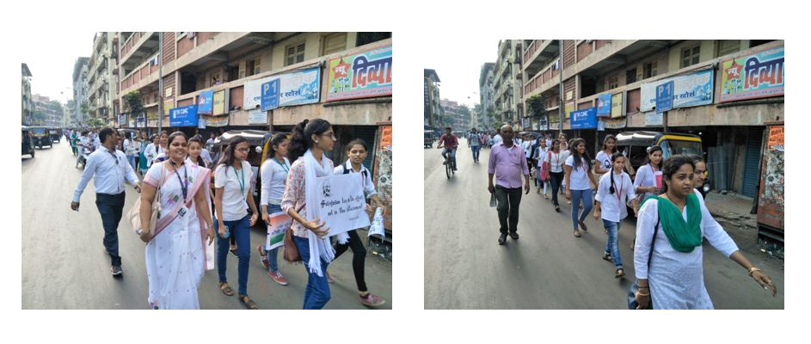
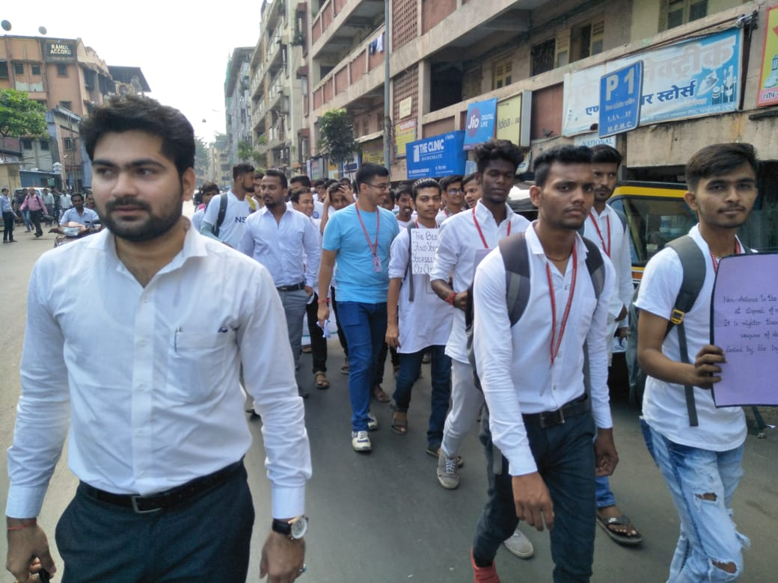
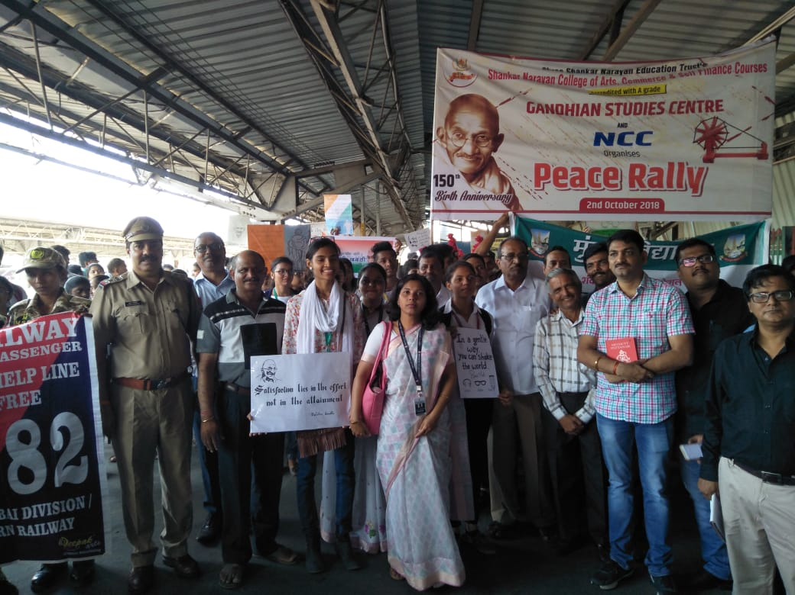

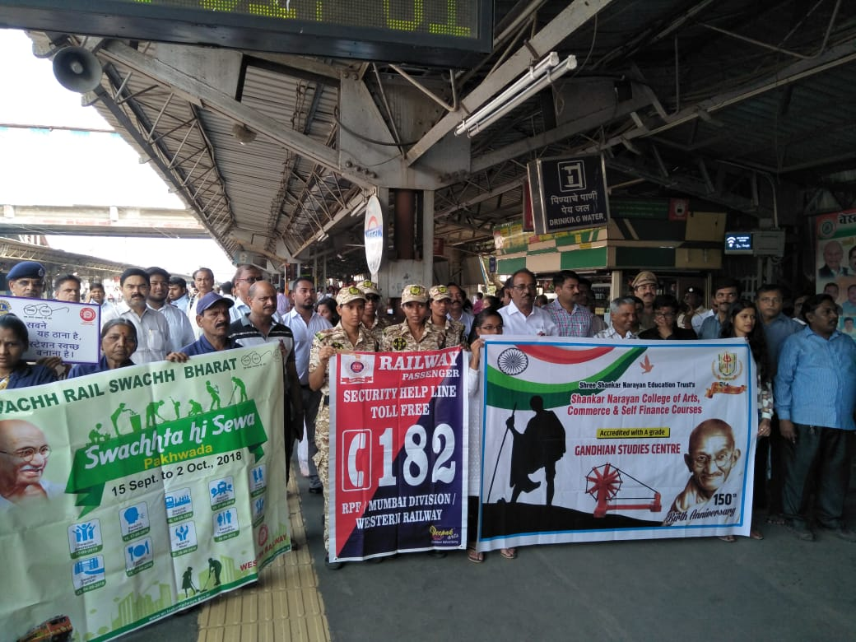

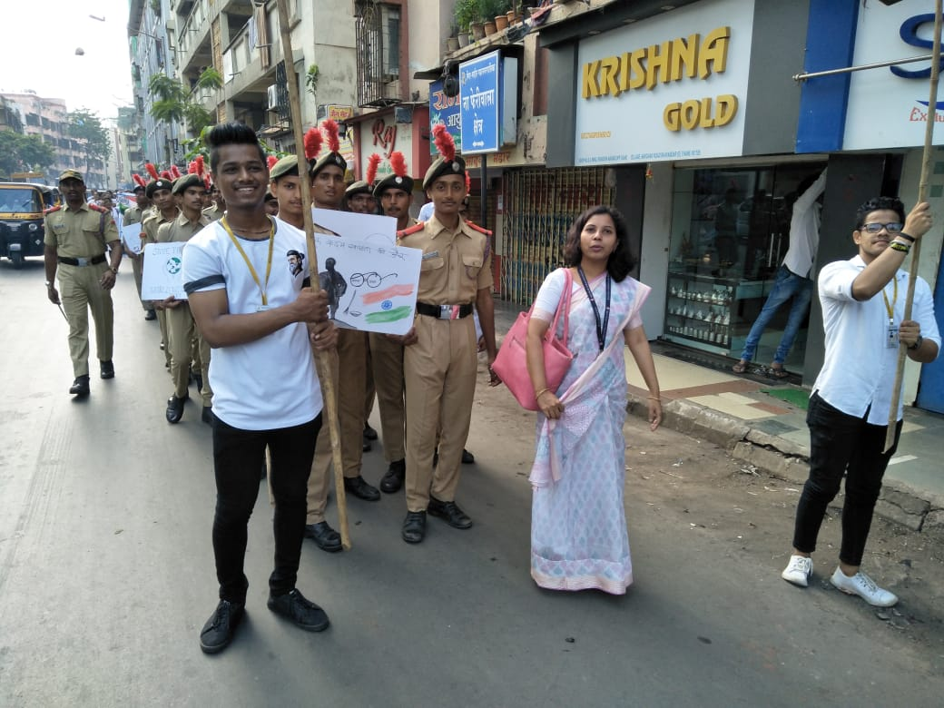
30th January 2019 Paying homage to Bapuji on his death anniversary.
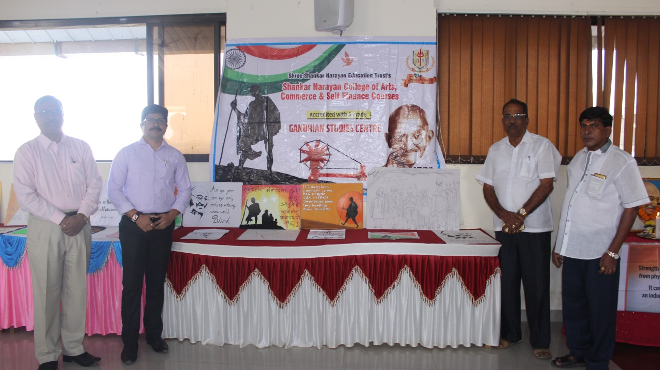

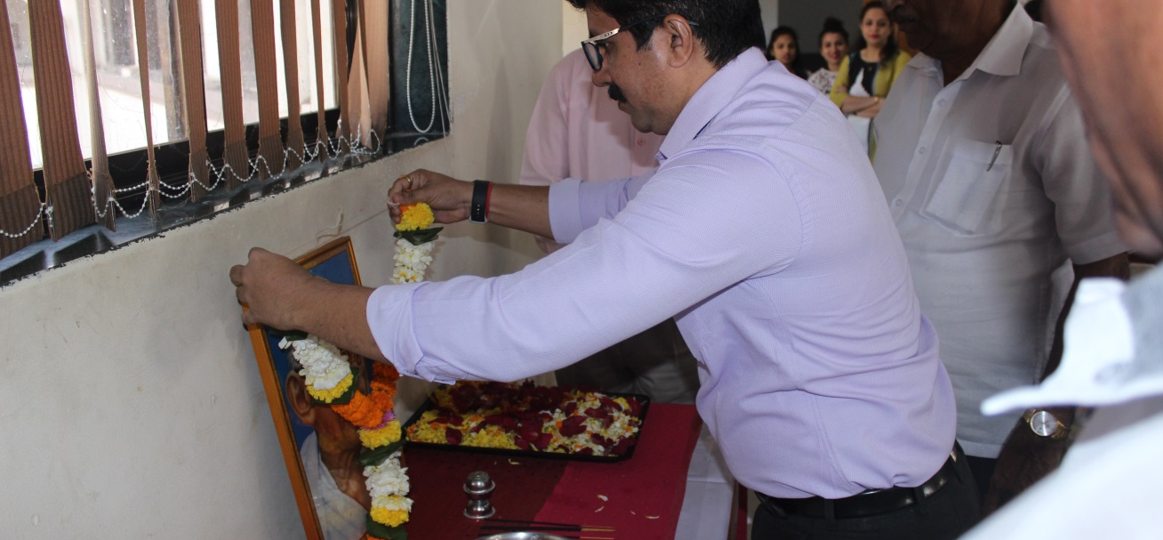
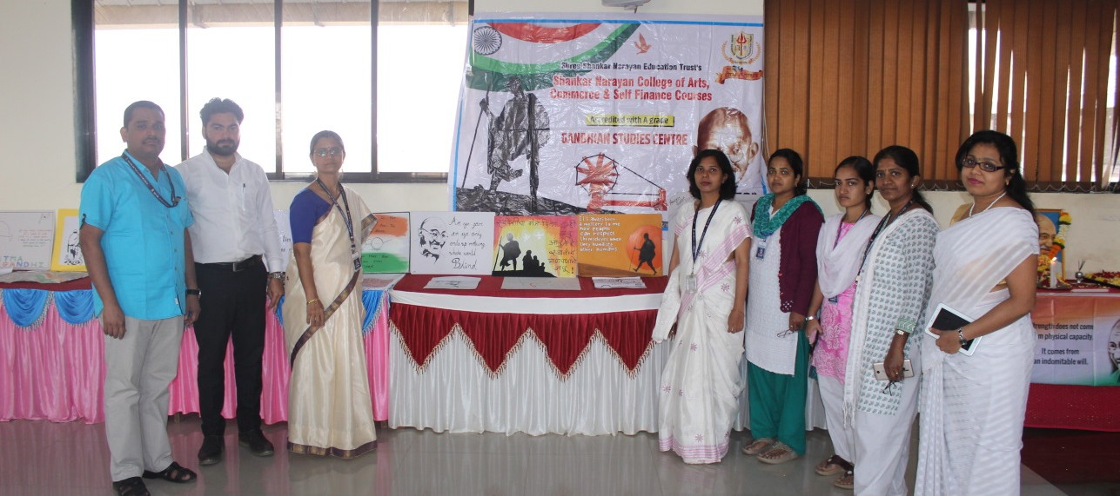
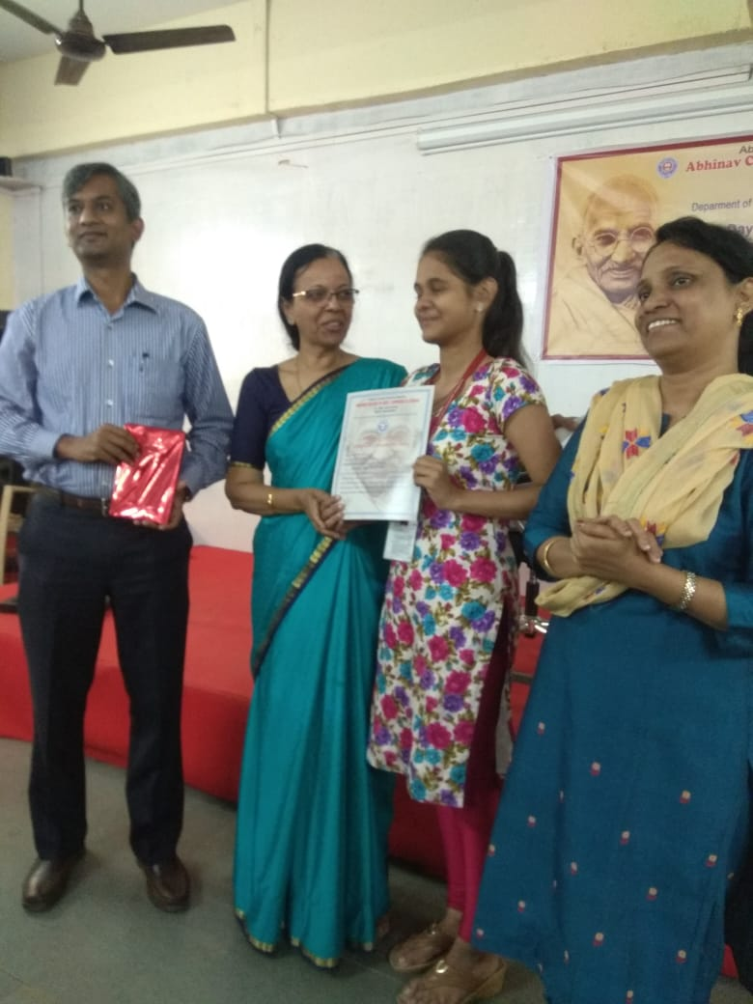

Ms.Manisha joshi Won First prize for best paper presentation

2019-2020
Date | Title of the Activities | Organising unit/ agency/ collaborating agency | Name of the teachers  coordinated | Number of the students participated
 | Title of the Activities | Organising unit/ agency/ collaborating agency | Name of the teachers  coordinated | Male | Female
18th September 2019 | Speech based on Theme-“Idealism in Gandhiji’s Thoughts” | ----------------------- | Dr. Shital Khadakkar and Members of Gandhian Studies centre | 02 | 05
2nd October 2019 | Tribute to Mahatma Gandhiji on birth anniversary | ------------------------ | Dr. Shital Khadakkar and Members of Gandhian Studies centre | 11 | 15
3oth January 2019 | Tribute to Mahatma Gandhiji on death anniversary | ----------------------- | Dr. Shital Khadakkar and Members of Gandhian Studies centre

Date | Title of activities | Organising unit /agency/ collabrating agency | Name of the Teachers Coordinating | Number of students participated
2/10/2020 | Conducted a seminar "Relevance of Gandhi philosophy in Contemporary world " | Institution Shankar Narayan College of Arts & commerce | Prof.Shital Khadakkar And Members of Gandhian Committee Centre | 55

GANDHIAN STUDIES CENTRE REPORT 2019-20

In the current academic year 2019-20, Gandhian Studies Centre of our college has organized various events. On 18th September, 2019 it held seminar on “Idealism in Gandhiji’s Thoughts”. This seminar aimed to propagate widely Gandhiji’s ideas and beliefs so as inculcate values, moralae, ethics, right and good conduct among students. At the beginning of the session, Prof. Shashikant Maghade, Department of Political Science addressed students in brief, threw light on Gandhiji’s life pattern, occurrences of various mourning events and phases in his personal and social life. Around 15 students had given speeches on various aspects of Gandhi’s social activities, hallmark of non-violence movement, ideology in contemporary world and its effect, etc.
Prof. Sunil Dhapse, Department of History and Prof. Chandrakant Khune, Department of Economics as an observer paid closed attention to all speakers and impartially differentiated them which carried seminar smoothly.
0n the occasion of 151th birth anniversary of Father of Nation, Gandhian Studies Centre conducted various events on 2nd Ocober, 2019. The event began with tribute to Bapu by garlanding his image followed by spiritual bhajan sung by our students. On this occasion books exhibition of Gandhiji’s life and related literature was held in the library. Also short clips of video were shown to educate students about importance of peace and morality and to have its long-lasting impact on their lives.
All the activities were conducted successfully under the guidance and supervision of Senior Member of the Gandhian Studies Centre, Prof Ranjita Virkar. Also other members Prof. Nilesh Patki, Prof. Rachel Lijjo, Prof. Bhushana Thakur, Prof. Jyoti Badigar, Prof. Deepak Mishra, Prof. Satish Rode and Prof. Nitya had supported in the arrangements and in maintaining disciplines.

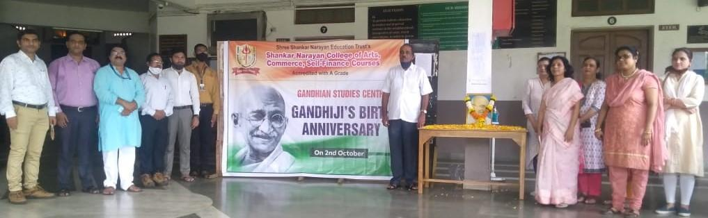
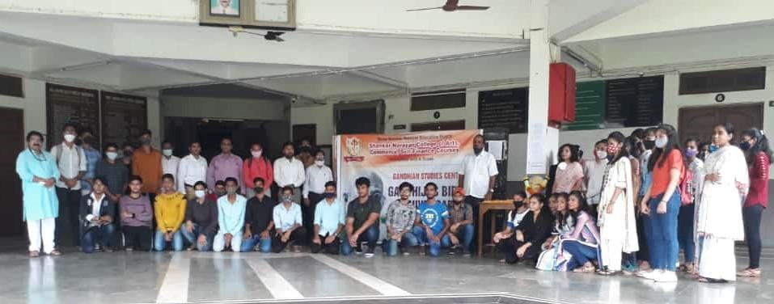
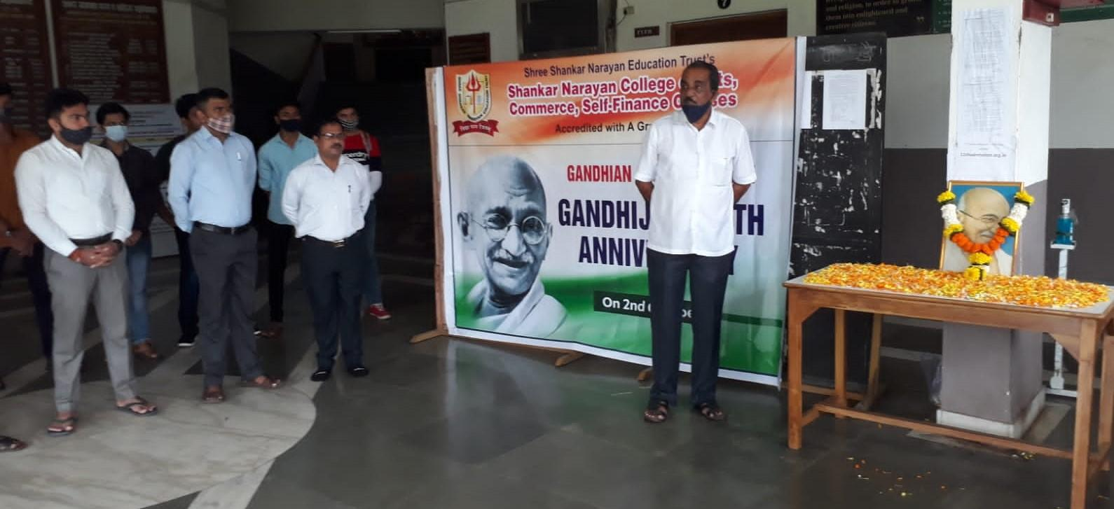

2020-2021
Shri Rohidasji Patil, Chairperson of S N Education Trust , Members of Gandhian Studies Centre, Staff and students pay tribute to Gandhiji on his 153rd Birth Anniversary

Title of the Activities | Organising unit/ agency/ collaborating agency | Name of the teachers  coordinated | Number of the students participated
Title of the Activities | Organising unit/ agency/ collaborating agency | Name of the teachers  coordinated | Male | Female
Webinar on ‘ Relevance of Gandhi Philosophy in Contemporary world’ on 2nd October,2020 | Gandhian Studies Centre, Shankar Narayan College and Sadbhavna Sangh, Maharashtra State | Dr. Shital Khadakkar  Speaker: Varsha Vidya Vilas, Social Activist and member of Sadhbhavna Sangh, Maharashtra State | 46 | 87
State level Webinar on ‘Mahatma Gandhi: Myths and Facts’ on 3oth January, 2021 | Gandhian Studies Centre and Department of Political Science, Shankar Narayan college of commerce, Arts and Self-Finance Courses | Dr. Shital Khadakkar  Prof. Shashikant Maghade  Speaker: Shri Sanket Munot, Social Activist | 77 | 79

GANDHIAN STUDIES CENTRE
Report 2020-21
Every year Gandhiji’s birth anniversary is celebrated by conducting activities in the college and community. Due to covid-19 pandemic, Gandhian Studies Centre organised a webinar on ‘Relevance of Gandhi’s Philosophy in Contemporary world’ on 2nd October, 2020. For this seminar the Guest Speaker was Varsha Vidya vilas who is a Social Activist and a member of Sadhbhavana Sangh, Maharashtra State. She highlighted anti-social elements and atrocities existing in the society all over the world like gender violence, riots, terrorism, drug abuse, etc. She narrated few historical incidences that happened in Gandhiji’s life which moulded him to work towards the upliftment of the poor and betterment of the society. Further, she emphasized the importance of Gandhiji’s principal of non-violence, peace, equality, etc in today’s world which will help the society to get rid of anti-social elements. This webinar was attended by 100 participants including students, teaching, non-teaching and others. The webinar was organized under the guidance of Principal Dr. V. N. Yadav and with the support of all the members of Gandhian studies centre.
The Gandhian Studies Centre and Department of Political science jointly organized State level webinar on ‘ Mahatma Gandhi: Myths and Facts’ to pay tribute to Father of Nation on his 73rd Death Anniversary. Prof. Maghade, introduced Guest speaker for the webinar. He gave information related to Gandhiji’s life. Shri Sanket Munot, a social activists was speaker for the webinar. He explained myths and misconception about Gandhiji which are prevailing in the society. After delivering the speech, he conducted interactive session with the participants. The participants raised various questions related to Gandhiji’s life and his activities satyagarh, quit India Movement, Pune pact, what Gandhiji have done to untouchables, etc . He answered every participants by briefly explaining the historical facts about Gandhiji’s work. Total 256 participants attended the webinar. These participants represented 18 colleges and 04 universities in India. Dr. Shital Khadakkar, GSC involved in preparatory activities for the webinar. She summarized the salient features of this webinar. Prof Maghade, PS made necessary arrangements for the smooth conduct of the webinar. The Principal Dr. V. Yadav and Management extended their support to make webinar a successful event.
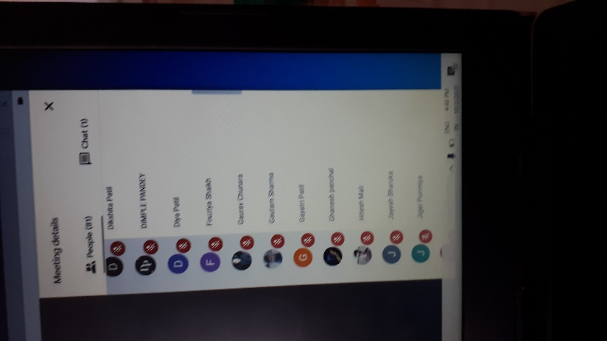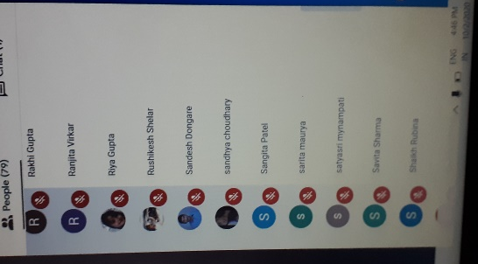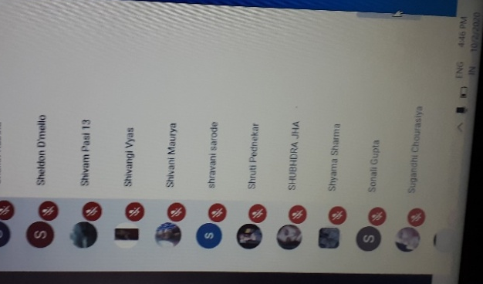
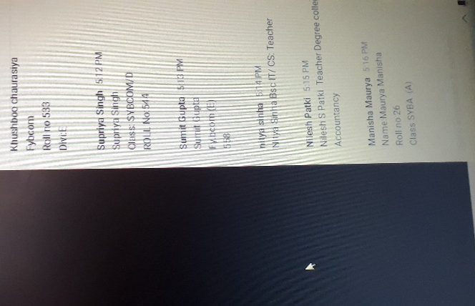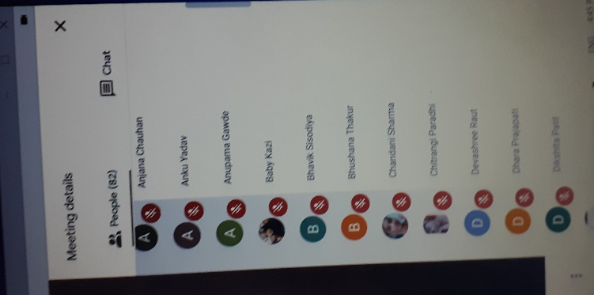
Birth Anniversary Celebration on 2nd October 2020
2021-22

Name of the Committee: Gandhian Studies Centre
Title of the Activities | Organising unit/ agency/ collaborating agency | Name of the teachers  coordinated | Number of the students participated
Title of the Activities | Organising unit/ agency/ collaborating agency | Name of the teachers  coordinated | Male | Female
Gandhiji’s Birth Anniversary on 2nd Oct 2022 | Gandhian Studies Centre | Dr. Shital Khadakkar | 8 (student) | 13 (student)
Gandhiji’s Birth Anniversary on 2nd Oct 2022 | Gandhian Studies Centre | Dr. Shital Khadakkar | 5 (teacher) | 1 (teacher)
Gandhiji’s Ideology on Humanism in Imbalanced World on 7 Oct 2021 | Gandhian Studies Centre, Department of History and IQAC. | Dr. Shital Khadakkar | 43 (teachers) | 35 (teachers)
 | Gandhian Studies Centre, Department of History and IQAC. | Dr. Shital Khadakkar | 54 (student) | 72 (student)
 | Gandhian Studies Centre, Department of History and IQAC. | Dr. Shital Khadakkar | 18 (others) | 19 (others)
Homage to Mahatma Gandhi on Death Anniversary on 30 Jan 2022 | Gandhian Studies Centre | Dr. Shital Khadakkar | 30 | 28
Awareness Program and Release of Code of Conduct on 01 Apr 2022 | Gandhian Studies Centre and IQAC | Dr. Shital Khadakkar | 21 (teachers) | 41 (teachers)
 | Gandhian Studies Centre and IQAC | Dr. Shital Khadakkar | 21(Students) | 35(Students)

Report 2021-22
2nd October, 2021
On the occasion of 153rd Birth Anniversary of Mahatma Gandhi, homeage was paid by Gandhian study centre. On the day honourable Rohidasji Patil, Chairperson of Shankar Narayan college addressed the importance of Gandhiji’s ideology to all the students, teaching and non-teaching staff.
7th October, 2021
A national level webinar on ‘Gandhiji’s ideology on humanism in Imbalanced World’ jointly organized by Gandhian Study Centre, Department of History and Internal Quality Assurance Cell (IQAC) of the college. A webinar was inaugurated by Chairperson of the Shankar Narayan college. The speakers from renowned Universities conducted the four technical session. The 1st session on ‘Gandhiji’s thought on Humanism’ was held by Dr. Santosh Bansode, Member of Board of studies, Department of History, Sant Gadge Maharaj Amaravati University. He explained views on humanity by Gandhiji. The 2nd session on ‘Ethics and Values- Important Pillars of Human Life’ was conducted by Dr. Shamrao Koreti, Department of History, Sant Tukdoji Maharaj Nagpur University. The 3nd session on ‘Social Imbalances and Inequalities- A persistent Phenomenon’ was conducted by Dr. Kaushiki Dasgupta Vidyasagar, Department of History, Midnapore, West Bengal. The 4th session on ‘Gandhiji’s Ideology to overcome social issues in today’s world’ was conducted by Dr. Jagdish Sonawane, Department of History, Savitribai Phule Pune University. All the sessions were informative, interactive and knowledgeable. All the participants were well informed about the Gandhiji’s ideology by this webinar. For this national webinar 400 participants from 4 universities and 20 colleges were present. This webinar was conducted under the guidance of Principal Dr. V. N. Yadav and Supported by Management. This webinar was organized and well executed by Dr. M. Satyashri, IQAC Coordinator; , Prof. Sunil Dhapse, Head of Department, History and Dr. Shital Khadakkar, Coordinator, Gandhian Studies Centre.
1st April, 2022
In this academic year 2021-22, the Code of Conduct was released by Gandhian Studies Centre and IQAC for all the stakeholders of the Institution- Management, Principal, Teachers, Administrative staff, Peons and Students. On 1st April, 2022 awareness programme on Code of Conduct was held with the aim to create awareness about duties, responsibilities and behavior of all stakeholders in the college campus as well as the community. After this session, Honourable Chairperson Rohidasji Patil released Code of Conduct in presence of all the stakeholders. Also the copies of Code of conduct were distributed to all the stakeholders.
Gandhiji’s birth anniversary is celebrated by conducting activities in the college and community. Due to covid-19 pandemic, Gandhian Studies Centre organised a webinar on ‘Relevance of Gandhi’s Philosophy in Contemporary world’ on 2nd October, 2020. For this seminar the Guest Speaker was Varsha Vidya vilas who is aSocial Activist and a member of Sadhbhavana Sangh, Maharashtra State. She highlighted anti-social elements and atrocities existing in the society all over the world like gender violence, riots, terrorism, drug abuse, etc. She narrated few historical incidences that happened in Gandhiji’s life which moulded him to work towards the upliftment of the poor and betterment of the society. Furher, she emphasized the importance of Gandhiji’s principal of non-violence, peace, equality, etc in today’s world which will help the society to get rid of anti-social elements. This webinar was attended by 100 participants including students, teaching, non-teaching and others. The webinar was organized under the guidance of Principal Dr. V. N. Yadav and with the support of all the members of Gandhian studies centre.
The Gandhian Studies Centre and Department of Political science jointly organized State level webinar on ‘ Mahatma Gandhi: Myths and Facts’ to pay tribute to Father of Nation on his 73rd Death Anniversary. Prof. Maghade, introduced Guest speaker for the webinar. He gave information related to Gandhiji’s life. Shri Sanket Munot, a social activists was speaker for the webinar. He explained myths and misconception about Gandhiji which are prevailing in the society. After delivering the speech, he conducted interactive session with the participants. The participants raised various questions related to Gandhiji’s life and his activities satyagarh, quit India Movement, Pune pact, what Gandhiji have done to untouchables, etc . He answered every participants by briefly explaining the historical facts about Gandhiji’s work. Total 256 participants attended the webinar. These participants represented 18 colleges and 04 universities in India. Dr. Shital Khadakkar, GSC involved in preparatory activities for the webinar. She summarized the salient features of this webinar. Prof Maghade, made necessary arrangements for the smooth conduct of the webinar. The Principal Dr. V. Yadav and Management extended their support to make webinar a successful event.

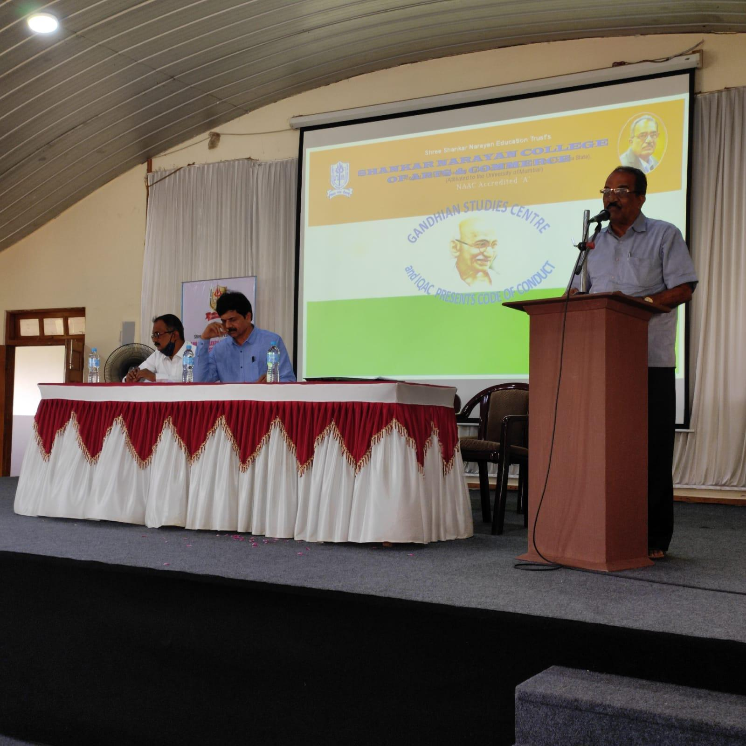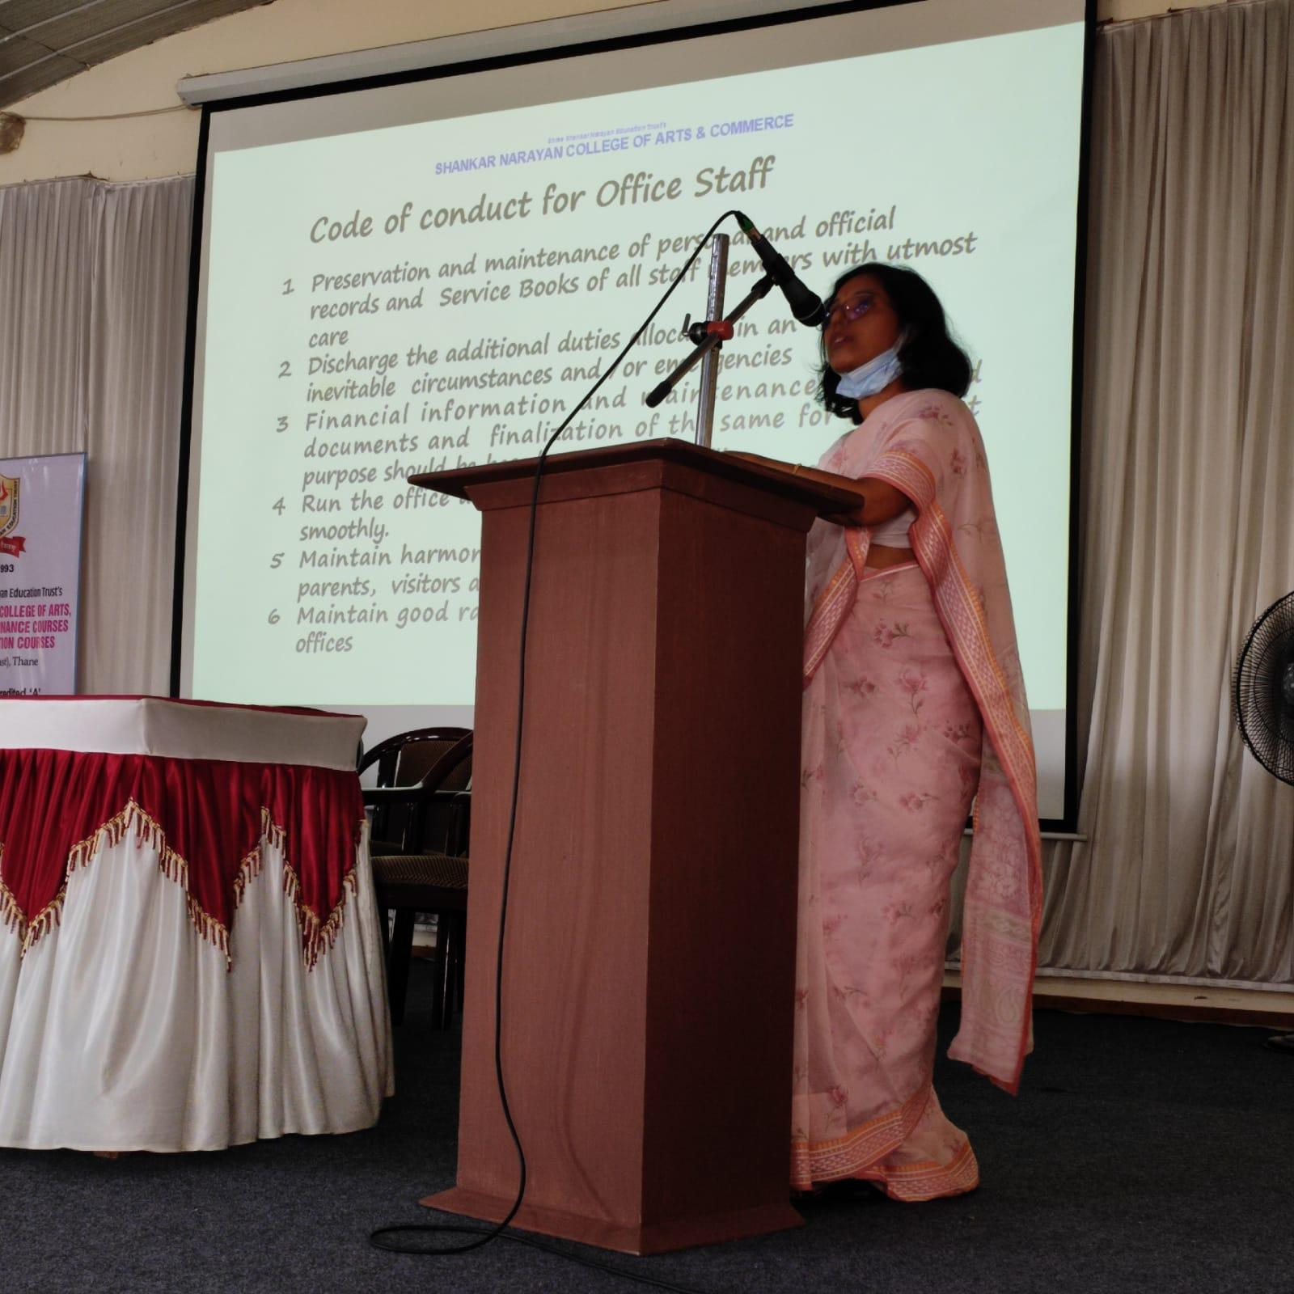
AWARENESS AND RELEASE OF CODE OF CONDUCT 1st April 2022

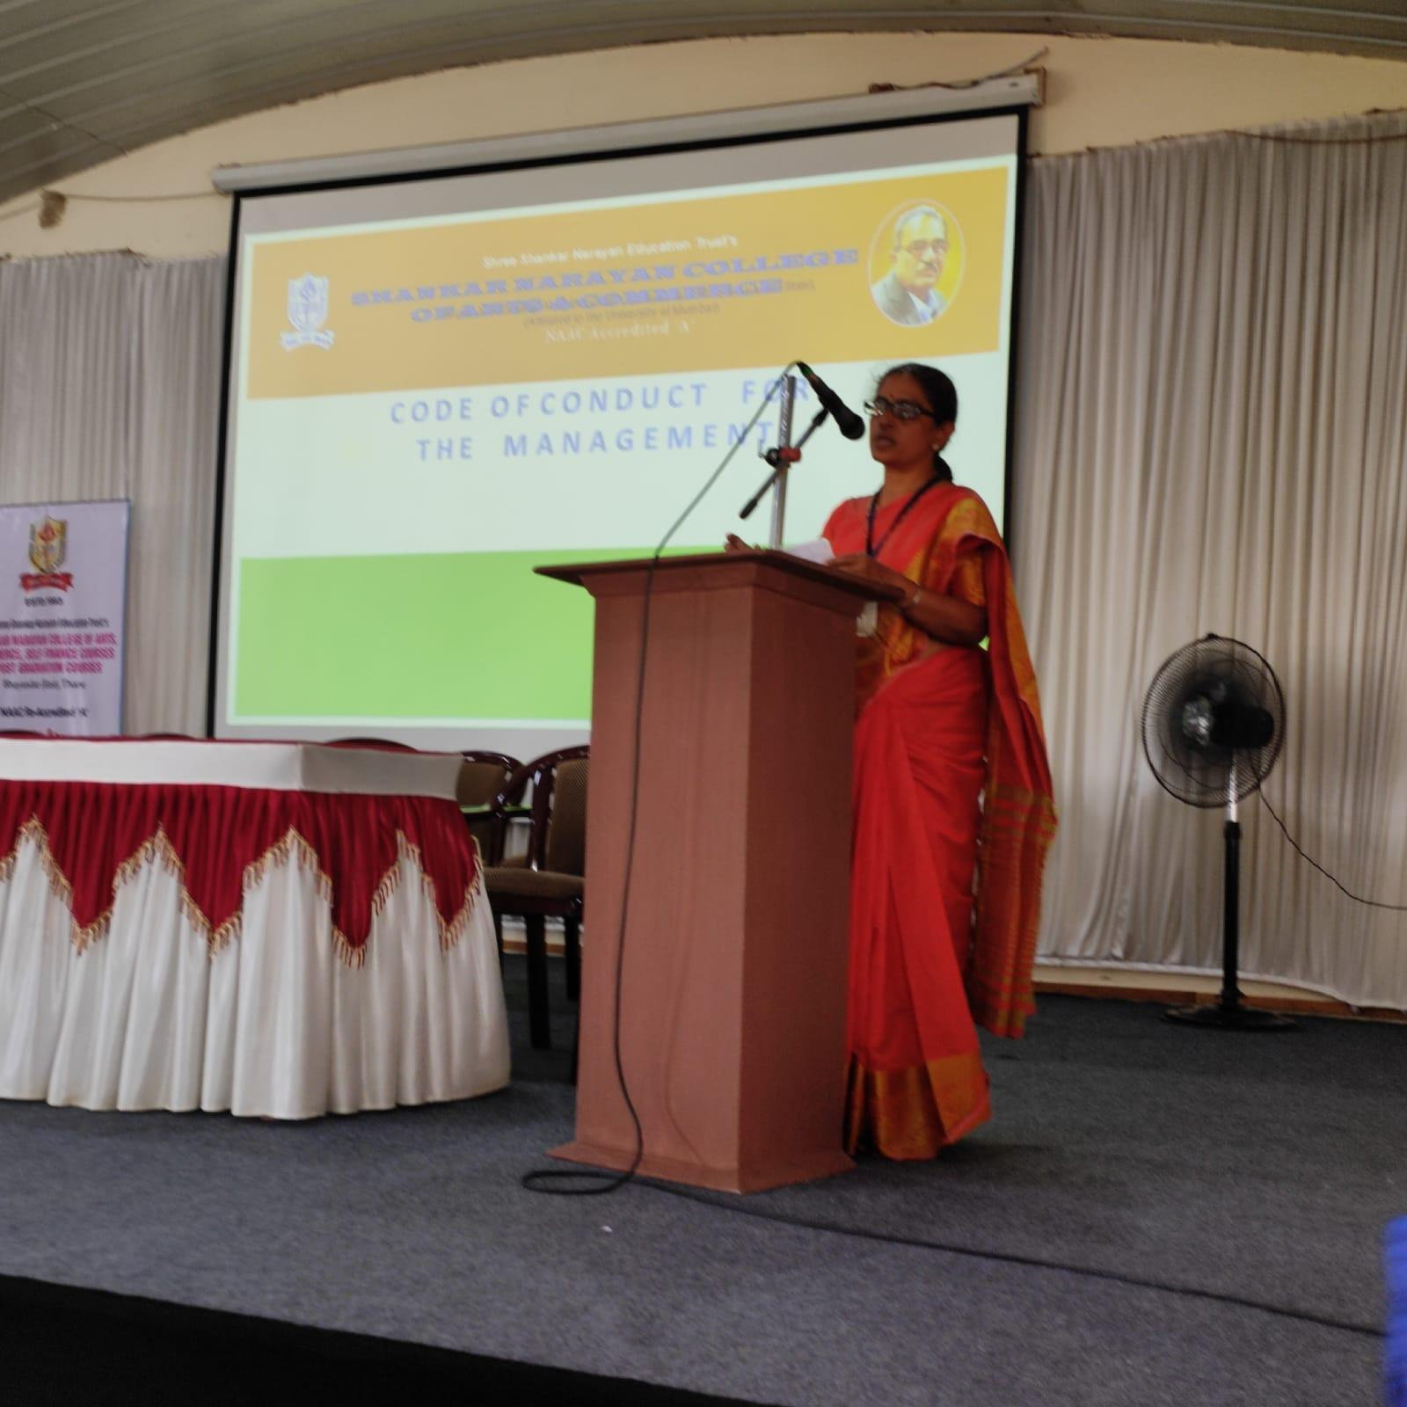
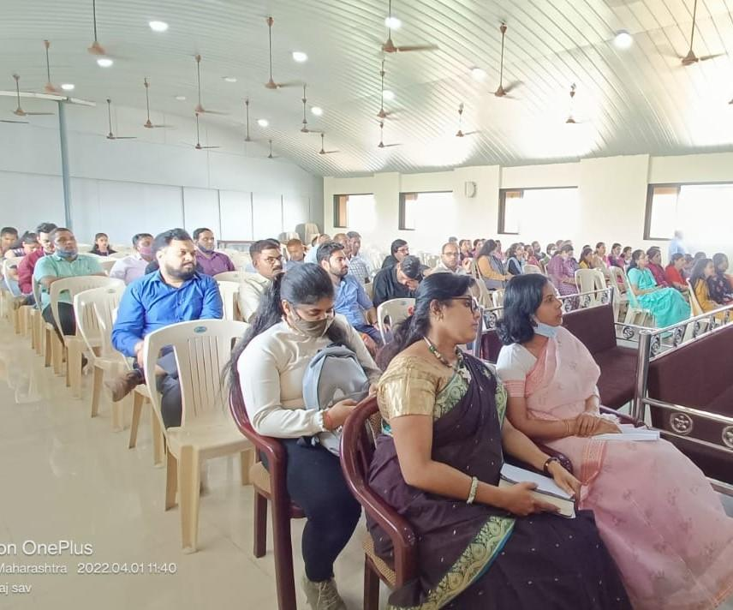
AWARENESS AND RELEASE OF CODE OF CONDUCT 1st April 2022

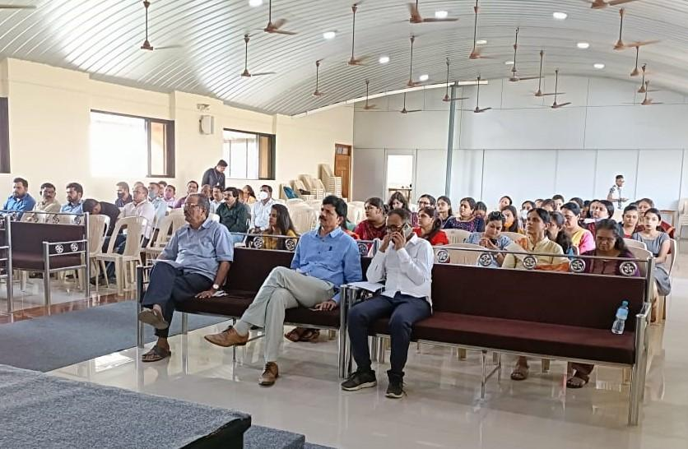

AWARENESS AND RELEASE OF CODE OF CONDUCT 1st April 2022

2022-2023

Gandhian Studies Centre conducted seminar “Relevance of Gandhian Thoughts in Contemporary World” on 30th September 2022 in the Auditorium, Main Building. The speaker for the Seminar was Dr Hubnath Pandey, Head of the Hindi Department, University of Mumbai, member of Sarvodya Mandal and Social activist. In his speech he told about Gandhiji's views on Indian diet in particular about scientific basis of vegetarian diet. He explained Gandhiji's views on the importance of speaking truth in life. He emphasized that Gandhiji stressed on character of individual in terms of good and bad habits. Students learn about the significance of ethics and morals in one's life. The honorable Chairperson Shri Rohidasji Patil, Secretary Shri Maheshji Mhatre and Principal Dr V N Yadav were present for the programme. Also, 265 students and 12 Teaching staff were present for the seminar.
On 2nd October, 2022 the members of Gandian studies centre, teachers and students were present in the college campus to pay homage to Father of Nation.
The Gandhian Studies Centre observed Khadi Day on 3rd October 2022 on the occasion of 154th Birth Anniversary of Mahatma Gandhi. All the students, teaching and non-teaching staff were appealed to wear Khadi Dress to promote handwoven khadi for 'Gram Udyog' - Rural selfemployment and it was followed by all. The students from Gandhian Studies Centre gave short speech on the process of khadi wooven and Art in all the class rooms. Subsequently, the Pledge for non-violence and peace was given in all classrooms by members of Gandhian studies centre. Thus Gandhian Studies Centre celebrated Gandhiji's 154th birth anniversary by conducting various programmes.
On 30th January 2023 seminar on Gandhiji's Assassination was conducted by Gandhian Studies Centre. The speaker for the Seminar was Prof Sunil Dhapse, Department of History and social activist. This seminar was conducted to observe death anniversary of Gandhiji. Prof Dhapse sequentially unfold historical milestone in Gandhiji's activities for the nation. He explained that though Gandhiji's work including non-violence philosophy was adhered and followed by majority, few people were against his idealism. Gradually, the negativity raised to a vast extent. This eventually lead to Assasination of Gandhiji. This seminar was intended to threw light on Gandhiji's thoughts of non-violence and attempted to reduce myths about his assasination. For this seminar 57 students, 10 teachers and Principal Dr V N Yadav were present. The seminar was successful with extended cooperation from Management, Principal and Members of GSC.

Dr. Shital Khadakkar, Coordinator Gandhian Studies Centre

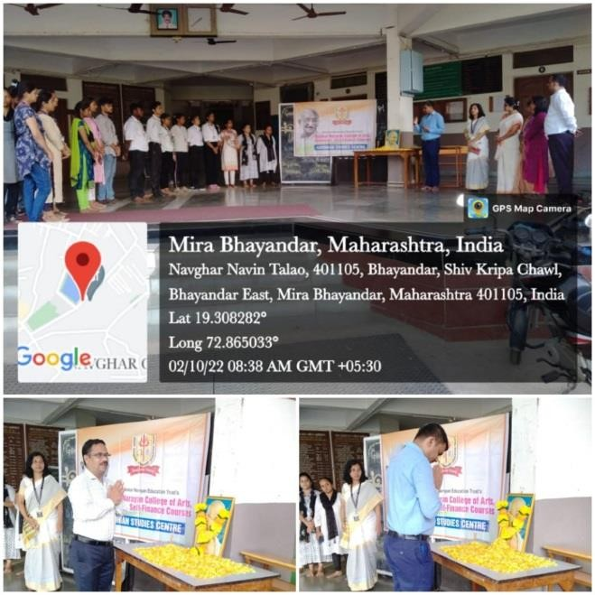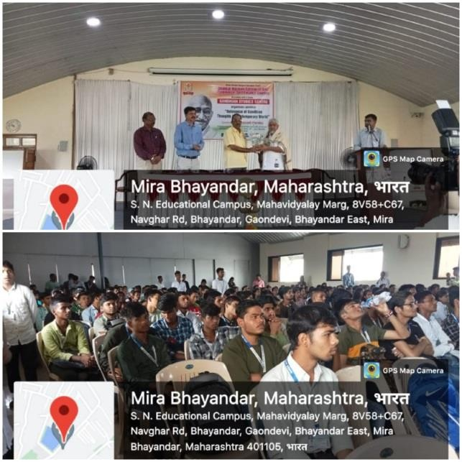
2nd Oct 2022-Birth Anniversary of Mahatma Gandhi
28th Sep, 2022 Seminar: Shri Rohidasji Patil, Chairperson of Shankar Narayan Education Trust felicitating Dr. Hubnath Pandey, Professor, University of Mumbai and Social Activist

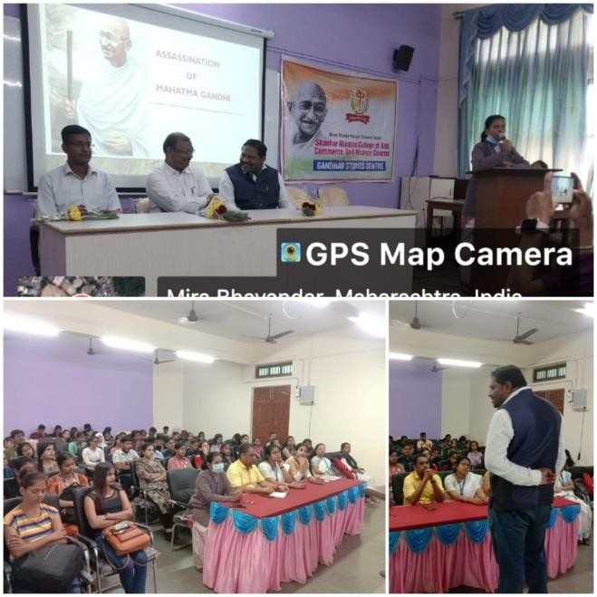
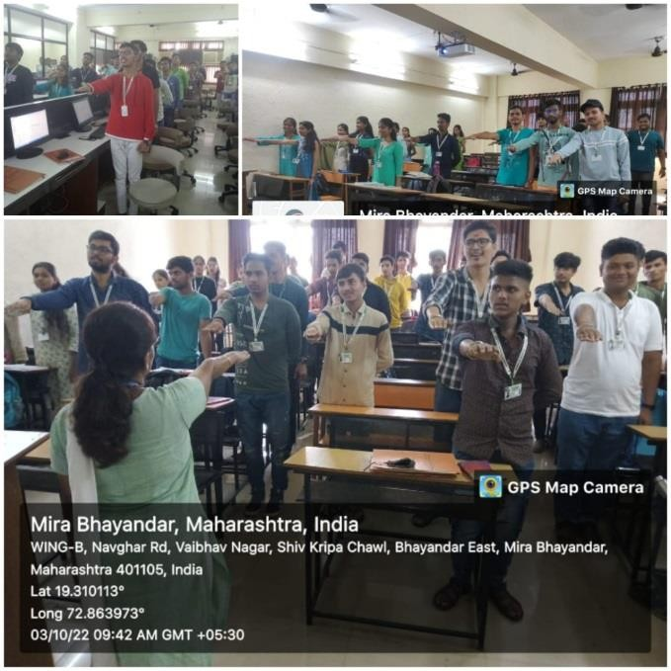
30th Jan, 2023-Prof Sunil Dhapse, Department of History delivering speech on Assassination of Gandhiji
3rd Oct, 2022 Pledge given in class rooms for Nonviolence and peace

7.1.1. National Cadet Corps [NCC]
Objectives:
  - To develop character, comradeship, discipline, leadership, secular outlook, spirit of adventure, sportsmanship and ideas of selfless service amongst the youth of the country.

  - To create a human resource of Organized, trained and motivated youth to provide leadership in all walks of life and always be available for the service of the nation.

  - To provide us suitable environment to Motivate the youth to take up the careering the Armed force.

Major Activities:

2018-19
Celebrated Independence Day in the college campus at 8.30 am
Recall the memories of Surgical Strike Day on 29th September, 2018
Swachha Bharat Abhiyan undertaken in the college campus on 15th June, 2018
Republic Day celebrated by performing drill on 26th January, 2018 at 8.30 am
2019-20
Guards of Honour performed on Kargil Vijay Diwas to pay homage to martyed in kargil war on 26/07/2019
Celebrated Independence Day in the college premises
Tribute given to Mahatma Gandhi on Mahatma Gandhi Jayanti in association with Thane District Traffic Police
Celebrated Independence Day by performing NCC Drill
Republic Day celebrated by performing drill in the college campus
2020-21
Guards of Honour performed on Kargil Vijay Diwas to pay homage to martyed in kargil war on 26/07/2020
Guards of honour performed to Martyr Soldier in Pulwama Attack on 26/11/2021
Participated in FIT INDIA CYCLUTHON, FIT INDIA DECEMBER CAMPAIGN 2020-21 – 1st – 25th January organised by Government of India Ministry of Youth Affairs and Sports
2021-22
Guards of Honour performed on Kargil Vijay Diwas on 26/07/2021
Celebrated Independence Day in the college premises
Republic Day celebrated on 26th January at by performing drill in the college campus at 8.30 am.

Activities conducted for the year 2022-23
Yoga session arranged on 21st June 2022 at 10.00 am on the occasion of International Yoga Day, 14 cadets participated in Yoga session.
NCC in collaboration with NSS and Cultural Committee organised inaugural function of 75 years of India’s Independence. On the same day tribal day was celebrated by portraying Tribal culture and also mass anthem was sung.
Celebration of Independence Day at 9.00 am and organised rally on Swachha Bharat Campaign at 11.00 am from college to Bhayander station.
Shock Shastra was arranged to pay tribute martyrs of 26/11 Mumbai Taj attack in college campus. 12 cadets performed.
Republic Day celebrated on 26th January at 9.00 am in the college campus.
Shock shastrahass arranged to pay tribute to martyrs in Pulwama attack on 14th Feb. at 11.00 am, 26 cadets participated in program.

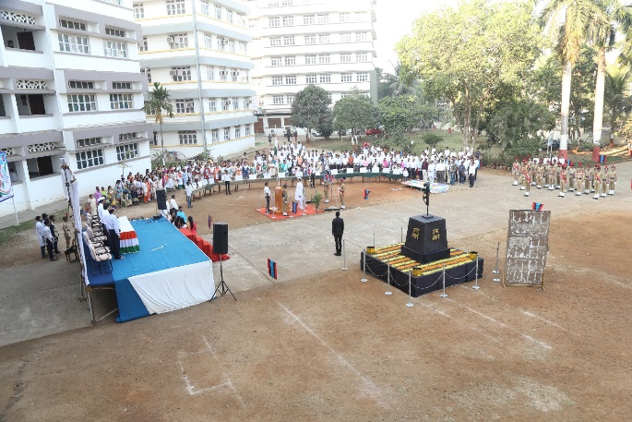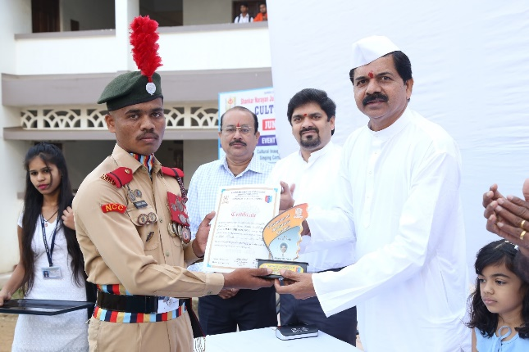

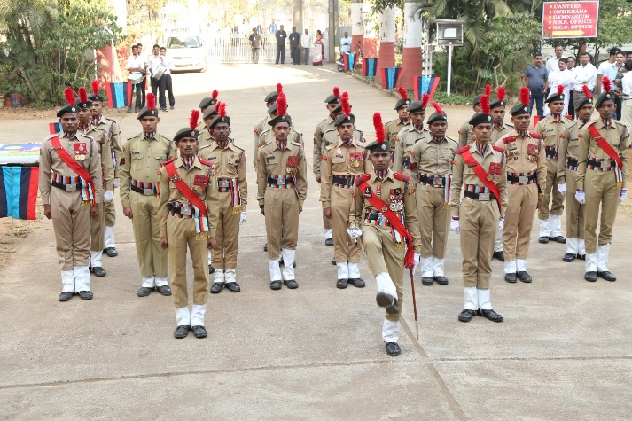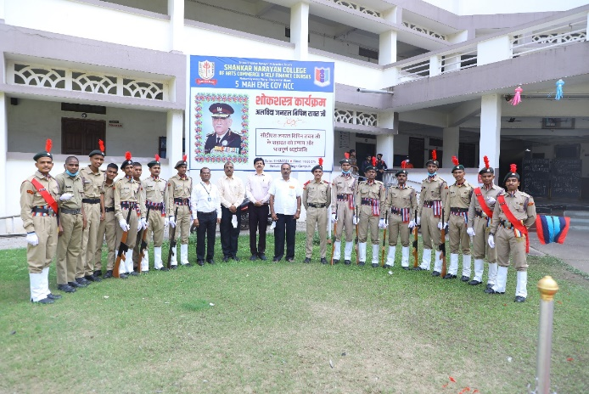

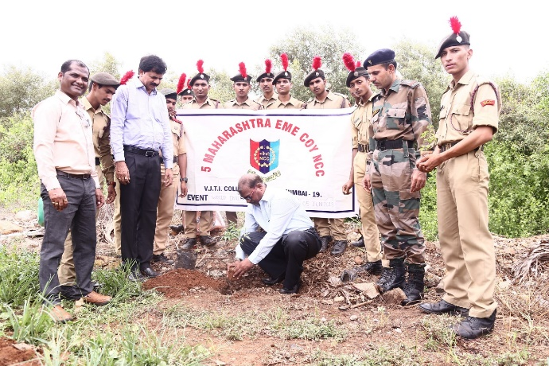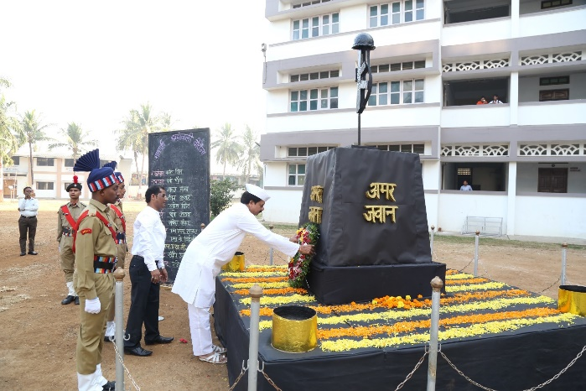
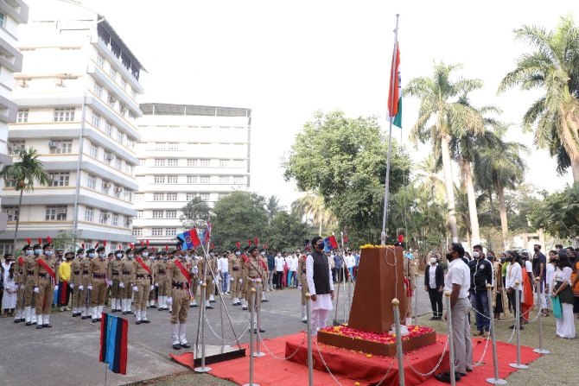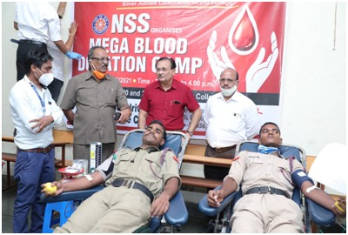
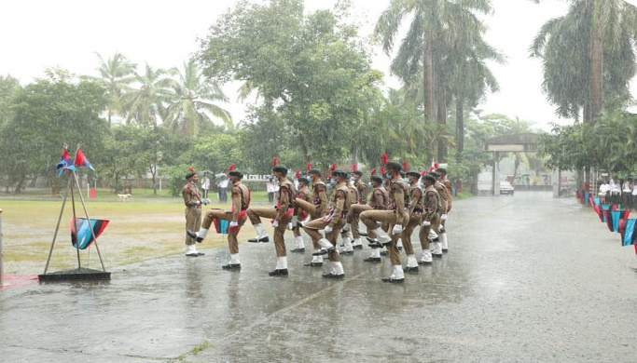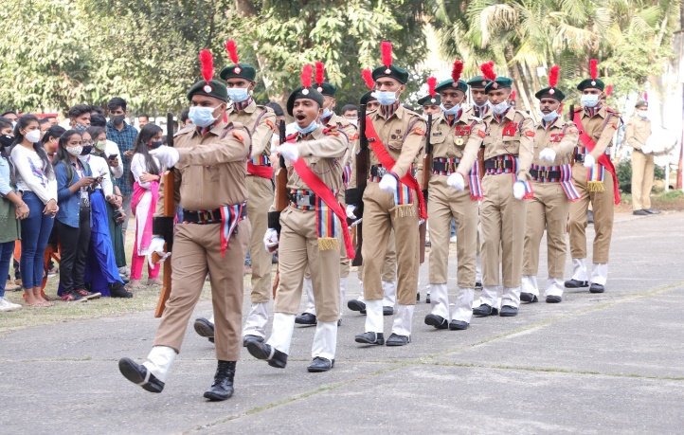

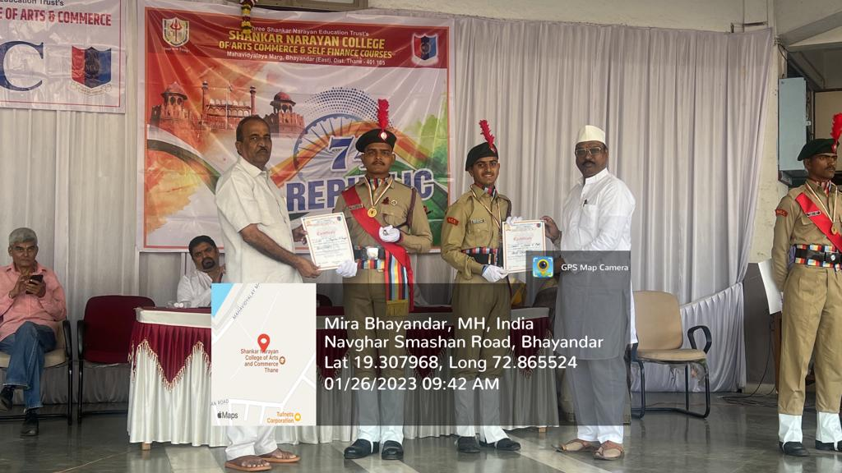

Awarded NCC cadets on Republic Day with Certificates and medals

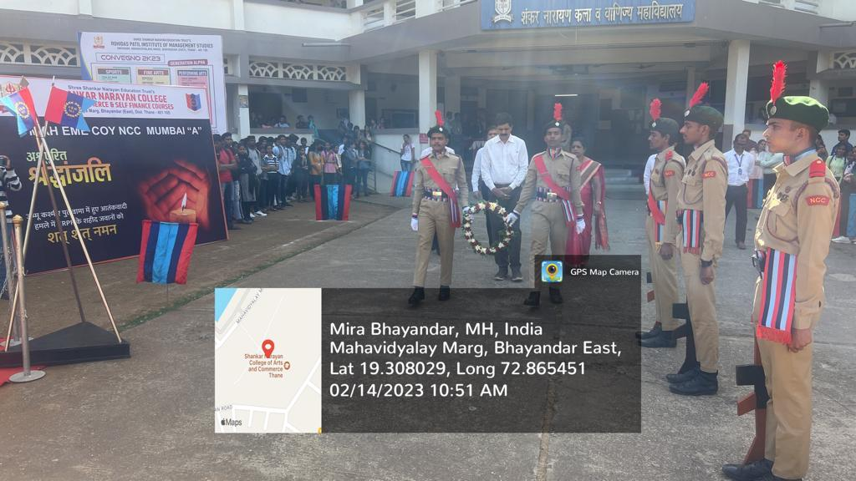
Shock shastrahass arranged to pay tribute to martyrs in Pulwama attack
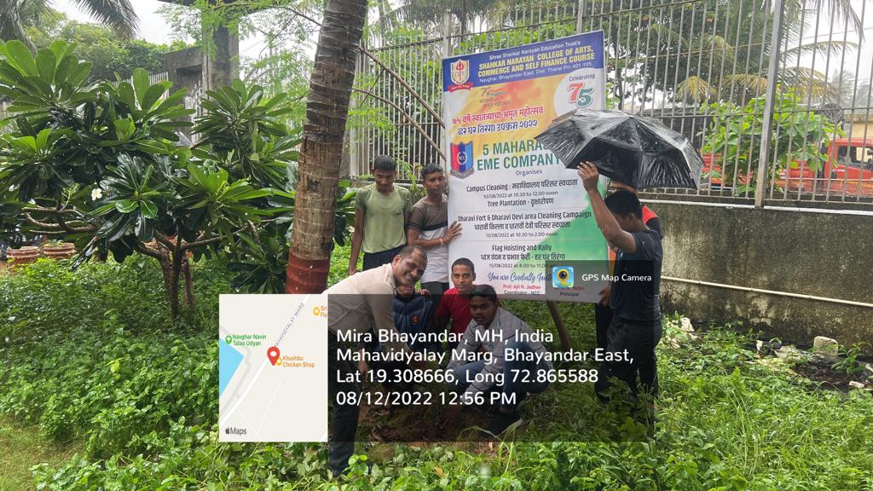
Tree Plantation in College Campus
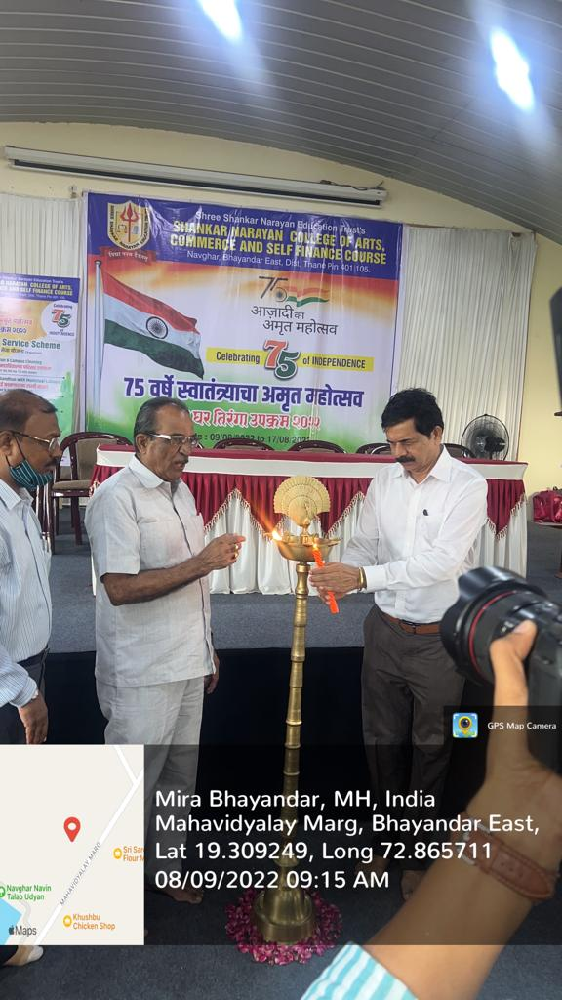

Inaugural of Celebrating 75 Years of Independence

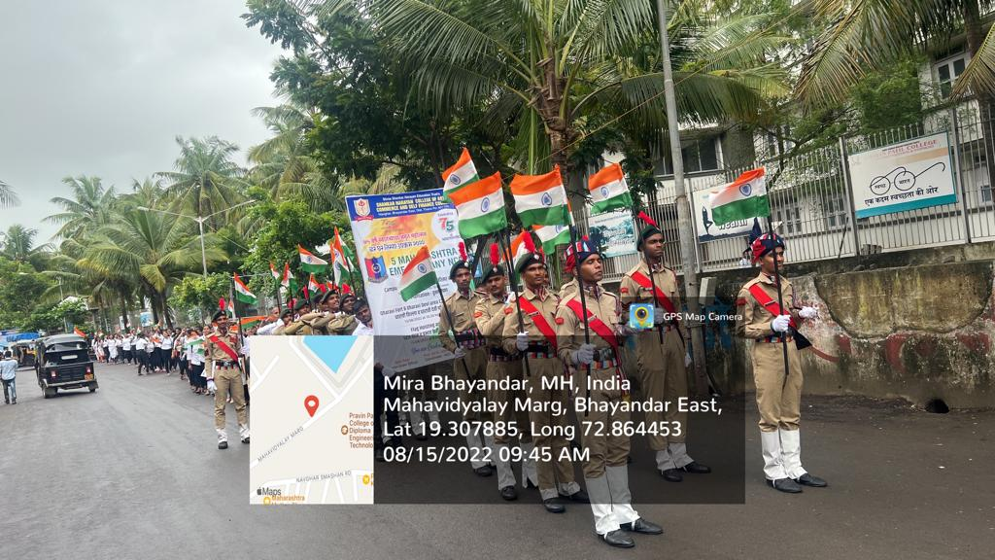
Rally on Swachha Bharat Abhiyan on 15th August

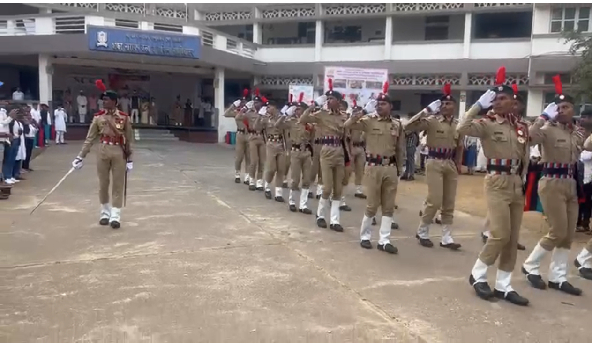
NCC parade on Republic Day of India

7.1.1. NATIONAL SERVICE SCHEME (NSS)

NATIONAL SERVICE SCHEME

YEARLY REPORT 2018-19

N.S.S. Cell, University of Mumbai has allotted three units to our college for the year 2018-19. This year we allotted two units for Arts and Commerce and one unit for Self-Finance. In this manner 200 students from B.com, B.A. and 100 from Self-Finance Courses were enrolled for three units. On 27th July the N.S.S. P.O. Prof. Chandrakant Khune, Prof. Shital Khadakkar and Prof. Sandeep Burken organised orientation programme for
N.S.S. volunteers for the awareness about N.S.S. unit and its activities.

N.S.S. unit of our college organised various activities under the guidance of our principal Dr. V.N.Yadav.

1) WORLD YOGA DAY
The college NSS unit decided to celebrate the International Yoga Day on 21st June for the academic year 2018-19. As per the plan, we did the publicity of it by the day of notice and mouth publicity. We informed all the interested people to come in the college auditorium at 9:00 am to participate on Yoga Day. Prof. Amol bavaskar and Sunil Dhapse, Yoga trainer has been invited on that day to conduct the Yoga session.
On 21st June, 2018, Sunday, students, NCC cadets, NSS volunteers as well as teaching and non-teaching staff were present at 9:00 am in auditorium of the college. Shri Rohidasji Patil graced the occasion by lighting the lamp and inaugurated the yoga session. Prof. Amol bavaskar and Sunil Dhapse started the yoga session with prayer and conducted various as ans, Vajrasns, Padmasan Dhanuvrasan etc. which are most useful for human beings and to get relief from stress. It was 2 hours session, 70 participants were present for the same.

2) PULSE POLIO (28/07/2018):-
Pulse polio activity was organised in our college by the NSS volunteers. 31 volunteers participated in the event.

HEALTH AWARENESS PROGRAMME 28th September 2018
NSS unit of our college has organised Health Awareness Programme on 28TH August, 2018. We have started this programme at 10:30 AM To 12:30 PM. In this programme there are 69 volunteers. health awareness programme there are 2 leaders. Behind every leaders there are 22 students.We had gone our college adopted area i.e. Indira nagar. We went door to door. And ask some questions…

N.S.S. DAY CELEBRATION (24-09-2018)
On this day all the NSS volunteers gathered in the college campus for the celebration of NSS day celebration. On this day there was cleaniness awareness and anti-plastic rally from college to bhayander station.

GENDER SENSITISATION (28-09-2018)
NSS unit of Shankar Narayan College organized workshop on 28th Sept, 2018. In this workshop around 100 students participated. To take this lecture prof. Aruna madam had come from Abhinav college and one lady professor was from our college.

GANDHI JAYANTI
NSS Unit of Shankar Narayan College celebrated Gandhi Jayanti on 2nd Oct, 2018.The event started at 7:30 am from college with rally. Around sixty students participated in this rally. The rally started from college to Bhaynder station…

VOTERS ID REGISTRATION (1-10-2018 TO 30-10-2018)
In this event the students whose age was above 18 or at the age of 18 were allowed for making of the voters ID. All the students were allowed to fill the form with the help of the officer of the voters ID department. In the event there were 37 students who filled up the form of the voters ID.

HIV AWARENESS
The aids awareness activity was conducted by the red ribbon club in the first week of December from 1st December to 6th December 2018. On 1st Dec. Tag distribution, rally and street play were organized in which 300 participants has participated. On 2nd dec. The street play was organized in the local area 23 student has participated in the event. On 3rd dec. Seminar and counseling of this activity was conducted in that 186 student has participated. On 4th dec. There was also a seminar and counseling of this activity and 78 volunteer were in this activity. On 5th and 6th dec. There was a poster exhibition on the aids awareness in which 95 participant had participated.

YEARLY REPORT 2019-20

N.S.S. cell, university of Mumbai has allotted three units to our college for the year 2019-20. This year, we allotted two units for Arts and Commerce and one unit for Self-Finance. In this manner 200 students from B.com, B.A. and 100 from Self-Finance Courses were enrolled for three units. On 27th July 2019 ,the N.S.S. P.O. Prof. Chandrakant Khune, Prof. Sheetal Khadakkar and Prof. Sandeep Burken organised orientation programme for N.S.S. volunteers for the awareness about
N.S.S. unit and its activities.

N.S.S. unit of our college organised various activities under the guidance of our Principal DR. V. N. Yadav.

WORLD YOGA DAY 21st June 2019
The college NSS unit organised the International Yoga Day on 21st June for the academic year 2019-20. As per the plan, we did the publicity of it . We informed all the interested people to come in college auditorium at 9:00 am to participate in World Yoga Day. Yoga trainer had been invited on that day to conduct the Yoga session.
NSS volunteers as well as teaching and non-teaching staff were present at 9:00 am in auditorium of the college. Shri Rohidasji Patil graced the occasion by lighting the lamp and inaugurated. Ambika yoga center conducted Yoga session with prayer and started with various aasans, Vajrasan, Padmasan and Dhanuvrasan etc. which are most useful for human beings and to get relief from stress. It was 2 hours session, 79 participants were present for the same.

INDEPENDENCE DAY CELEBRATION/PRABODHAN GRANTHALAY 15th August 2019.
On 15th August. 2019,NSS Volunteers celebrated independence day 200 volunteers were present.

OPENING OF PRABHODAN GRANTHALYA.
On 15th August 2019 college unit started prabhodan granthalya in adopted area Indira nagar slum. 200 volunteers were present.
❖

DISTRIBUTION OF VARIOUS GROCERIES TO FLOOD AFFECTED IN KOLHAPUR DISTRICT.
For the Kolhapur and Sangli flood affected area people, our college sent help on 16th AUGUST 2019, in the form of day to day use goods. 20 volunteers were present.

CELEBRATION OF COLLEGE FOUNDATION DAY CELEBRATION & ANTI-PLASTIC CAMPUS HELP On 19th SEP 2019.
ON 19 Sept2019 NSS Volunteers celebrated college foundation day.On this occasion NSS Unit awareness about importance of Anti-plastic free society. 76 volunteers were present.

N.S.S. DAY CELEBRATION & CLEANLINESS PROGRAMME AT BHAYANDER RAILWAY STATION 24th SEP 2019
On this day all the NSS volunteers gathered in the college campus for the celebration of NSS day celebration. On this day there was cleanliness awareness and anti-plastic rally from college to Bhayander railway station. 29 volunteers were present.
- COSTITUTION DAY CELEBRATION.

On the occasion of constitution day, NSS Unit and department of Political science organised constitution day on 26th November. 39 volunteer were present.

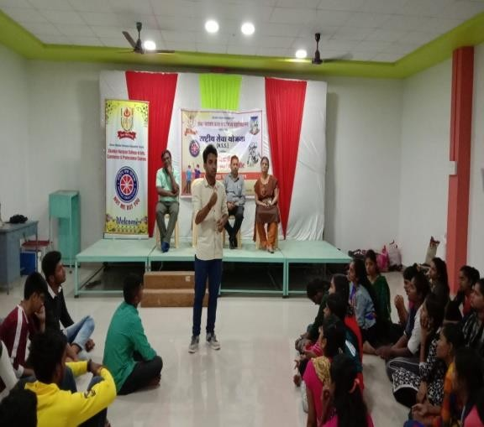
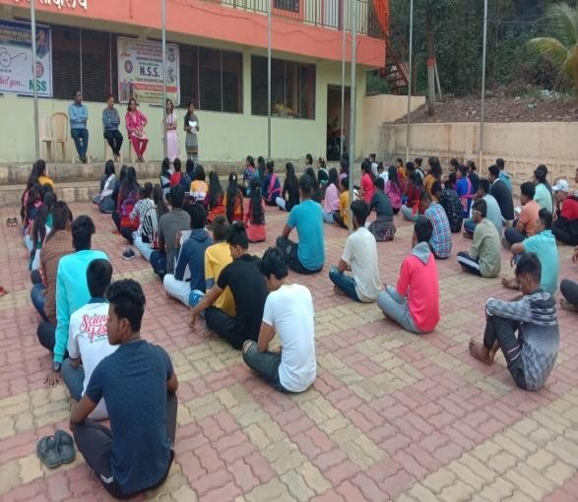

2019-2020
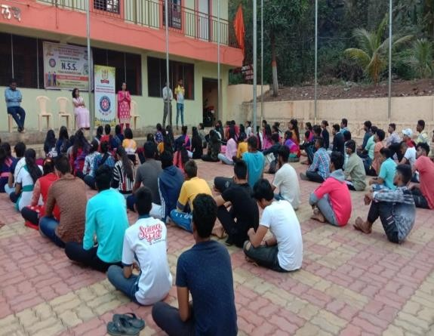
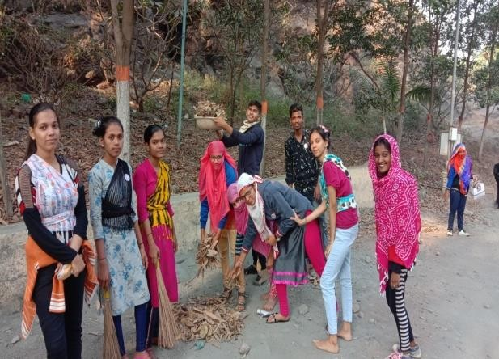

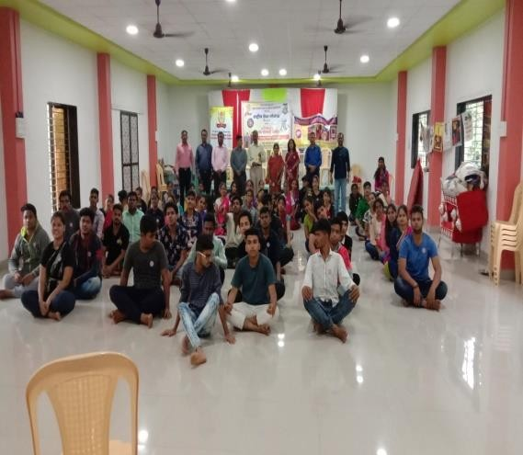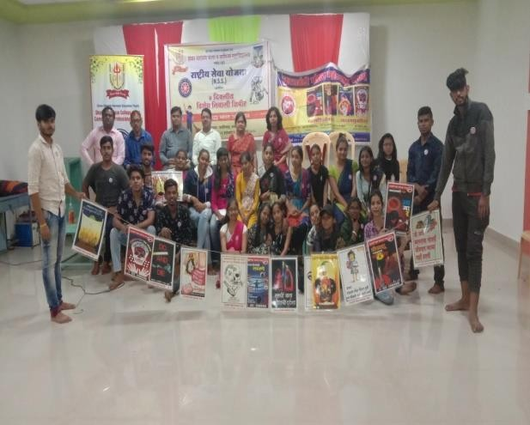

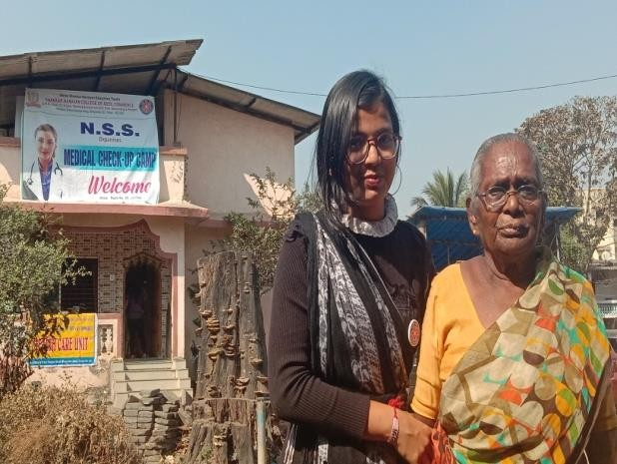
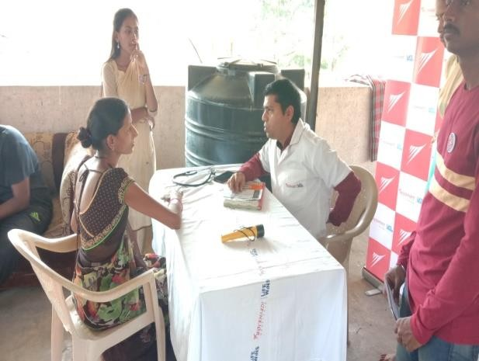

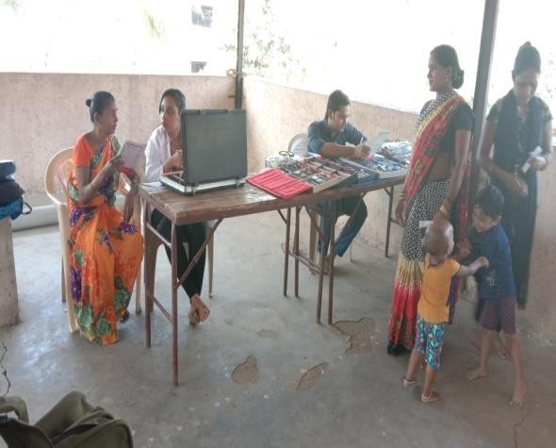
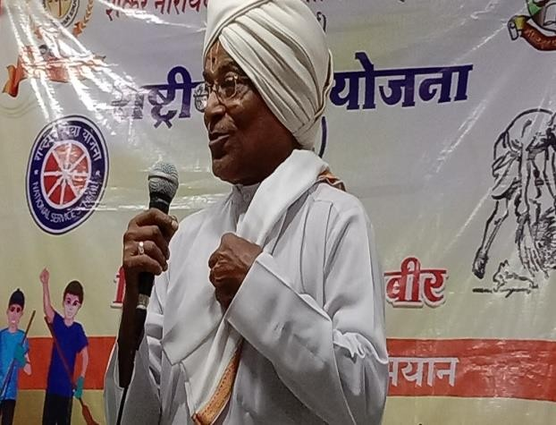

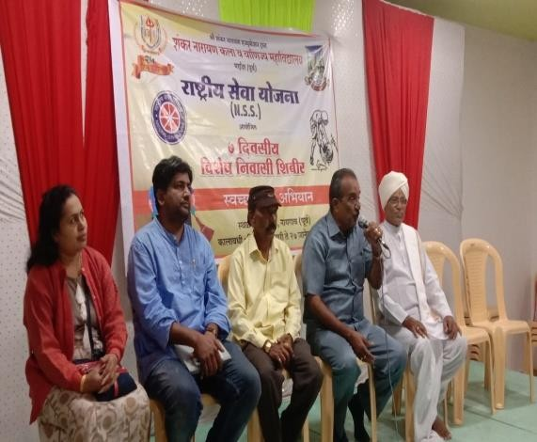

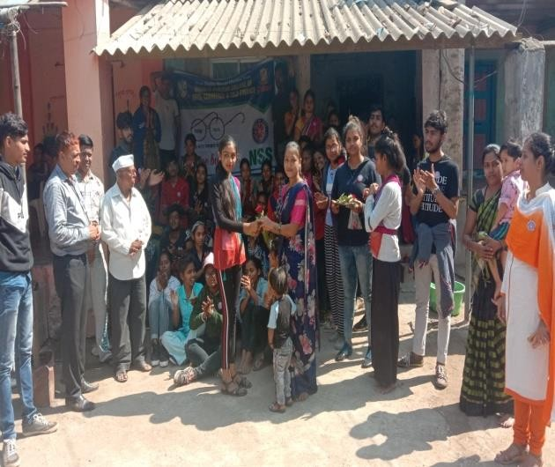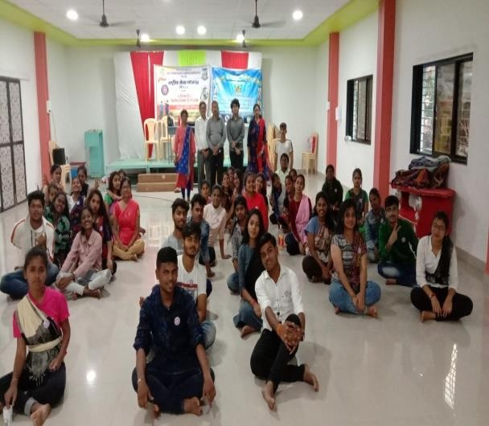

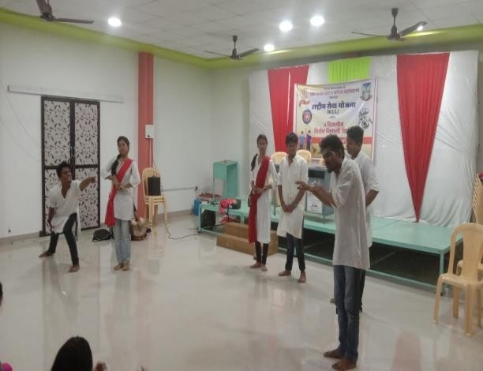
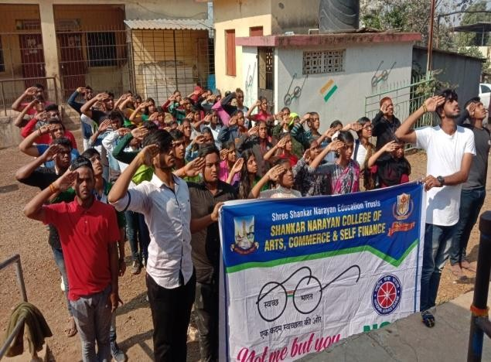

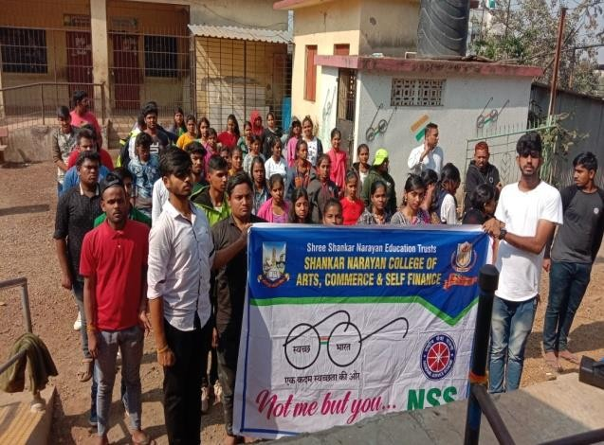
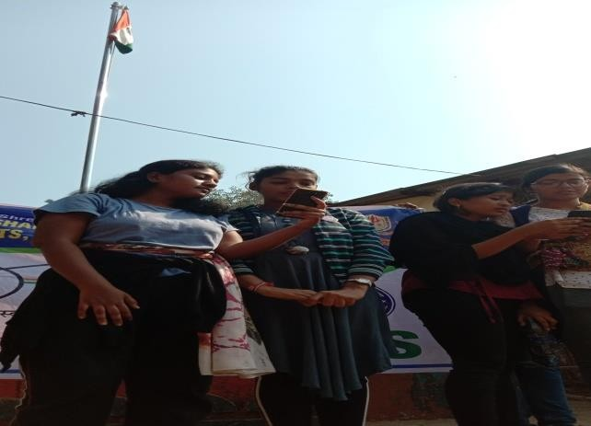

NSS ACTIVITY REPORT 2020-21
N.S.S. cell, university of Mumbai has allotted three units to our college for the year 2020-21. This year, we allotted two units for Arts and Commerce and one unit for Self-Finance. The N.S.S. P.O. Prof. Chandrakant Khune, Dr.. Sheetal Khadakkar and Prof. Sandeep Burken
N.S.S. unit of our college organised various activities during COVID- 19 pandemic, under the guidance of our Principal Dr. V. N. Yadav.

WORLD YOGA DAY
The college NSS unit organized the International Yoga Day on 21st June for the academic year 2020-21. As per the plan, we did the publicity of it , our nss volunteers made posters and slogans in World Yoga Day.

INDEPENDENCE DAY CELEBRATION/PRABODHAN GRANTHALAY 15th
August 2019.

On 15th August. 2020,NSS Volunteers celebrated independence day volunteers were present for this event.

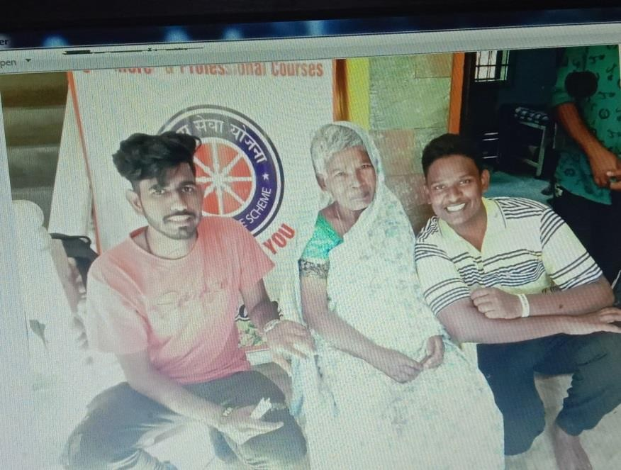
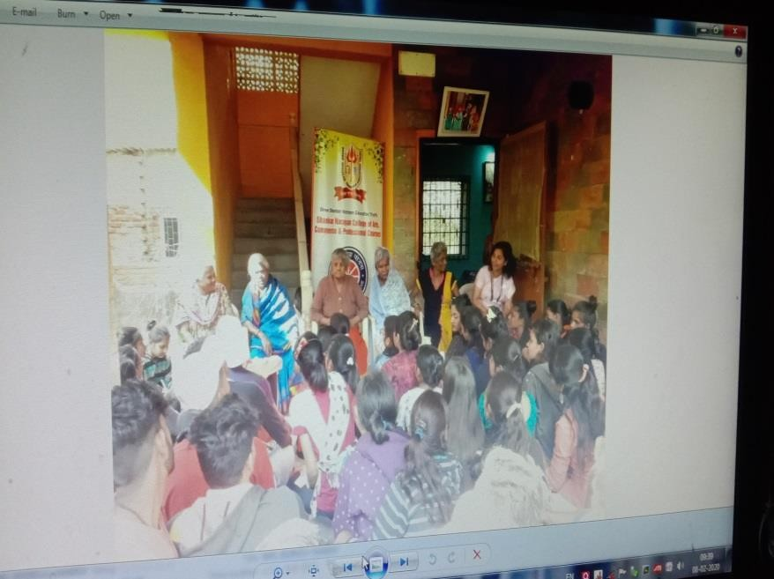v

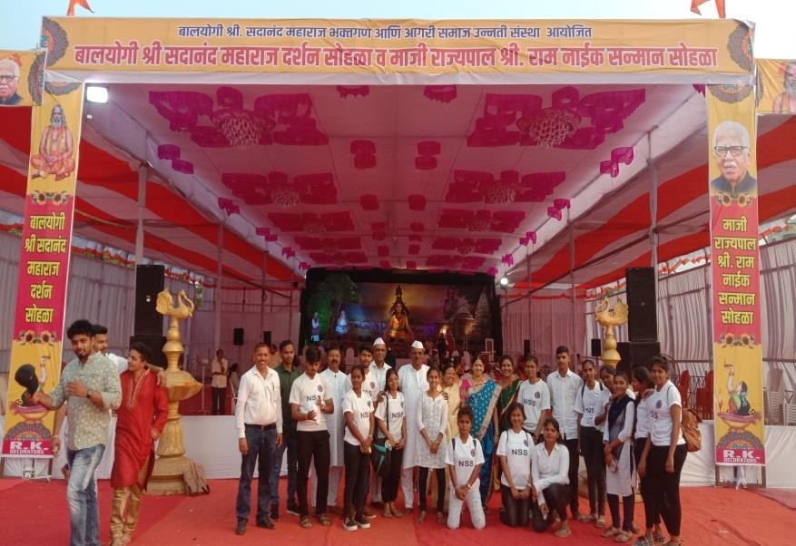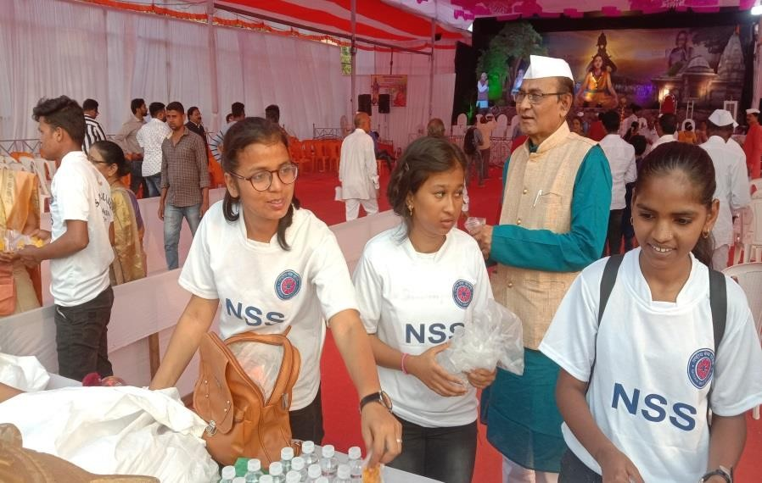

Social Service in Parayan in Aagri Samaj Mandir, Bhayandar East
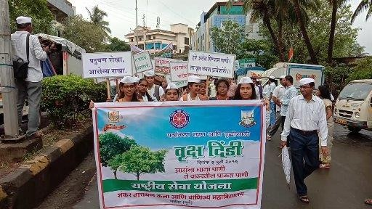

Vruksh Dindi in Mira Bhayandar

NSS Annual Report- 2021-22
The NSS unit of Shankar Narayan College organised various activities during the current academic year 2021-22. Our college has 03 NSS unit Comprising of 03 Programme Officers and 300 volunteers. The activities conducted includes Health and hygiene, Environment Conservation, Celebration of important days, Pledge relating various social issues, etc in accordance to the guidelines and circulars issued from University of Mumbai, Central Government, State Government and local authorities. All the activities undertaken under the guidance of Respected Principal-Dr. V N Yadav, support of college Management and regular co-operation from Area Coordinator- Prof. Aruna Gujar. Brief report of the activities undertaken are as follows:
1. 21st June, 2021
11 volunteers- 07 females and 04 males attended Webinar on ‘National Yoga Day’organised NSS unit of Siddharth College of Arts, Science & Commerce.
- 10th October, 2021
05 volunteers- 03 female and 02 male participated in Webinar on ‘World Mental Healthy Day’ organised by NSS Unit, Bhavans College, Mumbai.
- 1st December, 2021
10 volunteers- 05 females and 05 males attended National Webinar ‘ End Inequalities, End Aids’ on the occasion of World HIV-AIDS Day organised by NSS unit and Red Ribbon club of S.M. Shetty College of Science, Commerce and Management studies.

Constitution of India and Voting Rights of Citizens of India (07 Activities)
- 22nd November, 2021
36 volunteers- 19 females and 17 males involved in ‘Voting awareness programme’. This programme included sticking bills and displaying banners at various college notice boards and at prominent spots of college campus. For spreading voting awareness our volunteers distributed pamphlets to vendors, shopkeepers, auto drivers, etc considering them as facilitators for spreading voting awareness among people in Mira- Bhayander area.
- 26th November, 2021
83 volunteers- 62 females and 21 males watched a short film on ‘Making Constitution of India’. The link was shared by NSS unit of our college. The Volunteers learnt how constitution of India was scultured after discussion held for every article in the constitution.
- 26th and 27th November, 2021
41 volunteers- 18 females and 23 males participated in reading of ‘Preamble To the Constitution’ appealed by Ministry of Parliamentary Affairs, Government of India. Every year our volunteers acquainted with important features of Indian Constituion-Equality, Sovereignity and fraternity to maintain harmony, botherhood and overall nation’s development.

- 28th-30th November, 2021
The Voter’s Registration campign held in N.S.S Office. During this campign total 276 students above 18years were registered for voters’list.
- 25th January, 2022
A Webinar on ‘Electoral Literacy for Stronger Democracy’ on the occasion of voters’ day was organised by NSS unit of our college. The speaker for the event was Prof. Aruna Gujar, Department of Political Science, and NSS Area Co-ordinator. She explained how voting rights are important for the development of the country and hence registration for voters’ ID to be done by every eligible citizen.

- 26th January 2022
A quiz on Republic day was organised by Science Association and Electoral Club and Bharat College of Arts and Commerce, Badlapur. 01 female and 01 male volunteer participated in the quiz.
- 26th January, 2022
Online quiz on National voters day was conducted by IQAC and Distance of Lifelong learning and extension Unit, Tolani College of Commerce. 05 females and 12 males volunteers participated in the quiz.

Women Empowerment
1. 17th June, 2021
05 Volunteers-3 Females and 02 males volunteers attended Webinar On "Opportunities for Self Employment" Jointly Organized by IQAC and Alumni Association , Siddharth College Of Arts , Science & Commerce, Fort, Mumbai.
- 28th September, 2021
02 female volunteers participated in National Level Webinar on Eradication of Blind Faith organised by NSS UNIT in Association With Arts Department, S.S.T. College of Arts & Commerce, Ulhasnagar, Thane.
- 21st December, 2021
10 volunteers- 04 females and 06 males attended one day National Workshop on ‘Gender Audit’ held by WDC and IQAC of KJ Somaiya College of Arts and Commerce, Vidyavihar, Mumbai. They get knowledge on importance of evaluation of policies for gender equality.
- 24th January, 2022
A National- Girl Child Quiz was Conducted by NSS unit, D.T.S.S. College of Commerce, Malad, Mumbai. 08 females and 02 males volunteers participated in this quiz.

Days celebration/Birth anniversary (6 Activities)
1. 25th June, 2021
07 volunteers- 05 females and 02 males volunteers participated in E-Quiz on Birth Anniversary of Rajashri Shahu Maharaj organised by NSS Unit, Siddharth College of Arts, Science & Commerce, Fort, Mumbai.

- 15th August, 2021
Ensuring measures to follow covid appropriate behaviour, 14 volunteers and 3 programme officers were present for flag hosting ceremony on the occasion of Independence day.
Honourable chairperson of Shankar Narayan Education trust Shri Rohidasji Patil address importance and contribution of NSS unit in spreading awareness regarding appropriate measures to tackle COVID 19 pandemic situation in the country.

- 15th September, 2021
06 volunteers-4 female and 2 male participated in inter-collegiate webinar ‘Adhunik siksha mein hindi bhasha ka mahatva' organised by NSS Unit, S. M.Shetty College of Science, Commerce and Management Studies, Powai, Mumbai. The volunteers gain information regarding the importance of hindi language in this contemporary world.
- 24th September, 2021
The NSS day celebrated by undertaking cleanliness programme. Cleanliness, sanitation and beautification of college campus was done by our volunteers. This event was attended by 34 present volunteers, 7 ex-volunteers and College management. During the celebration, Chairperson of our college Shri Rohidasji Patil felicited Mr. Atul Jamunaprasad Rajak, ex volunteer felicitated for his achievement - India’s Book of record in obtaining maximum certificates in NSS activities.
- 4th October, 2021
04 volunteers -02 male and 02 female participated in Quiz Competition on Occasion of International Non-Violence day organised by NSS unit of B. Harris College of arts and A.E.Kaleskar College of Commerce and Management.
- 12th January, 2022
An Online Quiz Competition on ‘National Youth Day’ held by Student Council, K J Somaiya College of Science and Commerce, Vidya vihar, Mumbai on the occasion of Birth Anniversary of Swami Vivekanand. 19 female and 18 male volunteers participated in this quiz.

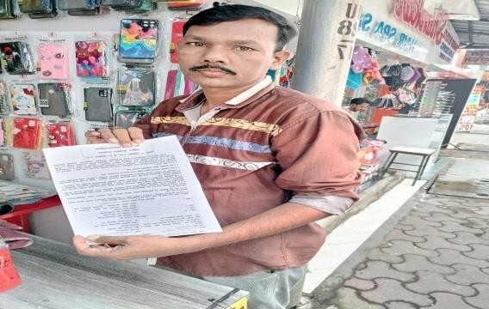
Voter Awareness among Society

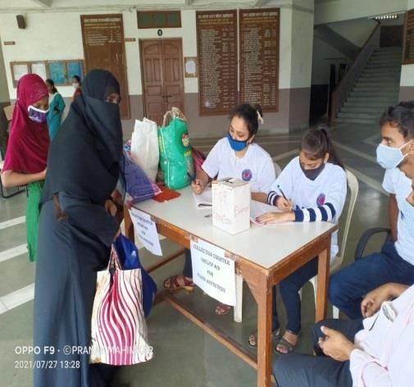

Annual Report 2022-2023
N.S.S. Cell, University of Mumbai has allotted three units to our college for the year 2022-23. This year, we allotted two units for Arts and Commerce and one unit for Self-Finance. In this manner 200 students from B.com, B.A. and 100 from Self-Finance Courses were enrolled for three units. On 30th September 2022, the N.S.S. Program Officers Prof. Chandrakant Khune, Dr. Shital Khadakkar and Dr. Sandeep Burken organized an orientation programme for N.S.S. volunteers for the awareness about N.S.S. unit and its activities.
WORLD YOGA DAY
The college NSS unit decided to celebrate the International Yoga Day on 20th June for the academic year 2022-23. As per the plan, we did the publicity of it circulating notice and mouth publicity. We informed all the interested people to come into the college auditorium at 9:00 am to participate in Yoga Day programme Ambika Yog Kutir Sansthas Yoga trainer has been invited on that day to conduct the Yoga session.
On 20th June, 2022, NSS volunteers as well as teaching and non-teaching staff were present at 9:00 am in the auditorium on 5th floor of S.N.College. Shri Rohidasji Patil graced the occasion by lighting the lamp and inaugurated the yoga session. This started with prayer and conducted various Asanas, Vajrasans, Padmasan Dhanuvrasan etc. which are most useful for human beings and to get relief from stress. It was a 2 hours session, 57 participants were present for the same.
World population day
On the occasion of world population day NSS unit of our college organised drawing competition on “Save Earth” for the students of MBMC primary school at Navghar, 18
RALLY EVENT
On the occasion of Independence day as well as “AZADI KA AMRIT MAHASOV” 15th August, 2022 we observed flag hoisting ceremony. Then we hosted a rally event from Shankar Narayan college to Bhayander railway station and a cleanliness drive conducted at Bhayander railway station . This event started at 7:00 and ended at 11:00 AM.

PULSE POLIO
Pulse polio activity was organized in association with Mira Bhayander municipal corporation primary health care centre ,Navghar gaon on 18th Sept 2022 our college 40 NSS volunteers worked in pulse polio drive 32 girls and 7 boys worked in this drive, total 39 volunteers participated in the event.
N.S.S. DAY CELEBRATION
On this day all the NSS volunteers gathered in the college campus for the celebration of NSS day celebration on 24th September 2022. On this day there was cleanliness of college campus and Craft making for MBMC school children in Navghar Gaon, Bhayander (E).
GANDHI JAYANTI CELEBRATION
NSS Unit of Shankar Narayan College celebrated Gandhi Jayanti on 2nd Oct, 2022.The event started at 7:30 am from the college with a rally. Around 15 students participated in this rally. The rally started from college to Bhayander station.
HIV AWARENESS
The AIDS awareness activity was conducted in the first week of December from 1st December to 6th December 2022. On 1st Dec. Tag distribution, was organized in which 100 tags pinned to students and teachers.
Voter Awareness Day
Voter Awareness Day WAS celebrated in college 20 volunteers were present for this event.
Republic day celebration
On Republic day 28 NSS volunteers were present.

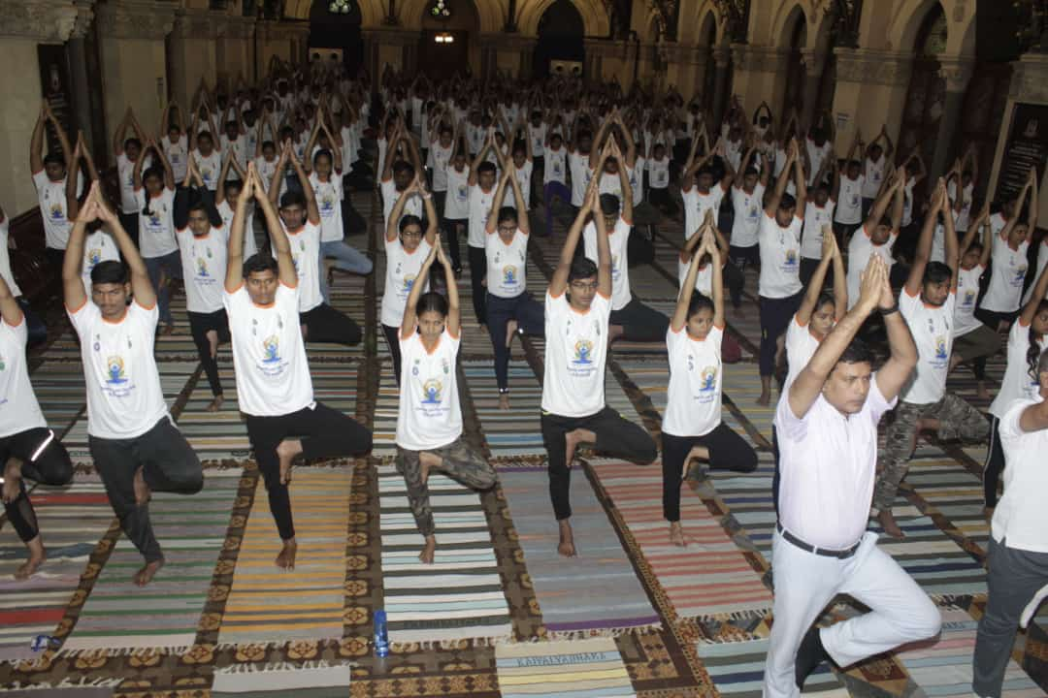
International Yoga Day at University of Mumbai

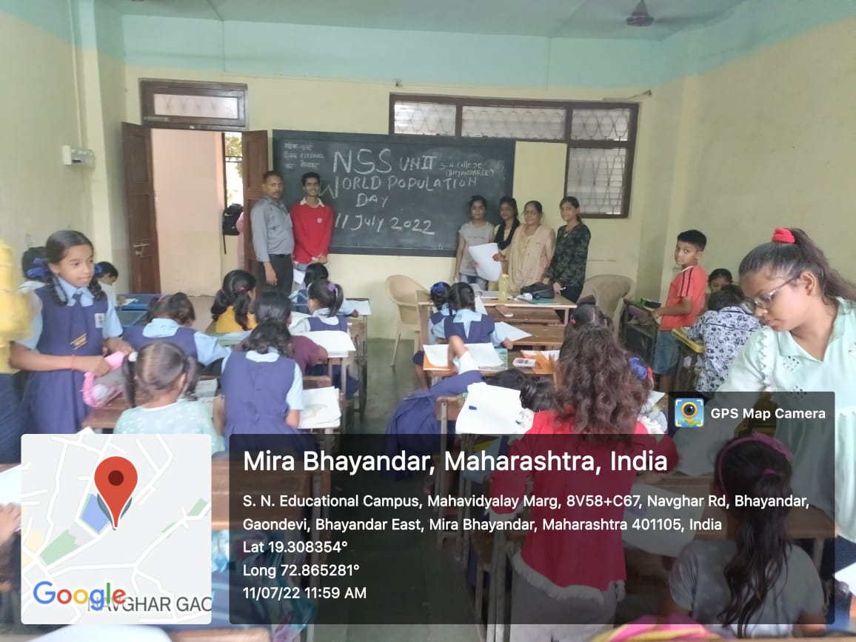

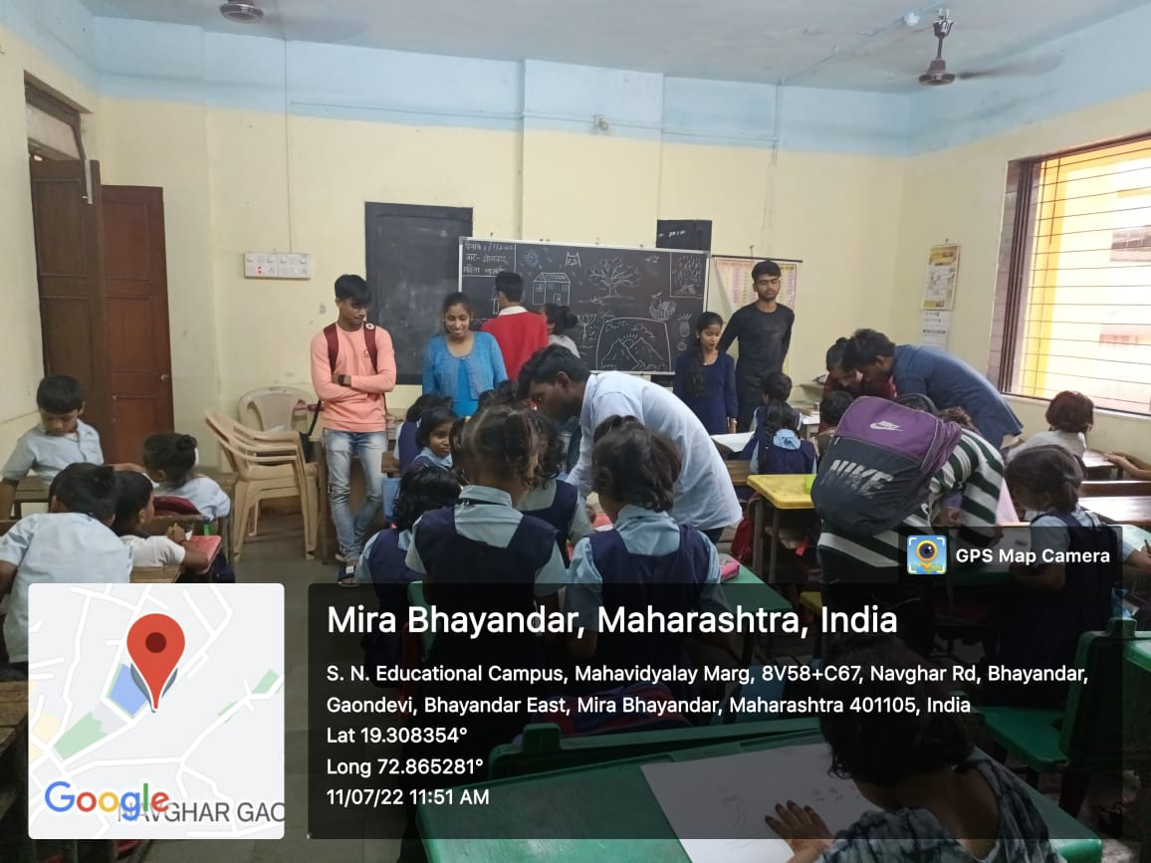
Drawing competition at Navghar School on the occasion of world population day

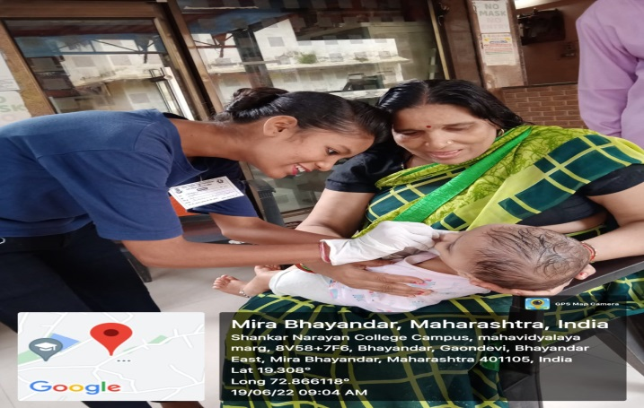

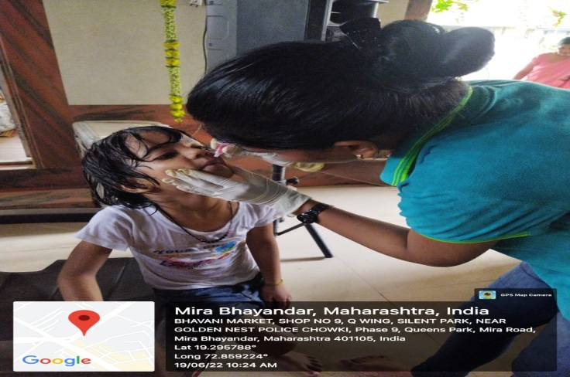
Active Participation Pulse Polio Drive

7.1.1. Vasundhara Nature Club

NAME OF THE ACTIVITY: plantation on World Nature Conservation Day
LIST OF PARTICIPANTS : 10
REPRESENTATIVE PICTURES :
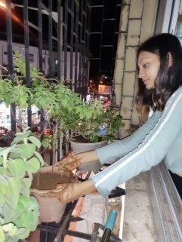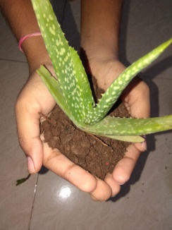

28th July - World Nature Conservation Day – observed by students of Vasundhara Nature Club by engaging in plantation activity at their respective homes and spread awareness regarding conserving green cover in their neighbourhood.

NAME OF THE ACTIVITY: Beach CleanUp Drive on occasion of Gandhi Jayanti
LIST OF PARTICIPANTS: 54
REPRESENTATIVE PICTURES

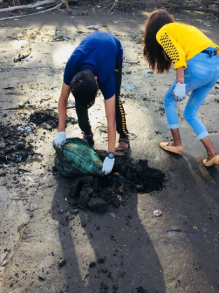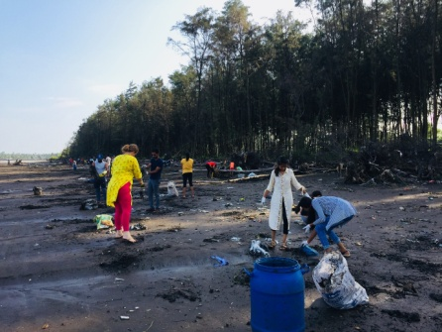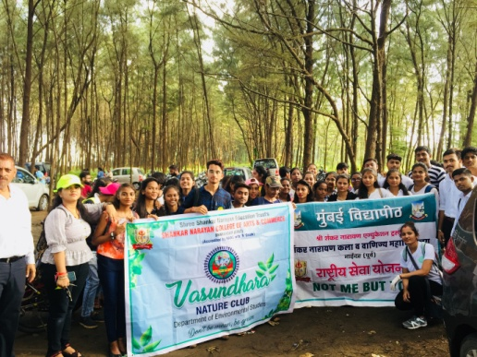
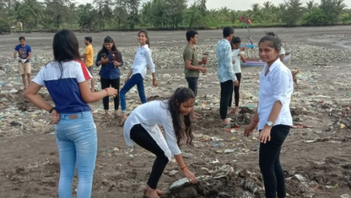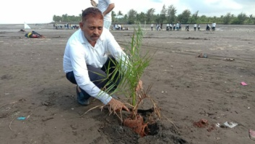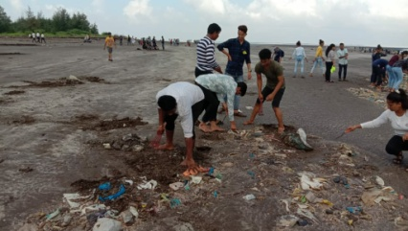
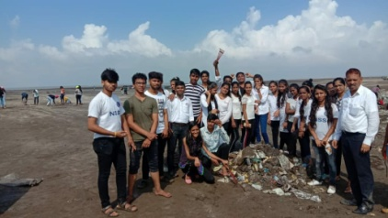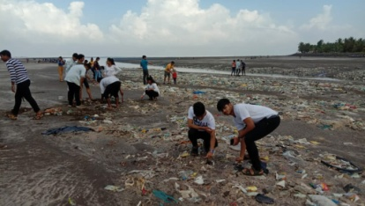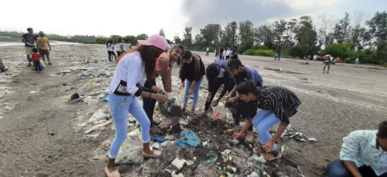

2ndOctober2019 – volunteers from Vasundhara Nature Club and NSS volunteers of Shankar Narayan College participated in a Beach Clean Up Drive organized by ‘Vasai Beach Cleaner’s on occasion of Gandhi Jayanti to spread awareness regarding a cleaner environment. Around 50 students joined hands with another 1000 people from all walks of life assembled at Bhuigaon beach (Vasai) to eradicate plastic trash vomited by the sea during high tides and accumulated on the sea-shore. Along with cleaning our students also engaged in plantation of Date plants organised by the community. Witnessing the amount of plastic trash that reaches our oceans through various means, our students felt motivated to continue to engage in activities that spread awareness regarding appropriate plastic disposal practices.

NAME OF THE ACTIVITY: Webinar on World Environment Day
LIST OF PARTICIPANTS : 25
REPRESENTATIVE PICTURES :

5th June 2020: Guest lecture by Zsuzsanna Zsalda, Director of Luna foundation, on Plastic waste nuisance in environment was organized to observe World Environment Day. it aimed to sensitize students regarding damage to several ecosystems due to mismanaged plastic waste.

NAME OF THE ACTIVITY: Inter collegiate Quiz competition on world Water Day
LIST OF PARTICIPANTS: 35
REPRESENTATIVE PICTURES
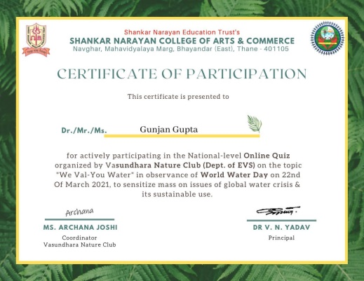

22nd March 2020: several students from Shankar Narayan College and other colleges participated in the Online Quiz competition held on 22nd March to spread awareness amongst mass regarding rising issues of waste resources like - global water crisis, water pollution, sustainable use of water resources, UNDP Sustainable Goals etc. all participants were awarded with e-certificates.

Plantation on Gandhi Jayanti
LIST OF PARTICIPANTS: 10
REPRESENTATIVE PICTURES
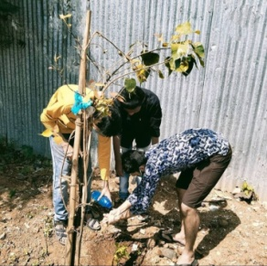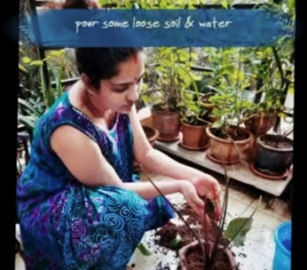

2nd October 2021 : to mark observance of Gandhi Jayanti, maintaining the COVID Protocols of lockdown & social distancing, students & teachers of Vasundhara nature club planted saplings in their home gardens, society & neighbourhood.

NAME OF THE ACTIVITY: Observe International Day of Climate Action
LIST OF PARTICIPANTS: 3
REPRESENTATIVE PICTURES
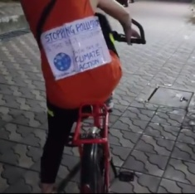

24th October 2021 :Cycling to spread awareness regarding International Day of Climate Action.

NAME OF THE ACTIVITY: Street play on World Water Day
LIST OF PARTICIPANTS:16
REPRESENTATIVE PICTURES
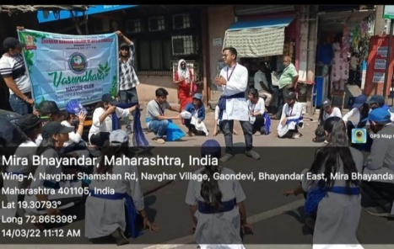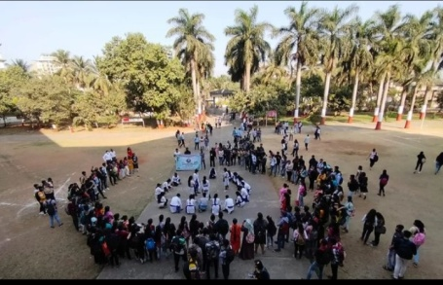

14 March 2022 : enthusiastic students of Nature club had enacted a play using slogans, songs, rap &drama in 5 different locations around Bhayander East area including- Hanuman Chowk, Godnevnaka, railway station, college campus & police chowki to sensitize public regarding water crisis & water conservation practices.

NAME OF THE ACTIVITY: Up cycled Waste Exhibition for Global Recycling Day
LIST OF PARTICIPANTS:32
REPRESENTATIVE PICTURES
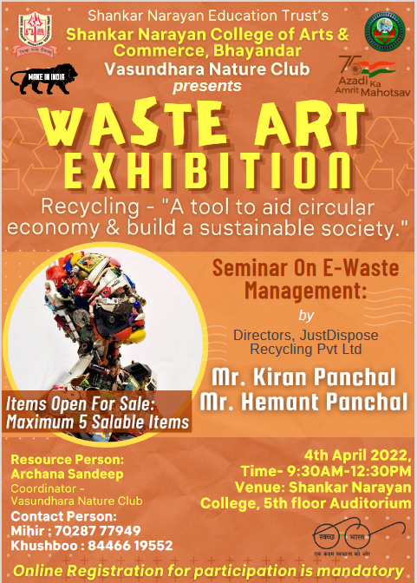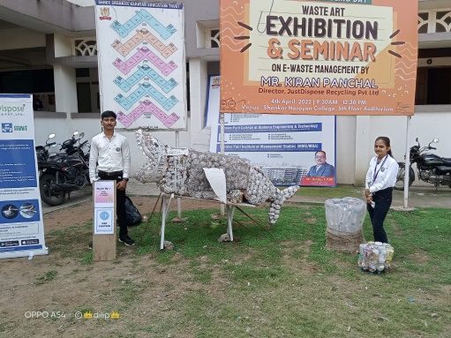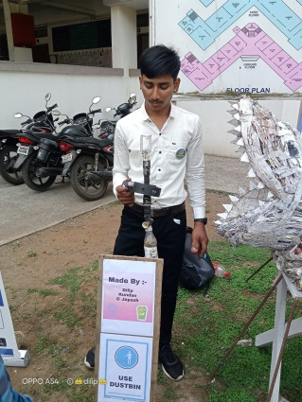

4th April 2022: JustDispose Recycling Pvt Ltd was invited to deliver lecture on E-waste management to sensitize our students and teaching staff regarding channelized disposal of E-waste through registered E-waste recyclers. Our students actively participated in Waste Art Exhibition that displayed several electronic working models from discarded & scraps of e-waste - like- vacuum cleaner, water dispenser, study lamp, e-waste bin made of scrap metals & wires etc.

NAME OF THE ACTIVITY: tree tagging for World Nature Conservation Day
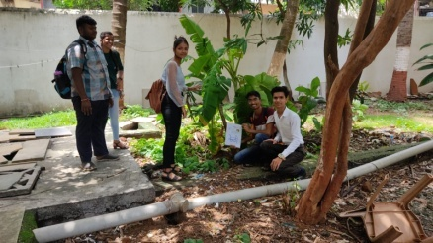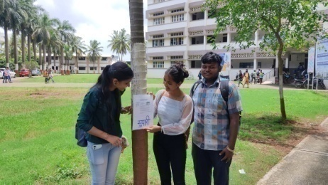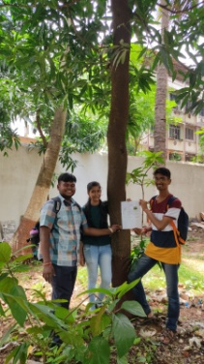

28th July 2023 : Students of Nature club took up the task of tagging of trees & plants in the college campus to spread awareness amongst the students, teaching & non-teaching staff about variety of vegetation in the vicinity. tags mentioning Common name, scientific name, medicinal value of numerous trees were put up.

15th August 2022
To celebrate 75 years of independence – Azadi ka Amrit Mahotsav, a Medicinal Grove was established & inaugurated by Shri Rohidasji Patil in the campus on 15th August. Around 40 variety of saplings accounting to about 100 saplings were donated & planted by our students. viz. Tulsi, neem, marigold, hibiscus, amla, aloe vera, shami, nilgiri, peppermint, panfuti, adulsa, jamun, Ashwagandha, lemon tree, periwinkle etc.
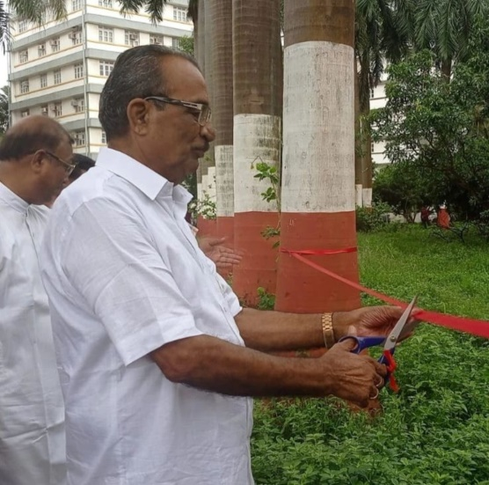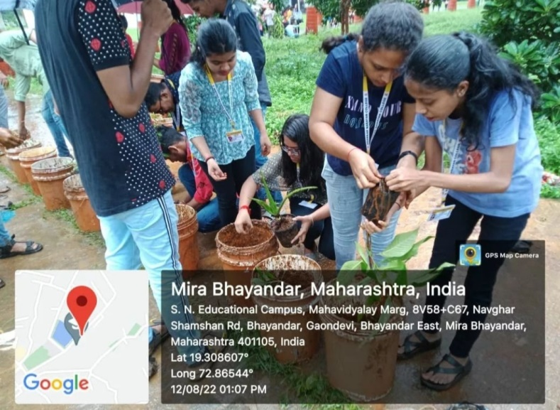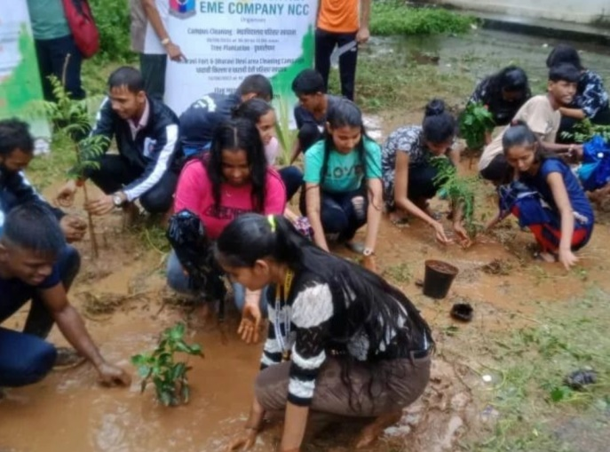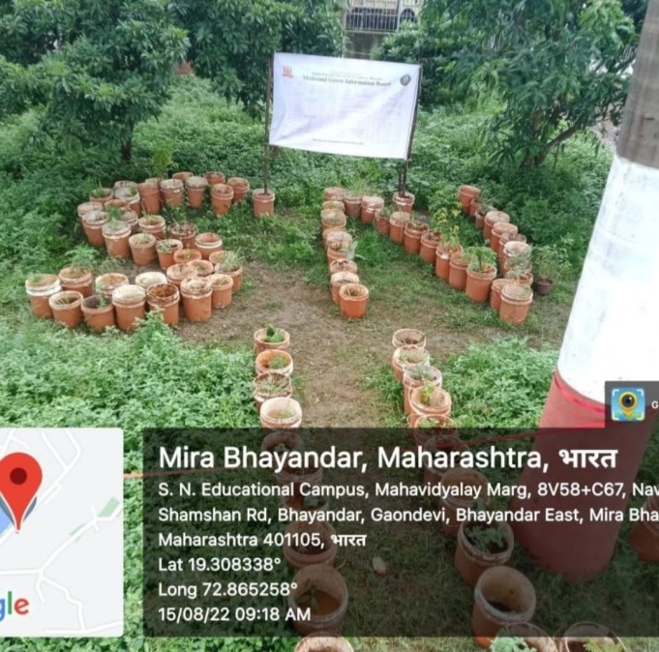

June 5th 2022: World Environment Day 'OnlyOneEarth' 2022 - Environment Awareness Program - "Survey-cum-Quiz".58 students participated. How well you know your environment. Also guiding studenst on new topics of circular economy & fast fashion, Sustainable Development Goals, updating their quick environmental facts / current affairs.

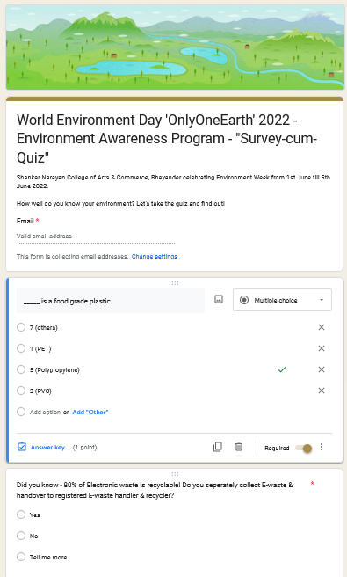

On occasion of world clean-up day on 17th September, 15 students of nature club participated in beach clean-up drive jointly organized by Municipal Corporation of Mira-Bhayandar (MBMC) & For Future India (FFI) unburdening tons of plastic waste from Velankani Beach. Our students received certificate & T-shirts from MBMC for participation.
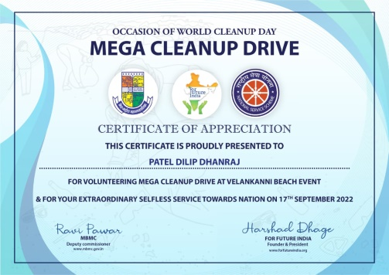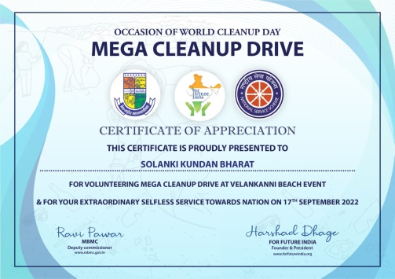

7.1.1. Women Development Cell Report
Objectives
- To investigate into practices unfavourable for women and suggest suitable remedial measures to them.
- To deal with cases of sexual harassment & to promote general well being of female students teaching & non-teaching women staff of the college .
- To create awareness about gender equality among students & other
- stakeholders' .
- To take care of health of female students and employees .
- To organize women empowerment oriented programs.
- The education of the girls through community interface.
- Social awareness and exploring entrepreneurship opportunities.

Major Activities
2018 - 19
Awareness campaign - An awareness campaign was conducted between 17th to 25th July. About 2000 students including males and females participated in the event.
Gender sensitization workshop - Gender sensitisation workshop was conducted in the college campus on 27th of July, 2018. About 120 students were present and were sensitized on the gender aspect.
Women's safety & security oriented programme - women's safety and security orientation programme was conducted on 14th of July, 2018. About 40 students participated in the event. Crucial issues such as women's safety and security were discussed.

Health & hygiene awareness programme - About 30 students participated in the health and hygiene awareness programme. Students were made aware about the health and hygiene that needs to be maintained.
Cancer awareness programme - Cancer awareness programme was organised on 7th Feb, 2019. About 35 students participated in the event. Students were made known about the disease cancer, how it should be prevented and what are the methods of treatment available.
Participation in state level intensive training workshop - The college participated in state level intensive training workshop that was held in Podar College of Commerce, Mumbai that was held on 2nd of march, 2019.
Film screening on women empowerment - Film on women empowerment was shown to students on 7th march, 2019. This enabled students to know what are the rights of a women and what actions she can take on her own. About 110 students participated in the event.
World women's day celebration - World women's day was celebrated on 8th of March, 2019. About 100 students participated in the event.
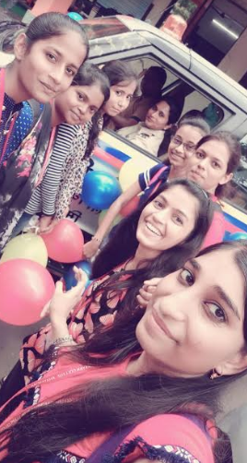
Nirbhaya Campaign Program
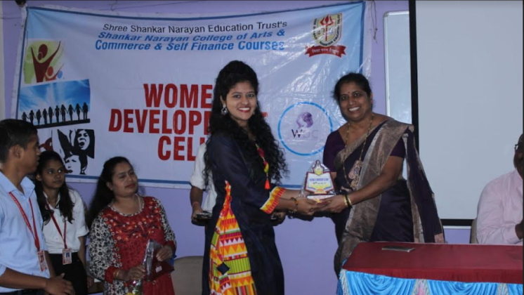
Felicitation of Ex-Female Students on the occasion of world Women's day
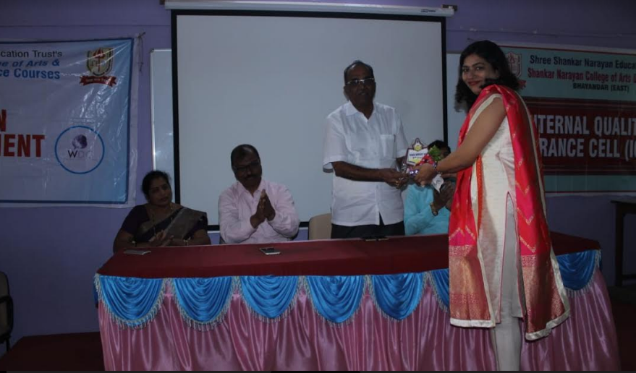
Felicitation of Ex-Female students by the Chairman, Shri Rohidasji Patil
2019 - 20
Mahila Melawa about "Prajwala Yojana" - Women's Development Cell collaborated with MBMC, Civic Development unit to organise a programme to create awareness about Prajwala Yojana. The event was held on 11th of Sept, 2019 and about 30 students participated in the event.
Workshop on Women and child Harassment, Cybercrime & addiction awareness - Workshop on women and child harassment, cybercrime and addiction awareness was conducted on 4th of January, 2020. About 100 students participated in the event. They were made aware about the problems that women and children face in the society and the actions that can be taken to prevent and deal with any kind of crime, harassment and addiction.
‘Women's Safety & Security’ Guest lecture - Guest lecture on Women's Safety and security was organised on 14th of February, 2020. About 96 students participated in the event.
Workshop on awareness about maintaining Health - Workshop on awareness about maintaining health was conducted in the college campus in collaboration with MBMC Health Unit on 29th January, 2019. About 80 students participated in the event. The event created an awareness as to can a healthy diet be maintained along with exercise and Yoga.
Participated in debate competition - Our student participated in the debate competition that was held on 4th of December, 2019.
Police Unaat Din Saptath - In collaboration with Navghar police station, the college celebrated Police Unaat Din Saptath on 4th of January, 2020. About 90 students participated in the event.
Haemoglobin check-up camp - Haemoglobin Check up camp was organised on 29th and 30th January in collaboration with MBMC health unit, Navghar.
Guidance to Mahila Vastister Sangh Regarding Competitive exams, Mira -Bhayander - Guidance lecture was organised on 22nd Feb., 2020 for Mahila Vastister Sangh in collaboration with MBMC, Bhayander. About 120 participants were present on the occasion of the event.
Workshop on awareness about govt.various schemes for Women Empowerment - Workshop on creating awareness about various government schemes for women empowerment was organised on 10th August, 2019. About 70 students participated in the event.
Jagtik Beghar Niwara Divas - Jagtik Beghar Niwara divas was celebrated on 10th of October, 2019. About 70 students participated in the event.
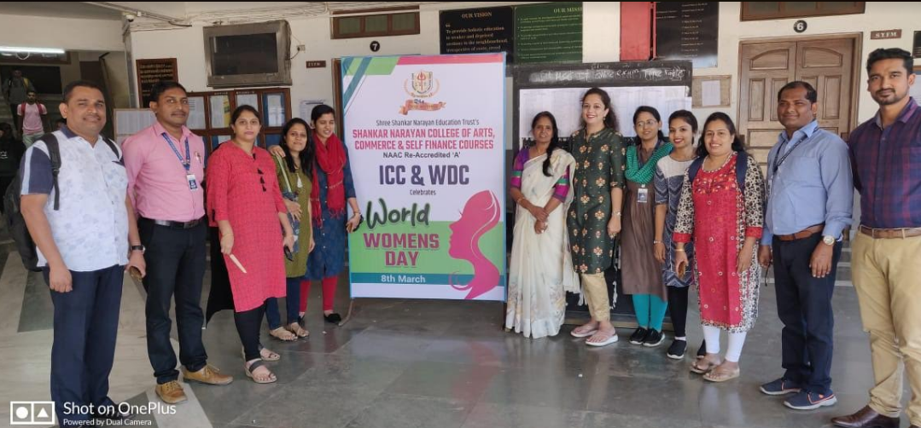
8th March, 2020 - International Women's Day Celebration

2020 -21
Organised Webinar on Cyber Sakhi - Our college collaborated with "Responsible Netism" to organise a webinar on Cyber Sakhi on 5th of March, 2021. The webinar focused on problems such as cybercrime and how to prevent them.
Organised Webinar on Health Related Issues - WDC and PTA of our college collaborated to organise a webinar on health related issues. The webinar discussed important issues such as problems that can occur if proper health and hygiene is not maintained. About 70 students participated in the event.
Attended webinar on Safety of women and Legal Procedure - The college attended a webinar on Safety of Women and Legal procedure organised by WDC of Seva Sadan College of Arts, Science and Commerce on 17th of October, 2020. About 27 students participated for the same.
Attended National Level Webinar on Women Empowerment - The college attended a National level webinar on Women Empowerment organised by IQAC cell of Sheth N.K.T.T. College of Commerce and Sheth J.T.T. College of Arts between 1st March 2021 to 5th March 2021. About 70 students participated in the event.
Attended National Level Debate Competition on “Has Gender Equality Been Achieved in India” - The college participated in the National level debate competition organised by WDC Cell and Yuva Jager of VPM’s B.N. Bedekar College of Science (Autonomous)and VPM’s Dr. V.N. Bedekar Institute of Management Studies on 8th March, 2021.
Attended National Level Webinar on Women Empowerment and Gender Equality - The college attended a National level webinar on Women Empowerment and Gender Equality organised by WDC cell and IQAC of G.M. Vedak College of Science, Tala on 3rd March, 2021. About 100 students participated in the event.

2021 - 22
Poster-Making - Poster making competition was organised on 7th march, 2022. About 85 students participated in the event.
Poetry recitation on the occasion of women's day - Poetry recitation was organised on the occasion of women's day on 8th of March, 2022. About 180 students participated in the event.
Self-Defence training - Self defence training was organised on 8th March, 2022 to empower female students. Suvidha kadam of our college guided the students. About 180 students participated in the program.
Workshop on promoting girls for competitive examination - A workshop on promoting girls for competitive examination was organised on 8th March, 2022. Bhavana Yadav, CAPF-2020,Govt.of India guided the students about various examinations that can be attempted by females. About 180 students participated in the program.
Seminar on women Empowerment - CS Dipti A. Mehta, Mehta & Mehta Co. was invited as the guest speaker for the seminar on women empowerment on 8th March, 2022. About 180 students participated in the program.
Group song performance women Empowerment, Rangoli making on women Empowerment, Dance Performance on women Empowerment - was organised on 8th march to encourage female students to participate for the event.
Seminar on safety & security of women - A seminar on women empowerment was organised on 10th March, 2022. Mrs. Rajshree Patil, API, Police Department, Mumbai, was invited as the guest speaker who discussed various crucial aspects of women empowerment. About 210 students participated in the event.
Essay writing Competition - Essay writing competition on the theme women empowerment was organised on 13th March, 2022. About 20 students participated in the event.
Film -screening(Article 15) - The Film, "Article 15" was shown to students on 14th of March, 2022. The movie focused on various issues faced by women and other communities of India.

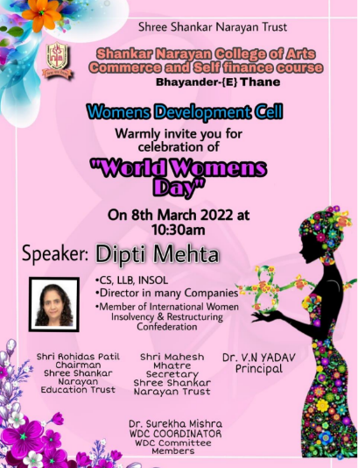
Invitation Card of International World Women's Day Program

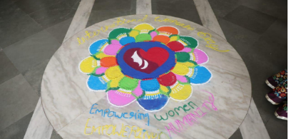
Rangoli Making on Women Empowerment
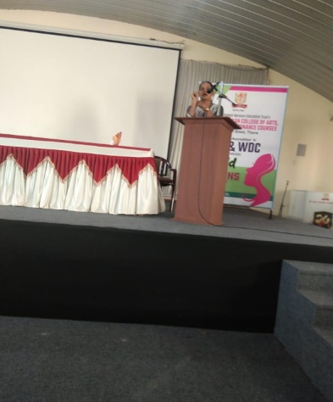
Competitive Examination Awareness Workshop

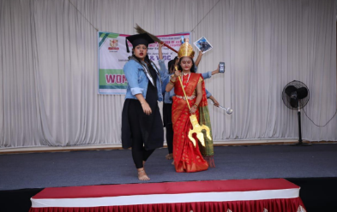
Dance performance on women Empowerment

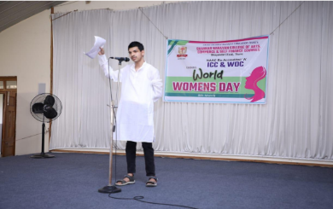
Poetry Recitation on women Empowerment

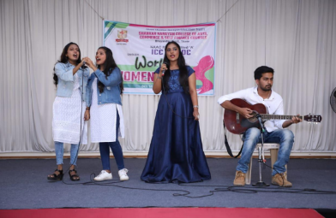
Group Song on women Empowerment
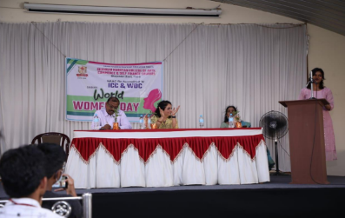
Maharashtra MPSC Selected No. 1 Ranker felicitation and Guidance Session
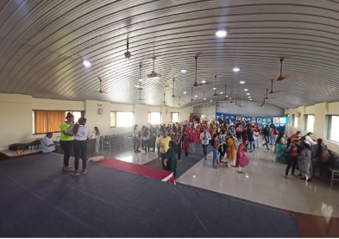
Self Defence Training Workshop

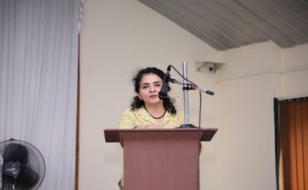

Mrs. Dipti Mehta, Mehta and Mehta Co. Spokesperson on the occasion of world Women's Day

2022-2023

- On the occasion of “Doctors Day” a seminar was organized on 6th July 2023 on “Women’s and their Health related Issues” at 10.30 am with the support of Wockhardt Hospital. The seminar was chaired by Dr. Rajashree Bhasale, Gynaecologist of Wockhardt Hospital.
- On the occasion of “World Heart Day '' a workshop was organized on 29th Sept.2023 with the support of Suffi Foundation and their team for students of our college about what primary aid we have to take with the person who suffers by such circumstances of Primary stage of Heart Problems
- A celebration of the international women’s day on 8th March 2022 with the theme of “Women Empowerment & Gender sensitization,” organized a programme were the women’s providing there services in different field equally with male are called on one platform to honour them and they get interacted with our students, shared their experiences of how to face challenges and come forward with self confidence. We invited women who are the auto rickshaw drivers, maids, police constables, bus conductors, post female peon and the like.
- The convener of our college ICC & WDC, invited at A. E. Kalsekar College of Commerce & Management ,Nalasopara,Palghar.,as a guest speaker on the platform of “World Women’s Day-One Week Celebration Programme” on 15th of March 2023. Dr. Surekha Mishra exchanged her views on the given topic “Women Empowerment & Gender Sensitization”. More than 100 students participated in it .They discussed with the speaker there views, some of them raised their questions and received clarifications. This was one of the inter exchange programmes.
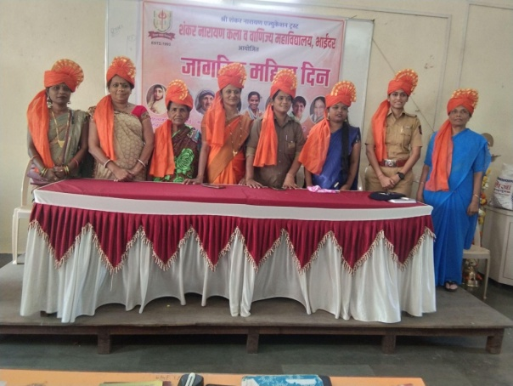
Felicitation of valuable service providers on the occasion of Women's Day

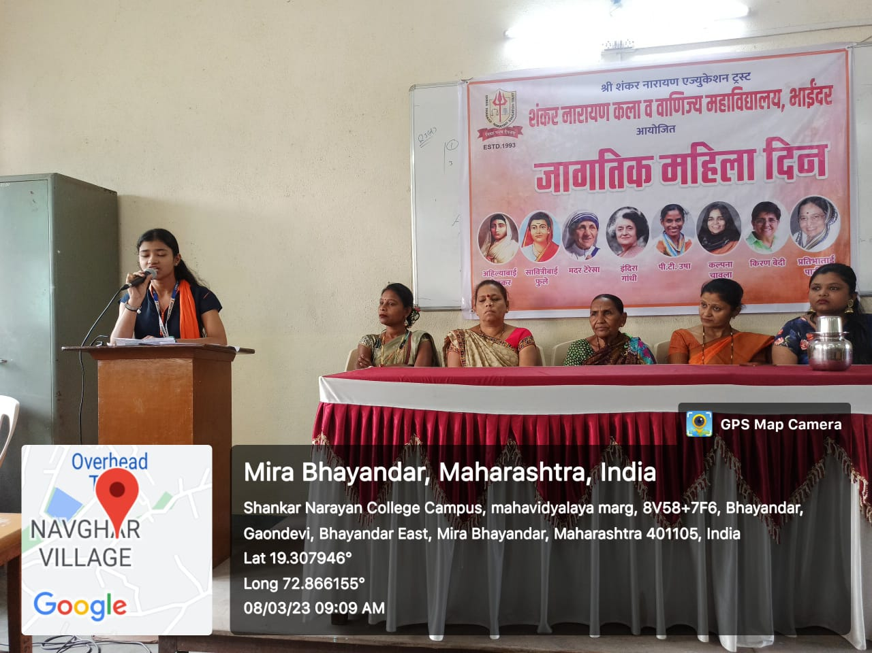
Speech on Women Empowerment by Student

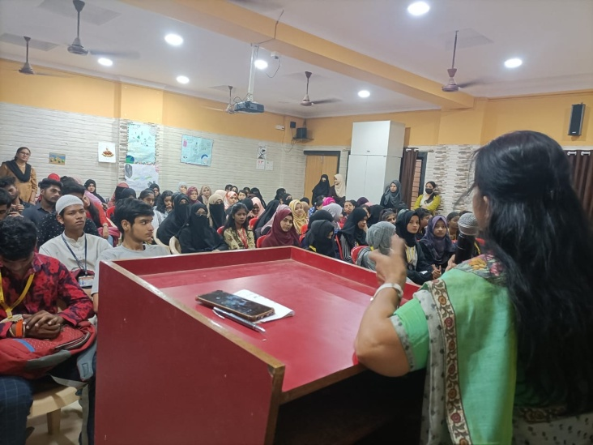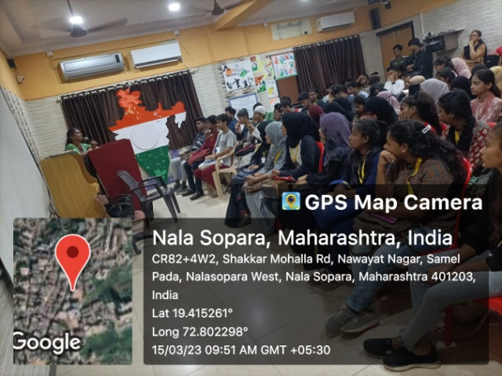
Dr. Surekha Mishra exchanging her views about women empowerment in other colleges

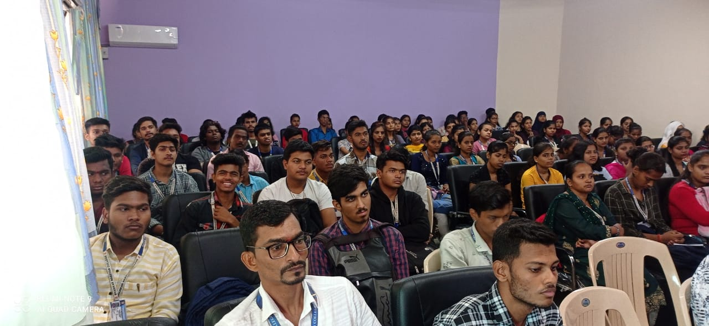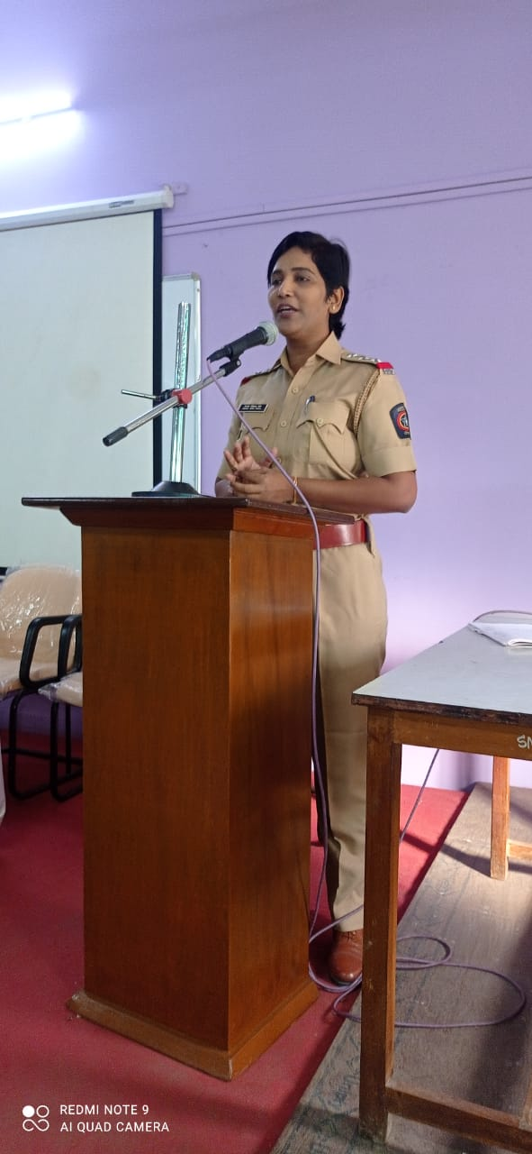
Workshop on Women Safety and Security by Mrs .Tejashree Shinde ( IPS)
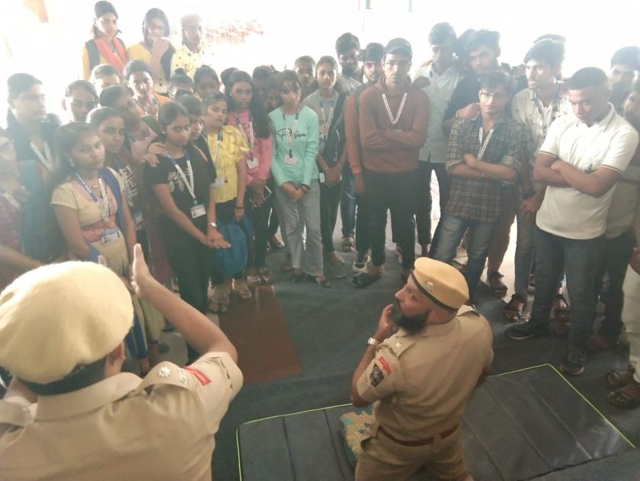

On the ocassion of World Heart Day - Primary stage of Heart Problems workshop

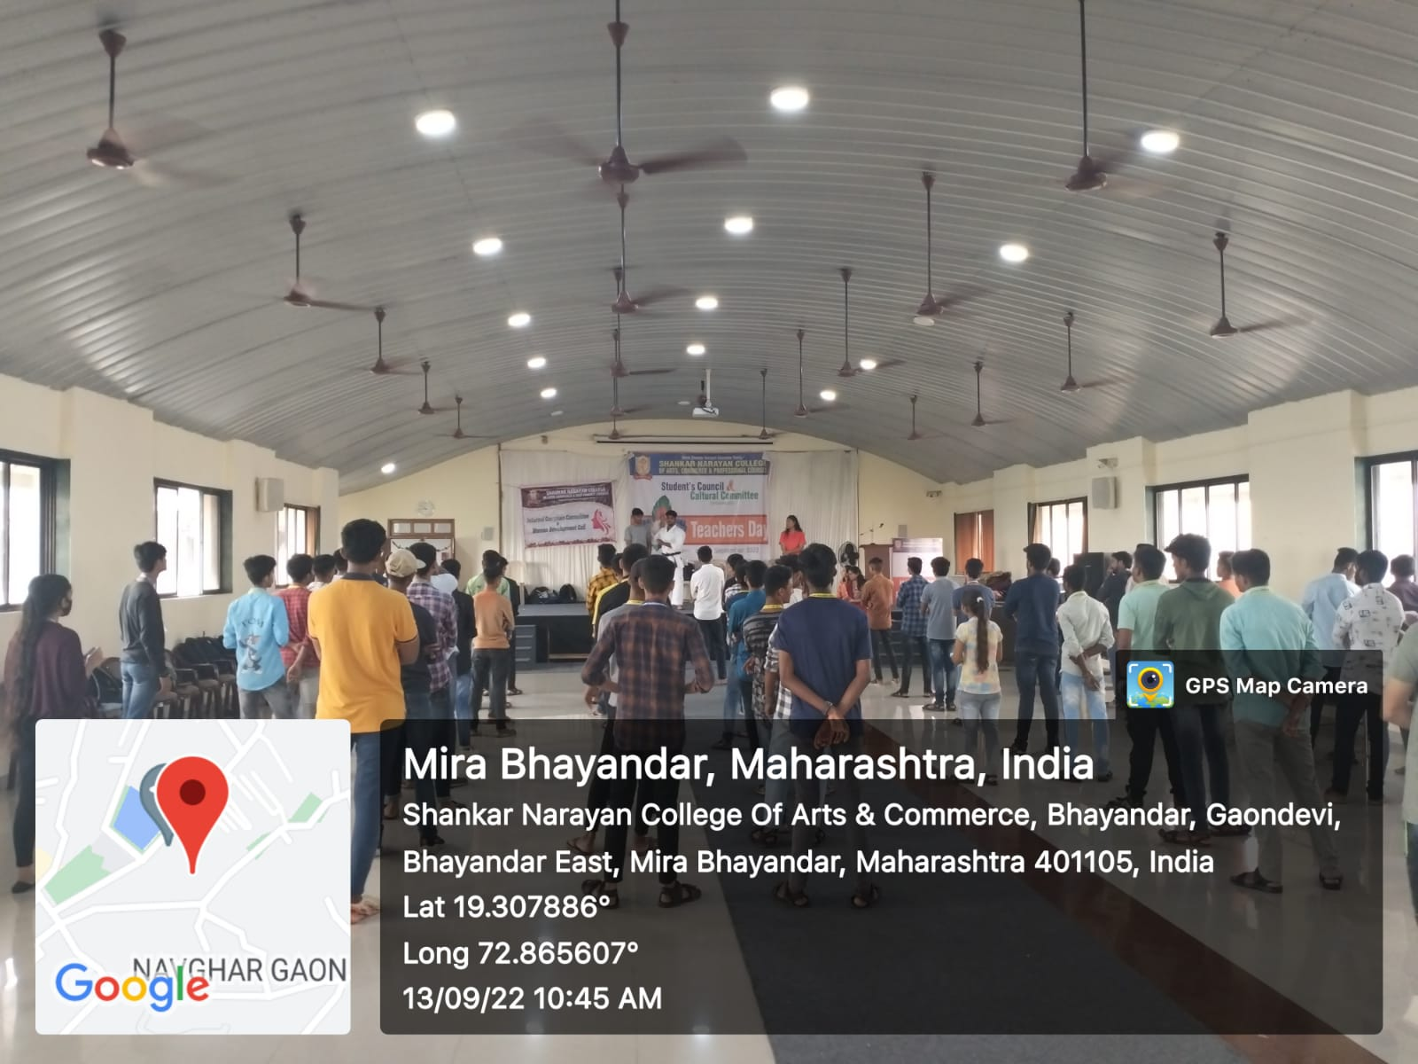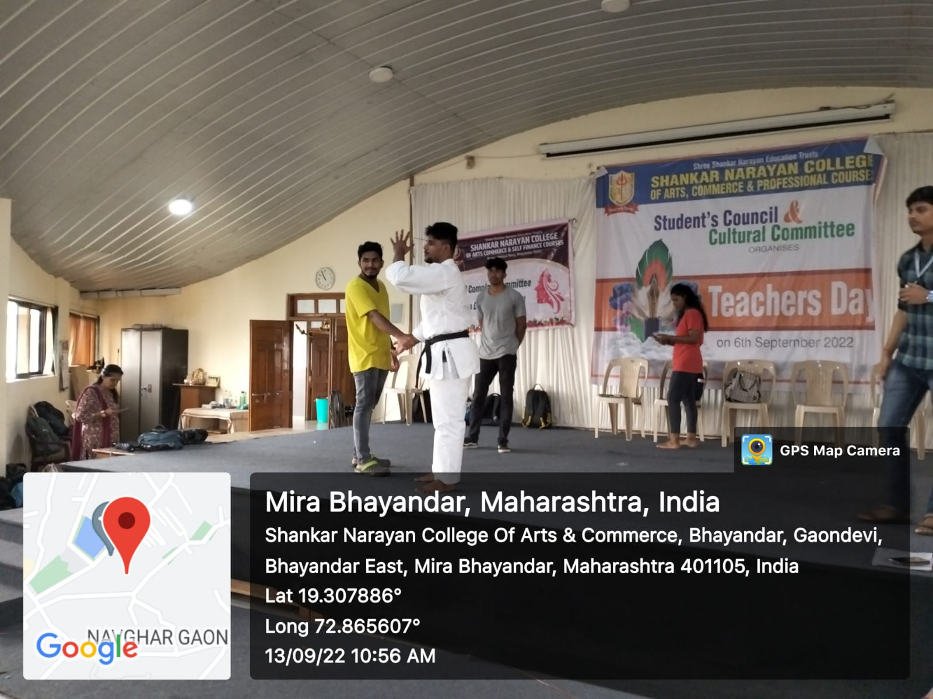

Self Defense Training Programme

